**OSIRIS**

Open Source Independent Review and Interpretation System

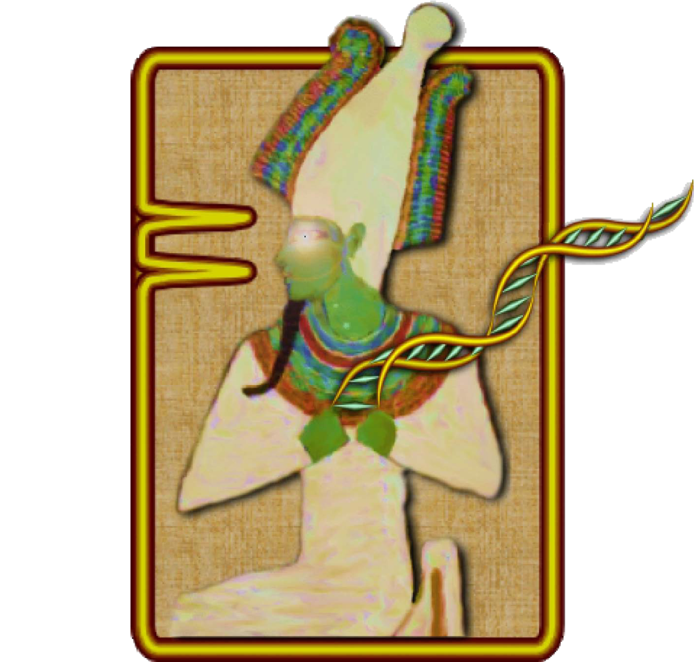

**Version 2.13**

**User’s Guide**

**Rev. 1**



National Center for Biotechnology Information

National Library of Medicine

National Institutes of Health

U.S. Department of Health & Human Services



# Table of Contents

Table of Contents 2

Background 5

Getting Started 6

Obtaining and Installing OSIRIS 6

Quick Tutorials 6

A Tutorial for STR Analysis 6

Configuration 12

Lab Settings 12

**Optimizing Settings** 13

Add a new Operating Procedure 13

General - .fsa and .hid files 14

File/Sample names 14

Thresholds 18

Sample Limits 20

Assignments 43

Configure Editing – Acceptance/Review Tab 45

Artifact Label Setup 46

Grid Colors 47

Analysis 48

OSIRIS Report Files 51

Analysis Report Table 51

Using Table Cells to Display Information 52

Plot Preview Graph and Graph Menu 53

Table Toolbar and Menu 54

OSIRIS Plot Files 57

Allele and Artifact Hover Boxes 58

Display Bases or Time on the x-axis 59

Graph Toolbar 60

Resizing Plots 62

Export Graphic File 63

Zooming and Panning the Graph 63

Editing Peaks, Loci and Samples 65

Peak Editing 65

Locus and Sample Editing 66

Reviewing Editing and Analysis 69

Disabling and Deleting Samples 70

Sharing Your Data 71

Creating an Archive 71

Extracting an Archive 72

OSIRIS Flexible Spreadsheet Export 73

Initial Setup 73

Export Parameters 75

Example: 78

Export Setup Tutorial 79

OSIRIS Artifact Handling 82

Definitions 89

Appendices 91

Appendix A. Program Elements 91

Compiled Software 91

Message Book 91

Operating Procedures and Kit definitions 92

Kit definitions 92

**Elements Defined:** 92

**Positive Controls Defined in Default Operating Procedures** 93

**Core/Extended/Interlocus Boundaries** 95

Appendix B. Site Folder Locations and Upgrading 96

Site Folder location 96

Permissions for Site and Volumes directory 97

Determining OP names in file folders 97

Appendix C. Sample Rework 98

Appendix D. Quality Assurance and Automation Uses 99

Appendix E. User Defined File Export 101

Appendix F. Artifact List 103

Appendix G. Adding a New Kit 109

New Kit 109

Appendix H. Dynamic Baseline Analysis and Normalization 110

Raw data filtering: 111

Detecting the true baseline: 112

Appendix I. Troubleshooting and FAQ 113

Troubleshooting 113

FAQ 117

Appendix J. Other Information Output to Analysis Files 118

The Comment Field 118

The Information Field 118

Appendix K. Privacy Information 120

Privacy Statement 120

Opt-out of Statistics Collection 120

Appendix L. A Quick Tutorial for Fragment Analysis 121

Analyze Your Own Data 125

OSIRIS User’s Guide Revision History 127

# Background

OSIRIS (Open Source, Independent Review and Interpretation System) is a public domain quality assurance software package that facilitates the analysis of multiplex short tandem repeat (STR) DNA profiles based on laboratory-specified protocols. OSIRIS evaluates the raw electrophoresis data contained in an .fsa or .hid file using an independently derived mathematically-based sizing algorithm. OSIRIS currently supports ABI capillary analytical and RAPID-DNA platforms and numerous commercially available CODIS-compliant marker kits.

OSIRIS searches for peaks by iteratively fitting expected parametric data signatures to the observed data, usually achieving peak fitting with correlations in excess of 0.999. Peak locations are determined with sub-second accuracy and converted to base pair coordinates. Traditional sizing methods for DNA fragments usually rely on either the local or global Southern methods to interpolate the internal lane standard (ILS) into base pair estimates. OSIRIS departs from this approach, using instead the correspondence between a sample’s ILS and an associated allelic ladder to map the time scale of the ladder into that of the sample. This integration of the ladder with the sample permits a straightforward and accurate comparison of sample peaks with ladder locus peaks. Typically, OSIRIS-analyzed sample peaks align within 0.1 base pair of the position within a locus. Thus, in addition to providing reliable and accurate peak analysis, OSIRIS offers two new peak quality measures – fit level and sizing residual.

OSIRIS can be customized to accommodate laboratory-specific settings sensitive to typical background noise and can accommodate customized naming conventions and internal laboratory controls. When appropriately validated, OSIRIS can serve as an expert system for identification and review of acceptable profiles.

OSIRIS was initiated in response to recommendations of a multidisciplinary advisory group (the Kinship and DNA Analysis Panel, KADAP) empaneled by the U.S. Department of Justice. KADAP was assembled to assist the New York City Office of the Medical Examiner (OCME) and New York State Police (NYSPD) DNA laboratories in the difficult and unprecedented legal and humanitarian challenges of the World Trade Center victim identifications by developing guidelines and recommendations for management of the identification process, focusing on ways to enhance the number and quality of identifications that could be made[1].

Developed in collaboration with state, local and federal forensic laboratories and NIST, the National Center for Biotechnology Information (NCBI) created OSIRIS using C++ and object-oriented design to facilitate the development of add-on applications by those using the program. NCBI performs internal quality assurance on its programs and will maintain OSIRIS at <http://www.ncbi.nlm.nih.gov/projects/SNP/osiris> as part of its extensive public domain toolkit for exploring and managing genetic data.

# Getting Started

**When viewing the electronic version of this guide** you may navigate to sections indicated in the table of contents by using bookmarks in a PDF viewer and by selecting hyperlinks in the document. If you select a hyperlink, Alt-Left arrow (‘Command-[’ on the Mac) will return to the page with the hyperlink you selected.

**Note:**

* **This Guide may need to be zoomed to fill the width of the screen for some figures to be clear in a PDF reader.**
* **Some network configurations of Microsoft Windows 10 will not open the OSIRIS help PDF file when the Microsoft Edge browser is the default reader for PDF files.** The simplest solution is to select an alternate PDF reader: In File Explorer, open the folder where OSIRIS is installed. Right click the OsirisHelp.pdf file and select “Open with >” then “Choose another app” from the pop-up context menu. Select a different PDF reader or a different browser that can open PDF files, check the “Always use this app to open .pdf files” checkbox, and click "Ok". To find your installation folder in Windows or the Mac, open OSIRIS and select Tools>Message Log from the menu. The first line of the log indicates the location of your OSIRIS installation folder.

**Please refer to the** **Troubleshooting** **section** in Appendix I of this User Guide to resolve problems with your own analyses.

## Obtaining and Installing OSIRIS

OSIRIS for Microsoft Windows and Apple Macintosh can be downloaded at <https://www.ncbi.nlm.nih.gov/osiris/download/>, where there are also links to installation instructions.

## Quick Tutorials

See A Quick Tutorial for Fragment Analysis in Appendix L to learn how to use OSIRIS for fragment analysis using only an internal marker.

## A Tutorial for STR Analysis

The following is a quick overview on using OSIRIS for STR analysis with an allelic ladder. The files shown in the examples illustrated in this guide are included with your OSIRIS download. All of the .fsa and .hid example files were created by the Human Identity Team at the National Institute of Standards and Technology (NIST). We recommended that you use the Quick Tutorial along with the provided NIST files to help familiarize yourself with OSIRIS. Details of OSIRIS’ features will be described in the later chapters.

The demonstration files include files from a number of kits in use in the forensic community in the U.S., including Applied Biosystems Identifiler and GlobalFiler, and Promega PowerPlex16 and Fusion. The Fusion and GlobalFiler files are in .hid format. Included in the Identifiler directory is a set of samples with specific artifacts with the locus indicated in the filename. Among the default Lab Settings included with OSIRIS are starting settings for optimizing OSIRIS performance for samples known to be single source, and for samples that may or may not be mixtures. Two examples include PowerPlex fusion HID Sole Source and GlobalFiler HID Mixture. We encourage users to analyze the Fusion and GlobalFiler data with the starting settings after completing the tutorial below.

Below is an illustration of the opening window. Note the menu bar availability above the logo. The logo disappears after a moment.

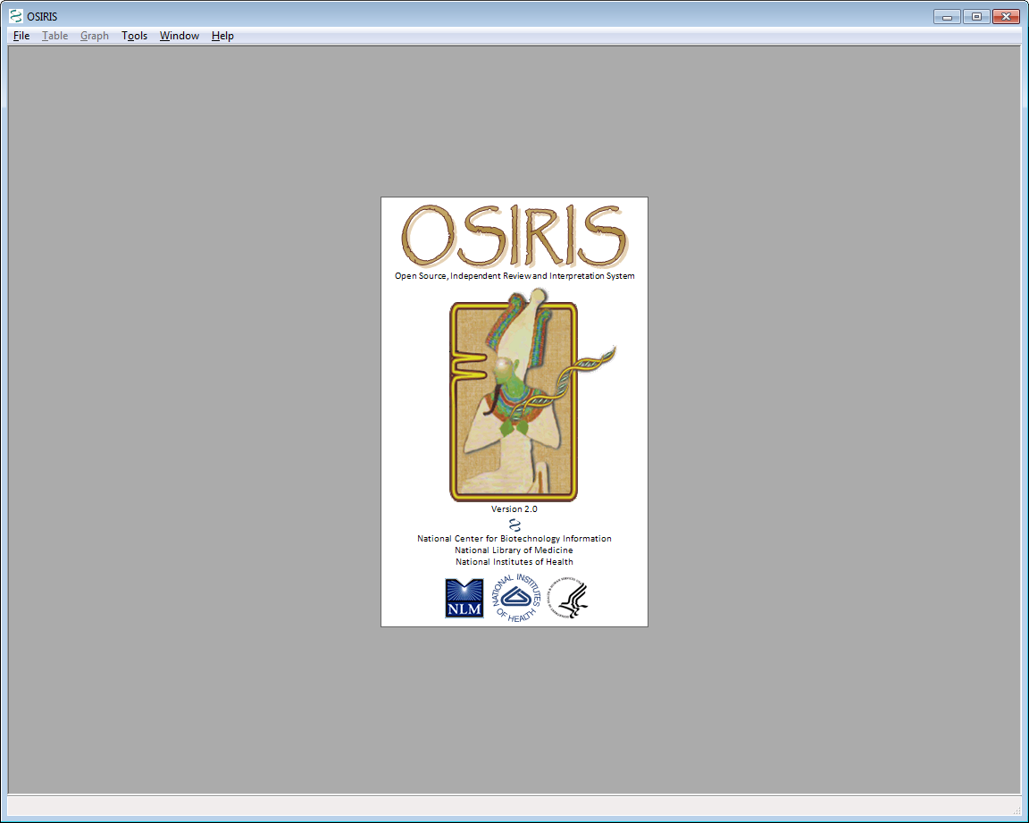

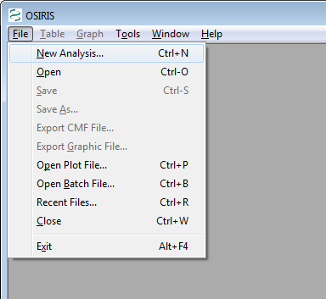

After the OSIRIS logo disappears, select “New Analysis…” from the “File” pull down menu as shown. A dialog box labeled “Analyze Data” will appear.

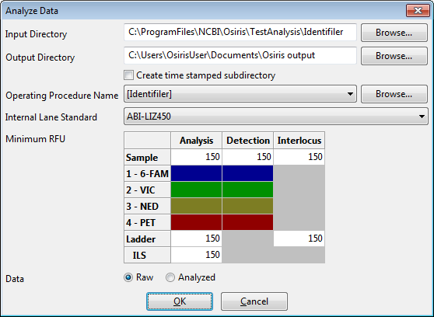

When the “Analyze Data” dialog box appears, the user can enter the specific information and click “OK” to begin the analysis. Note that different minimum RFU Threshold values may be set for Samples, Ladders and ILS (internal marker). The drop-down menus detail the kits and standards that OSIRIS currently recognizes. The Operating Procedure Name refers to the kit and many other settings which are described in detail in the Laboratory Settings section. Requests for other marker sets or controls can be sent to [forensics@ncbi.nlm.nih.gov](mailto:forensics@ncbi.nlm.nih.gov).

In the illustrated example, we are using data files created by NIST for IdentifilerTM and provided with the OSIRIS software. The NIST data files are located in a subdirectory named “TestAnalysis.” When using the Windows™ version of OSIRIS, it is a subdirectory of the directory where OSIRIS was installed. When using the Macintosh™ version, it is a subfolder in the folder containing the OSIRIS application. Note that file names on the Mac will not be selectable. Select the *directory* to be analyzed.

For the Input Directory, select \TestAnalysis\Identifiler in the directory where your installed OSIRIS (located in the C:\ProgramFiles\NCBI\Osiris directory in this figure). Select the [Identifiler] Operating Procedure from the dropdown list and click OK. When the analysis begins, a new window appears (see below) which shows each subdirectory that will be analyzed along with its current analysis status. The \Identifiler Artifacts analysis contains samples with specific artifacts. Select the \STRbaseIF analysis and click the View Selection button. If only one subdirectory is to be analyzed a new window opens upon completion with a table containing the results of the analysis.

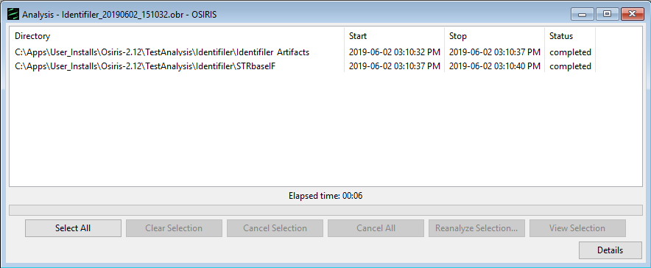

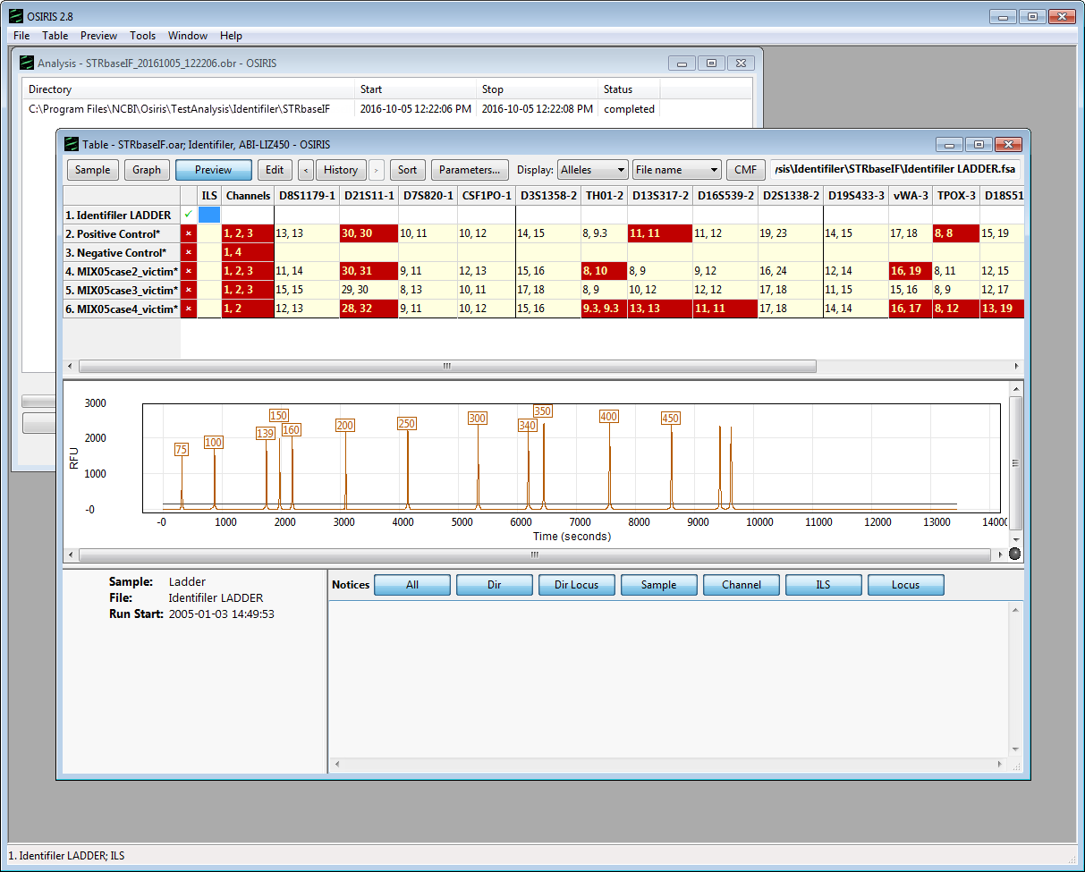

From the table above, the user can choose which peak data to display (alleles, base pairs (BPS), RFU, time, peak area), view plots containing the data, and edit the data. This is accomplished using the toolbar buttons at the top of the table window, the pull down menu labeled “Table” on the menu bar, or by right clicking the table cell of interest to display a pop-up menu. Note that when a cell is highlighted on a table, notices and detailed information appear in the bottom right pane of the window. There is a “Preview” option on the toolbar menus that toggle the display of a plot showing the peaks of the currently selected sample and allele. This is on by default but can be turned off in order to show more rows in the table. As you may have noticed, there are many colors used for the table cells. These colors can be modified and are explained in the “Grid Colors” section. Allele calls and artifacts can be edited as described in the “Table Toolbar and Menu (Editing)” section.

To view a more detailed graphical representation of one of the samples, click on the row of the desired sample and select the “Graph” button on the toolbar. Following is an example.

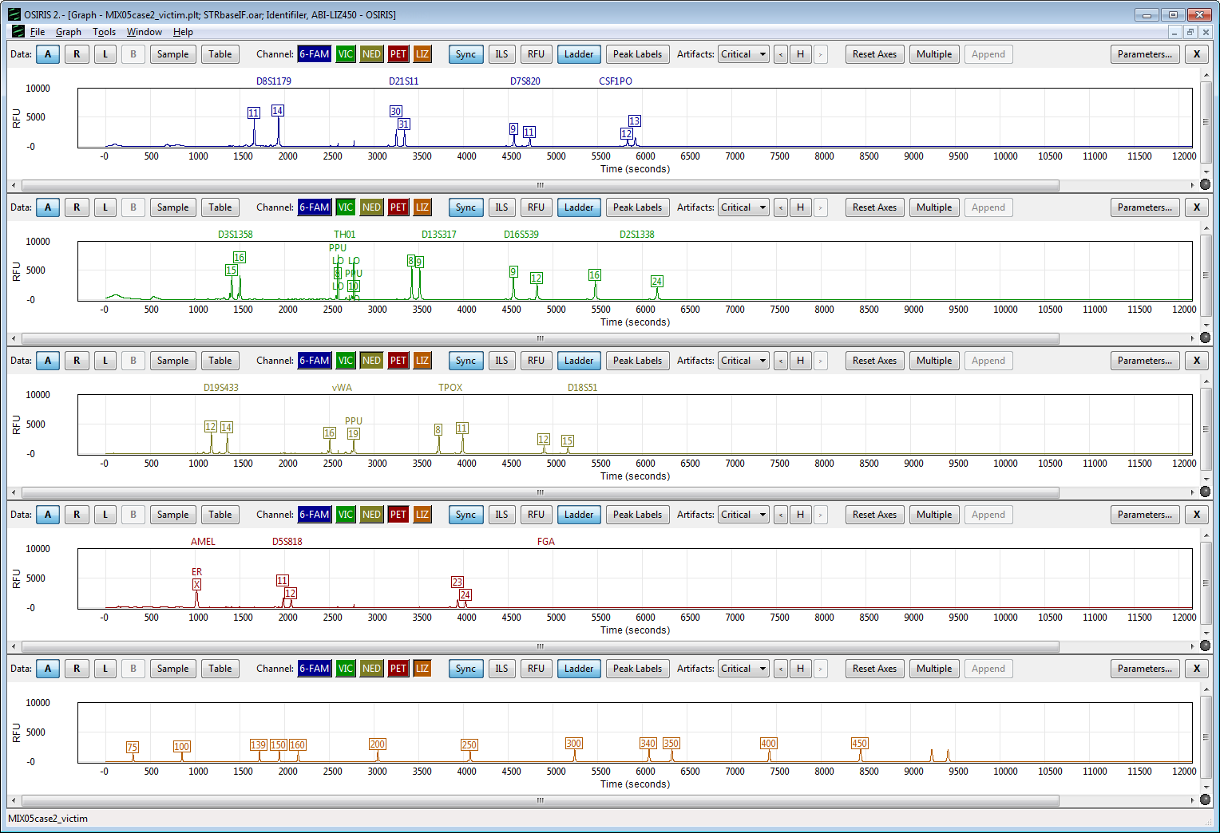

The image above shows a graph of the electropherograms. By default, there is a separate plot for each channel. The toolbar at the top of each plot as well as the pull down menu labeled “Graph” provides many options which are described in detail in the section titled “OSIRIS Plot Files.”

Adjust the height of the plots for your screen size. Click and drag the bottom edge of the top plot down to resize the plots to a convenient size for your screen. When the stacked plots are larger than the screen, use the scroll bar that appears on the right to scroll through the plots that are off-screen. If you have upgraded a previous OSIRIS version, you may have to select “Resizable plots” from the “Graph” pull down menu before resizing the plots.

Hold the cursor over one of the allele labels to display the allele peak information pop-up. Hold the cursor over one of the artifact labels to display the artifact information pop-up for the peak. An explanation of the information in the pop-up box is in Allele and Artifact Hover Boxes.

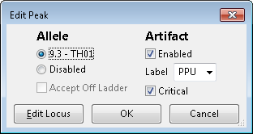Edit a peak. Click on a label to open the Edit Peak window. Here you can turn artifact and allele labels off or on by selecting enable or disable. You can select a different artifact label than the one chosen by OSIRIS from the Artifact Label dropdown list. Clicking ‘OK’ will save your changes. Click the “Edit Locus” button to open the Sample Editing window, which allows review and acceptance of quality notifications that are associated with loci. See Editing Peaks, Loci and Samples.

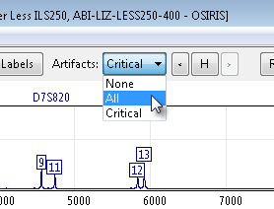

Display all the artifact labels. Select “All” from the “Artifacts” dropdown list to display all of the artifact labels, including non-critical artifact labels. See OSIRIS Artifact Handling for a discussion of how OSIRIS defines critical and non-critical artifacts.

You can zoom in by clicking a locus label or by clicking and dragging to box an area of one of the plots. See Zooming and Panning the Graph.

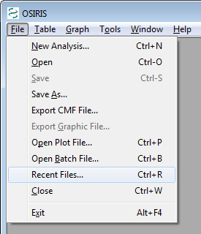

Recently viewed files can be accessed through a dialogue window by selecting “Recent Files…” from the “File” pull down menu, as shown here. An example is shown below. Type part of a file name in the Search bar to find files.

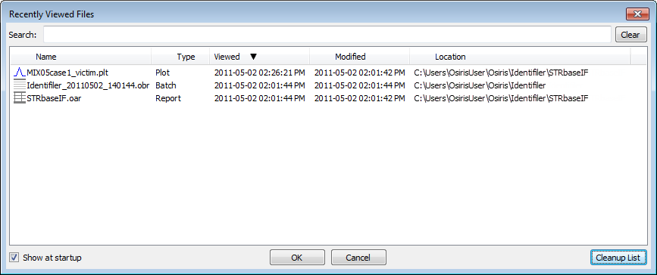

This list shows up to 1000 files that have been opened by OSIRIS and can be sorted by name, type, last time viewed, modification time, or location. To open a file, double-click on the file name or select one or more files and select the “OK” button. You may select and view up to 10 files at a time. To search for a desired file, simply type part of the file name in the “Search” text box at the top of the window and the list will be updated immediately to filter out all files that do not match the search criteria.

This concludes the quick-start tutorial. More detailed information about OSIRIS’ features can be found in subsequent sections of this guide.

## Configuration

OSIRIS has various parameters that can be configured to your specific protocols including laboratory settings and the colors to display in the analysis table.

NOTE: OSIRIS default Lab Settings are not optimally configured for all laboratory conditions. To get the full benefit of recent development, OSIRIS lab settings must be optimized, see Optimizing Settings below.

### Lab Settings

The laboratory settings are maintained in one or more Operating Procedures. These Operating Procedures define a specific kit or marker set along with many lab settings which can be configured in OSIRIS. OSIRIS provides many predefined Operating Procedures, one for each supported marker set. These pre-defined Operating Procedures cannot be modified by the user but are used as templates for creating new Operating Procedures with laboratory specific settings. User-created Operating Procedures can be protected from unauthorized changes by setting the Write permissions of the \Volumes directory where the Operating Procedure folders are stored. See Appendix B, Site Folder location for the \Volumes directory location, and Permissions for Site and Volumes directory for additional information on setting permissions. If a systems administrator is unavailable to help with these settings please contact us at [forensics@ncbi.nlm.nih.gov](mailto:forensics@ncbi.nlm.nih.gov?subject=OSIRIS%20Permissions%20Request) and put “OSIRIS Permissions Request” in the subject line. Note that the /Volumes directory will not be created until the user creates a new Operating Procedure.

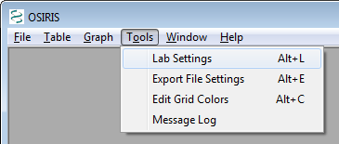

To configure OSIRIS, select the “Lab Settings” option under “Tools” on the menu bar as shown in the figure. This brings up the Lab Settings window with many options including: File Names, Locus/ILS Thresholds, Sample Thresholds, Allele Exceptions, and Acceptance/Review, which are discussed in the following sections.

#### **Optimizing Settings**

It is important to note that OSIRIS default lab settings are not optimally configured. Rather, they have been chosen to minimize changes from previous versions of this software. To help users optimize OSIRIS lab settings for their data using OSIRIS most recent features, two Operating Procedures are included with example Lab Settings. These include settings for single source samples, such as known references, and samples that may be mixtures, such as crime scene samples and stem cell engraftment chimerism test samples. The Operating Procedures are [PowerPlex Fusion HID Sole Source] and [GlobalFiler HID Mixture]. Both of those can be used to create new Operating Procedures which can be modified for .fsa files as described below in General - .fsa and .hid files. Note that custom Operating Procedures created based on those templates will not be automatically updated with new optimized lab settings changes made in new OSIRIS upgrades. Users will have to add the upgraded settings.

#### Add a new Operating Procedure

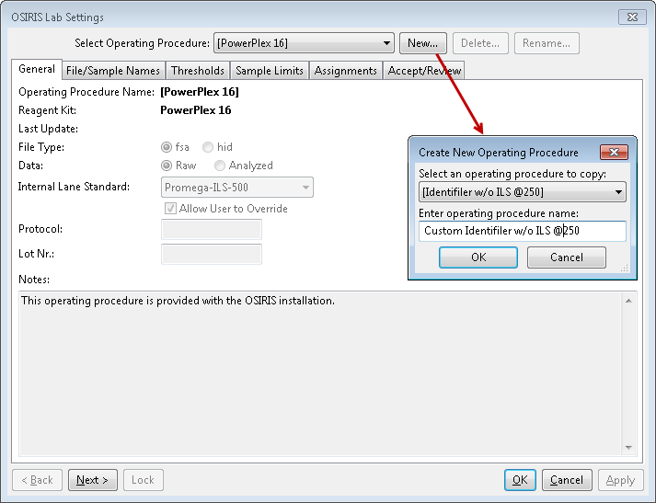To add a new Operating Procedure, click the “New” button and select a predefined or previously created procedure and enter the new procedure name. The names of the predefined Operating Procedures are enclosed in brackets. It is recommended that any newly created procedures not have a name enclosed in brackets in order to easily distinguish them. The new procedure can be saved at any time by clicking on the “Apply” button at the bottom of the lab settings window and is also saved when closing the window by clicking on the “OK” button. The following sections describe in detail the available lab settings for an Operating Procedure. If a laboratory is going to add positive controls or accepted off-ladder alleles to an Operating Procedure, the user can save time by entering those, then using the new Operating Procedure as a template for modified Operating Procedures.

##### Editing Operating Procedures

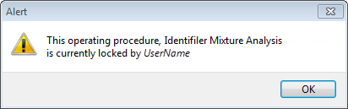A user must have Windows or Mac access privileges to be able to modify the Lab Settings in an Operating Procedure. To prevent multiple users from creating conflicting edits, when opening the Operating Procedure, OSIRIS will attempt to lock it, which is shown by the Lock button being inactive (gray) as in the figure above. While an Operating Procedure is locked, other users will not be able to use it for analysis.

There are some conditions that will prevent the Operating Procedure from being locked:

* If the user does not have access privileges that allows them to modify the Operating Procedure, it will not be locked.
* If the Operating Procedure is locked by another user or another instance of OSIRIS, it cannot be locked a second time. The user will receive a notice indicating which user has locked the Operating Procedure. When that OSIRIS process unlocks the Operating Procedure, the “Lock" button will become enabled and it can then be locked and modified.
* Beginning with OSIRIS 2.11 an Operating Procedure cannot be locked by a version of OSIRIS that is older than the version that created it or that last edited it. For example, if an Operating Procedure is created or edited using OSIRIS 2.12 it cannot be locked by OSIRIS 2.11. The purpose of this is to prevent loss of settings that are introduced in newer versions of OSIRIS.

#### General - .fsa and .hid files

The first ‘tab’ in the lab settings window is labeled ‘General’ and is used for basic settings. These settings include the setting for the default internal lane standard, whether the files are Raw or Analyzed data, and whether the file type is .fsa or .hid. Other lab settings may also need to be adjusted when customizing an Operating Procedure for one file type or the other. Three other settings, Protocol, Lot Nr., and notes do not affect the analysis, but are used for documenting the analysis and are copied to the output files during an analysis.

#### File/Sample names

The “File/Sample Names” tab is used to determine the type of an .fsa or .hid file by its file or sample name, using the “Search by:” “File name” or “Sample name” radio buttons, which control whether OSIRIS looks for sample type strings in the sample file names or sample names. As selected in the figure below, OSIRIS will only search the file name for sample-type stings. Note that if this setting is changed after analysis, the samples must be reanalyzed for the change to take effect. This allows users flexibility to use either the file name or the sample name in the file to designate samples controls and ladders.

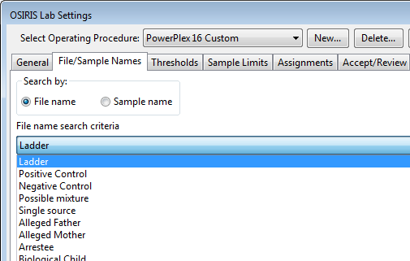

The names shown in the figure include ladder, positive control, negative control, possible mixture, single source, and all types defined by the guidelines for creating CMF files. You cannot add or delete the categories from this list defined by the CODIS CMF guidelines. However, you can customize any of the sample types within each category to match names used in your laboratory. At a minimum, users must specify enough information to identify ladder, positive control and negative control files.

In the following example, OSIRIS identifies a file as a negative control if it finds a name containing one of the character strings in the large text box in the middle of the window shown below “Negative Control.” You can also add any names that are commonly used by your laboratory or remove any names that you don’t want from the OSIRIS default list by editing the list. OSIRIS comes with a number of commonly used name strings for standard controls. When OSIRIS encounters any of these strings as a part of a sample or file name it will automatically assign the control type to the sample and check to make sure that the control meets expectations. In the example below, any sample with a listed string in its file name will be identified by OSIRIS as a negative control. It will (a) identify that a valid ILS exists for the sample, (b) determine that primer peaks are present in the sample and (c) determine if there are other peaks in other channels and notify the user if any of these conditions are violated for the criteria set for negative controls. Similarly, if the negative control string used in your lab is NOT on the list, OSIRIS will issue a warning stating that no negative control was found.

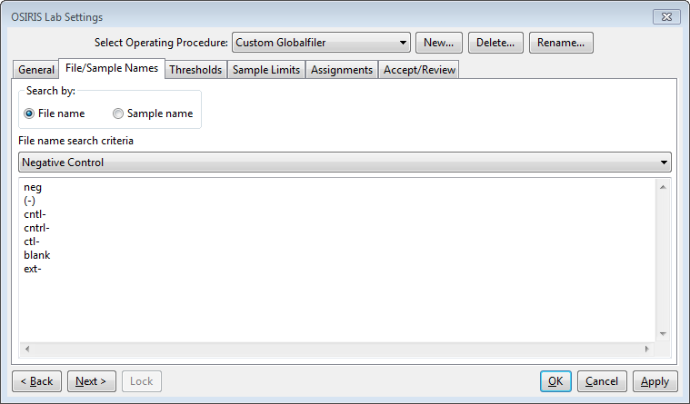

Following are some example file names and whether or not they would be identified as negative controls given the specifications in the figure above. If “Search by: Sample name” is selected, it will search sample names instead.

|  |  |
| --- | --- |
| **File Name** | **Negative Control** |
| f001-neg.fsa | yes, contains ‘neg’ |
| sample( - ) ctrl.fsa | no (spaces within parentheses) |
| ctl-positive.fsa | yes, although the name is misleading, it contains ‘ctl-’ |
| NormanEvanGordon(neg).fsa | yes |
| cntrl-1.fsa | yes, contains ‘cntrl-’ |

The user must ensure that the search criteria are not ambiguous. For example, if “ctrl-” is used to indicate a negative control, and “positive” is used to indicate a positive control, then a file named “ctrl-positive.fsa” is ambiguous and might produce unpredictable results. We recommend that users delete strings not used in their laboratory to avoid having samples that inadvertently contain control name strings.

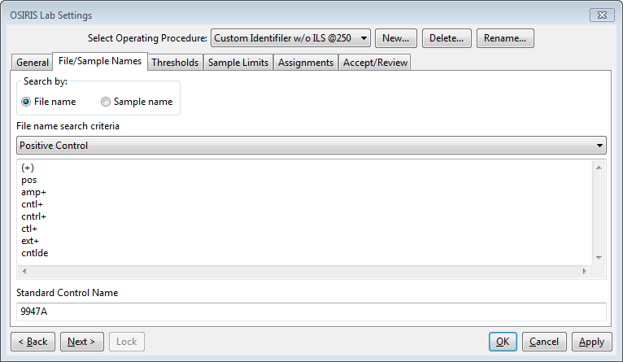

Positive control name search criteria are entered in the list in the figure above. OSIRIS can use several predefined positive controls and user-defined positive controls to validate control allele values. The user can enter a predefined positive control name in the “Standard Control Name” box, such as 9947A shown in the figure above, to set the default to validate 9947A positive control values. In this case, if any of the strings in the Positive Control list above is in a file name, OSIRIS will designate it a positive control and validate the allele values for 9947A. OSIRIS now uses a central file for the definitions of standard control alleles, based on a table which displays alleles for each locus and each standard positive control. The supported standard positive control names include: 9947A, 9948, K562, DNA007, 2800M and 3657 (note use of capitalization). Only standard positive names will be recognized. Not all loci are defined for all positive controls. All of the defined standard positive control loci/alleles can be found in a table in Appendix A.

The default can be overridden to validate a custom positive control by putting both the File name search criteria string above (like “pos”) and custom control “File name search criteria” string (like “Joe102”) from the Positive Controls Assignment table (described below). E.g., “posJoe102.fsa” will designate the sample as the custom Joe102 positive. Alternatively, “Joe102” could be entered in the File name search criteria list in the figure above, in which case “Joe102.fsa”, without ‘pos’, would be validated as the custom Joe 102 positive control. User-defined custom positive controls are entered in the Assignments tab as described below.

The default positive control can be changed to 9948, for example, by entering that value in the “Standard Control Name” box in the figure above. The “Standard Control Name” will display in the last column of the locus table in the table view.

If the user wants to use two different standard positive controls in the same analysis, such as 9947A and 9948, then one positive control will be the default standard positive, with the name entered in the “Standard Control Name” box, and the other will be the secondary standard positive control and the name will be entered in the text strings in the “File name search criteria” table above.

For example, if the user designates 9947A as the default standard positive control, but wishes to use 9948 as a second positive control, then the text string “9947A” must be entered in the “Standard Control Name” box as the default, and the text string “9948” must be included in the positive control “File name search criteria” table shown above.

The reason for this is that OSIRIS first decides if a file is a positive control based on the text strings in the positive control “Filename search criteria”. Then OSIRIS determines if the positive control is either a standard positive control that is not designated as the default or a user supplied custom positive control whose alleles have been entered in the “Positive controls” table of the Assignments tab. If it is neither of these, OSIRIS assumes it must be the designated default standard positive control.

For example, in a case where 9947A is the selected default standard positive control and “pos” is a text string in the search criteria above, if the user wishes to use 9948 as an additional positive control (not the default), then the following file names (if the search criterion is based on file names) would produce the corresponding results in OSIRIS:

If the text string “9948” is not in the positive control “File name search criteria” above:

**File name Result**

“general.fsa” not a positive control (no text string identifies it as a positive)

“pos.fsa” the default positive control, 9947A (identified as a positive, but no specific name)

“pos9948.fsa” the positive control 9948 (identified as a positive, and as 9948)

“9948.fsa” not a positive control (no text string identifies it as a positive)

This would change slightly if the user adds the text string “9948” to the positive control “File name search criteria”:

“general.fsa” not a positive control (no text string identifies it as a positive)

“pos.fsa” the default positive control, 9947A (identified as a positive, but no specific name)

“pos9948.fsa” the positive control 9948 (identified as a positive, and as 9948)

“9948.fsa” the positive control 9948 (identified as a positive by the text string in the table, and as 9948)

Following are some example file names and whether or not they would be identified as positive controls given the specifications in the figure above. Note all searches are case insensitive.

|  |  |  |
| --- | --- | --- |
| **File Name** | **Positive**  **Control** | **Positive Control** |
| 9947A.fsa | No, doesn’t contain a string in the list above |  |
| pos9947A.fsa | Yes, contains ‘pos’ | 9947A (default) |
| Positive.fsa | Yes, contains ‘pos’ (case insensitive) | 9947A (default) |
| posJoe102.fsa | Yes, contains ‘pos’ and ‘Joe102’ | Joe102 (custom) |
| Posjoe102.fsa | Yes, contains ‘pos’ and ‘joe102’ (case insensitive) | Joe102 (custom) |
| ctl-positive.fsa | No, although the name contains ‘pos’, it also contains ‘ctl-’, OSIRIS checks for negative controls first |  |

Possible mixture and single source character strings can be used in conjunction with presets on the “Sample Thresholds” tab to customize the analysis height thresholds depending on whether a sample is a known single source sample or a possible mixture. See “Disable Low Level Height Filters For Known Mixtures,” in Lab Settings Sample Limits below. As part of this group of settings, the user can specify if the default sample type is a potential mixture or is single source. If it is single source, then the mixture character strings may be used to identify potential mixture samples. When the default sample type is single source, the single source strings will not be used by OSIRIS. On the other hand, if the default sample type is possible mixture, the single source character strings may be used to identify single source samples. When the default sample type is possible mixture, any mixture strings will not be used by OSIRIS.

If character strings are specified for single source and the default type is mixture, then a sample is considered to be single source if the file name or sample name (whichever the user has selected for search), contains at least one of the listed strings. Any sample that does not contain one of the single source strings is considered to be a possible mixture. Conversely, if strings are specified for possible mixture and the default type is single source, then a sample is considered to be a mixture if the file name or sample name contains at least one of the listed strings. Any sample that does not contain one of the possible mixture strings is considered to be a single source sample. Positive and negative controls are automatically treated as single source samples in either case.

If the “Disable Low Level Height Filters For Known Mixtures” preset is not checked, the single source and possible mixture strings, and the specification of the default type, have no effect. On the other hand, if this preset is selected, and one or more of the associated presets is selected, then single source samples and mixtures are analyzed differently in the following respects. Single source samples are analyzed using all of the parameters specified in the Lab Settings. However, for possible mixtures, the specified low level height filters are disabled: fractional filter, pull-up fractional filter, stutter filter, and adenylation filter. This way, mixture alleles with heights that are relatively small with respect to the dominant alleles are not filtered out, while still minimizing the amount of editing needed for single source samples in the same directory.

#### Thresholds

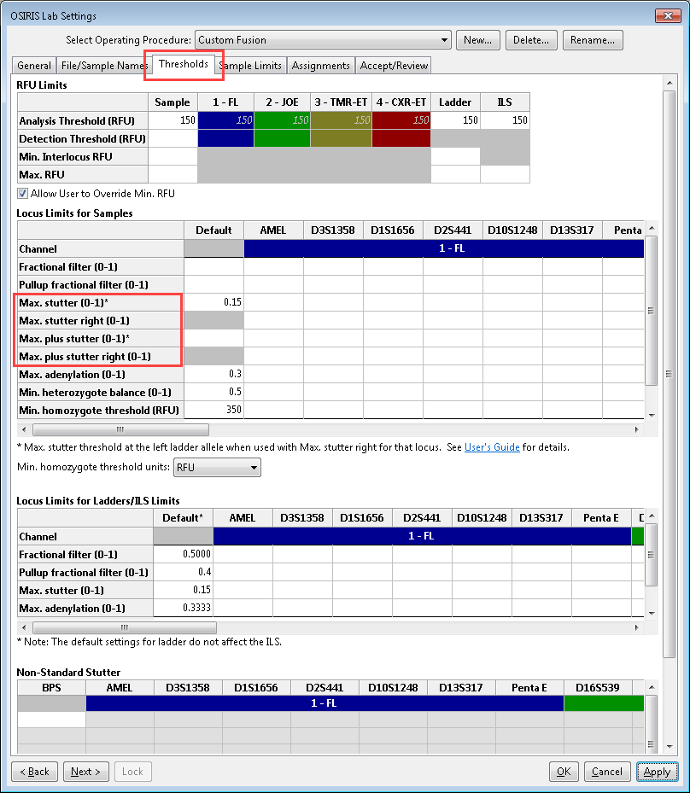The “Thresholds” section is used for setting various thresholds for samples and ladders. As shown here, default thresholds can be set for each value, or these can be overridden for each channel or each locus (or set individually if there is no default value).

**RFU Limits** Table

The analytical and detection thresholds can be set individually for each channel in OSIRIS v. 2.6 and higher. The default threshold for all the channels can be set in the “Sample” column, or individual thresholds can be set in the colored channel specific columns. If the default is set and a channel-specific value is set, the channel-specific value will override the default for that channel.

**Analysis Threshold** is the RFU level below which alleles and most artifacts will not be called.

**Detection Threshold** is the RFU level at which peaks are analyzed. Alleles and artifacts below this threshold will not be analyzed. This threshold may impact analysis of negative controls, homozygous loci and noise if there are peaks with RFU values between the Detection and Analysis Thresholds. (See settings below.) If this threshold is not set, or is set above the Analysis threshold, the Detection Threshold defaults to the Analysis Threshold RFU value.

**Min. Interlocus Threshold** is the analysis threshold for peaks in areas that lie between or beyond the extended locus boundaries. If not set, this defaults to the Analysis Threshold RFU. This may be set above (but not below) the Analysis Threshold RFU to prevent analysis of recurring interlocus artifacts.

**Max. RFU** is the level above which peaks will trigger an artifact notice.

There is also a checkbox labeled “Allow User to Override Min. RFU.” When this is checked, the user can modify RFU thresholds when performing a new analysis or a reanalysis. If this is not checked, the user cannot modify any of the RFU parameters with each analysis and will only be able to analyze the sample using the RFU thresholds set here. Note that modification of the RFU thresholds during a new analysis triggers a notification in the analyzed data indicating that the RFU thresholds set here were overridden.

**Locus Limits for Samples** Table

**Fractional filter** – a threshold to eliminate allele calls and to make critical artifact calls non-critical below a proportion of the highest peak in the locus. For interlocus peaks the proportion is of the highest peak in any of the loci in the channel. If the fractional filter is set to 0.2, and the highest peak in the locus is 1000 RFU, critical artifacts and allele peaks below 200 RFU will not be called and any artifacts will not be critical.

**Pull-up fractional filter** – a threshold to make critical artifacts non-critical and eliminate allele calls for pull-up peaks below a fraction of the highest peak in a locus. If the pull-up fractional filter is set to 0.2, and the highest peak in the locus is 1000 RFU, no critical artifacts or alleles will be called for pull-up peaks below 200 RFU.

**Stutter thresholds** – stutter thresholds may be set as one of the following:

* As a single default threshold for all loci
* The default may be overridden for one or more loci
* The threshold may be calculated individually for each allele. This is calculated by interpolating values along a straight line defined by the stutter threshold at the left-most ladder allele, and the stutter threshold at the right-most ladder allele.

See Stutter in the OSIRIS Artifact Handling section regarding calculation of these values.

**Max. stutter threshold** – the proportion of the parent allele RFU below which “minus stutter” peaks will be labeled as stutter. Minus stutter peaks are one repeat smaller than the parent allele, which we refer to as standard (minus) stutter. Allele calls for stutter peaks are optional. See Checked: Call Allele and Stutter Artifact below for specifying whether stutter peaks are given allele calls and Non-Standard Stutter below for non-standard stutter.

* If no locus-specific threshold is specified, then the locus stutter threshold will be the default stutter threshold which is used for every stutter test in that locus.
* If a locus-specific threshold is entered, then OSIRIS overrides the default value and uses the locus-specific threshold for every stutter test in the that locus.
* If a second locus-specific threshold is entered for the locus in “**Max. stutter right**”, OSIRIS overrides the default value and computes an allele-specific threshold for the locus. See **Max. stutter right** below for more details.

**Max. stutter right** – the minus stutter threshold at the right-most ladder allele when the user wants OSIRIS to calculate an allele-specific stutter threshold. There is no default value of this parameter.

To specify allele-specific stutter thresholds, both this value for a locus and the **Max stutter threshold** for the same locus must be specified. When both are specified, the **Max stutter threshold** (explained above) will be interpreted to be the minus stutter threshold for the left-most ladder allele. The allele-specific stutter thresholds are computed by using linear interpolation for peaks within the core ladder, and linear extrapolation for extended locus peaks.

Note: this value may not be less than the value entered for **Max stutter threshold**, above.

**Max. plus stutter threshold** – the proportion of the parent allele RFU below which “plus stutter” peaks will be labeled as stutter. Plus stutter peaks are one repeat larger than the parent allele and are called standard plus (or “forward” stutter. As for minus standard stutter, allele calls are optional. This setting can be helpful for loci that have plus stutter, or increased stutter between alleles separated by a repeat (e.g., stutter at 31 between alleles 30 and 32) because the plus stutter and the minus stutter thresholds are additive where they overlap (such as at the 31 peak between alleles 30 and 32). See Non-Standard Stutter below for non-standard stutter.

* If no locus-specific threshold is specified, then the locus stutter threshold will be the default stutter threshold which is used for every stutter test in that locus.
* If a locus-specific threshold is entered, then OSIRIS overrides the default value and uses the locus-specific threshold for every stutter test in the that locus.
* If a second locus-specific threshold is entered for the locus in “**Max. plus stutter right**”, OSIRIS overrides the default value and computes an allele-specific threshold for the locus. See **Max. plus stutter right** below for more details.

**Max. plus stutter right** – the plus stutter threshold at the right-most ladder allele when the user wants OSIRIS to calculate an allele-specific plus stutter threshold. There is no default value of this parameter.

To specify allele-specific plus stutter thresholds, both this value for a locus and the **Max plus stutter threshold** for the same locus must be specified. When both are specified, the **Max plus stutter threshold** (explained above) will be interpreted to be the plus stutter threshold for the left-most ladder allele. The allele-specific plus stutter thresholds are computed by using linear interpolation for peaks within the core ladder, and linear extrapolation for extended locus peaks.

Note: this value may not be less than the value entered for **Max stutter threshold**, above.

**Adenylation threshold** – the proportion below which minus-A “adenylation peaks” or shoulders in the n-1 position will not have a critical artifact or allele called. This setting does not affect peaks that fall in an n-1 position in the ladder.

**Min. homozygote threshold** – the threshold below which a critical artifact will be triggered for a single peak in a locus. Min. homozygote threshold should be set to a value that ensures that stochastic allele dropout will be detected. If the homozygote threshold is not set high enough, stochastic (random) effect may make the RFU of the second allele peak of a heterozygote fall below the detection threshold (if set, otherwise below the analysis threshold) and hence not be detected by OSIRIS. Therefore, the laboratory should determine a homozygote threshold that is appropriate for their process. Typically this would be approximately the detection (or analysis) threshold plus the laboratory’s stochastic threshold.

**Locus limits for ladders/ILS limits** – these settings behave in essentially the same way as the sample settings, but apply only to the ladders and ILS. Note that the “Default” settings apply only to the ladders. Scroll to the right for the ILS settings. The default lab settings supplied in the Operating Procedures generally give robust identification of ILS and ladders provided with most kits. They can be modified if ladders or ILS are within normal RFU ranges but OSIRIS does not appropriately identify peaks.

ILS thresholds are set by scrolling to the right all the way to the last column in the Locus Limits for Ladders/ILS table.

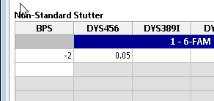**Non-Standard Stutter** – These are stutter peaks that are different from minus or plus one repeat. In the BPS column, enter the number of base pairs to the left (e.g., -2) or to the right (e.g., 2) of the parent allele that the stutter peak lies. Do not enter ‘-1’, which is treated as adenylation, or zero. In the Locus column, enter the proportion of the parent allele RFU below which “non-standard stutter” peaks will be labeled as stutter (e.g., 0.05 for 5% of the parent allele). See below for how to specify whether stutter peaks are given an allele call or only an artifact call.

#### C:\Users\rileygr\AppData\Local\Temp\2\SNAGHTML55353afc.PNGSample Limits

The figure on the right shows the “Sample Limits” tab which lists analysis parameters. There are two categories of Sample Limits settings. The settings highlighted in green below affect the sample QC analysis and whether notifications and artifacts are triggered. The settings highlighted in pink generally trigger notifications if multiple artifacts occur in a sample or a plate. These latter settings can be used to judge the severity of sample quality problems or problems that affect the quality of the entire analysis batch or plate. Thus, the settings highlighted in pink can be used for DNA analysis process QA. Note that these settings do not affect triggering *individual* artifacts and *sample* artifacts and notifications. So, if the “Max. No. of pullups peaks per sample” is set to 2 and the sample has only a single pull-up peak, that peak will still trigger an artifact and notification, but the sample will not trigger a “maximum exceeded” artifact. If the sample has three pull-up peaks, in addition to the artifact and notification triggered by each pull-up, the sample would also trigger a notification that the maximum number of pull-ups had been exceeded.

The two sample limit parameters in the “Sample Limits” table that are marked with red stars below directly affect the sample analysis and must be set. Values marked with green stars are also important as they affect the algorithm for the software’s rework estimation to use more, less or the same amount of sample DNA in a reamplification, however they are not mandatory. The ‘-’, ‘+’ and ‘r’ beside the stars indicate that those settings affect the “reamp less”, “reamp more” or “reamp regular”/“reinject” recommendations. See the discussion in Appendix C. The other sample limits that are highlighted pink, but are not starred are quality assurance measures that may indicate the quality of the entire analysis run and can be used for process analysis. They do not affect either the analysis of the sample or the identification of sample artifacts and are therefore optional. See the discussion in Appendix D regarding QA for further information. Please contact us about additional parameters that would be useful ([forensics@ncbi.nlm.nih.gov](mailto:forensics@ncbi.nlm.nih.gov?subject=Lab%20Settings,%20Other%20Thresholds)). Note that any numeric parameter (as opposed to a checkbox) that is left blank will not be tested; entering a zero sets the value to zero.

##### Settings that affect sample analysis

**Max. residual for allele (<0.5)** parameter sets the maximum difference between the base pairs of the allele peak compared to the ladder peak as a fraction of one base pair. A value of 0.25 indicates that alleles that fall within ±0.25 base pair of the comparison ladder allele center are not flagged for human review. OSIRIS typically performs well with this value and it should be a starting point for determining a laboratory’s own setting. See the discussion of excess residual for further information regarding this setting. (‘**★**’ – Directly affects the sample analysis. Required.)

**Incomplete profile threshold for Reamp More/Reamp Less** is a value that OSIRIS uses to differentiate between profiles with locus dropout due to insufficient target DNA and profiles with locus dropout due to degradation when it is estimating whether it would be better to use more or less target DNA in a reamplification. Laboratories may have to experiment to determine an appropriate value for their process. (‘**★-/+**’ – Affects the algorithm for the software’s rework estimation to use more, less or the same amount of sample DNA in a reamplification. Optional.)

**Ignore artifacts smaller than** has been changed starting in Version 2.10.2. It used to indicate that artifacts whose computed base pairs are less than this setting should be ignored. However, that made it possible for users to set the value high enough that it would prevent the calling of ladder alleles, causing the ladder analyses to fail. In Version 2.10.2, OSIRIS computes the ILS base pair size that is required for the robust analysis of ladders. This value is kit and ILS specific. Setting the “Ignore artifacts smaller than” parameter larger than this value will have no effect on the analysis. Setting it lower will allow artifacts and extended alleles to be called to the left of the ladder. This value can be set to be lower than the base pair of the left-most peak of the ILS. This will allow ladder peaks, sample alleles and artifacts to be called to the left of the ILS. This can be useful if there are ILS peaks that routinely appear within the primer peaks and which would otherwise be required to bracket ladder locus peaks. See the description of kit definitions for further information. For lane-standard-only fragment analysis, this parameter is used by OSIRIS without modification. (‘**★**’ – Directly affects the sample analysis. Required.)

**Maximum Number of Triallelic Loci in an Unmixed Sample** affects how many loci OSIRIS will accept in a sample without triggering a mixed sample message.

Override Default Channel Map for Fragment Analysis: ◻

FSA Channel for OSIRIS Channel 1: 1

FSA Channel for OSIRIS Channel 2: 2

FSA Channel for OSIRIS Channel 3 (if # channels at least 3): 3

FSA Channel for OSIRIS Channel 4 (if # channels at least 4): 4

FSA Channel for OSIRIS Channel 5 (if # channels at least 5): 5

**Override Default Channel Map for Fragment Analysis** is a parameter that applies only to fragment analyses which use only an internal lane size standard marker (ILS) (i.e., with no allelic ladder). Checking this box instructs OSIRIS to use the channel mapping specified by the user, as described below. The default setting is unchecked, which uses the default mapping, where the OSIRIS channel is the same as the .fsa/.hid file channel. Note that the number of channels must be set by selecting the correct Operating Procedure (such as LaneStandardOnly_2 or LaneStandardOnly_4).

The ABI .fsa/.hid file-standard assigns data channels (dyes) to specific file locations which can be set in the genetic analyzer software. In a lane-standard-only analysis, the user may have to explicitly set the correspondence between the OSIRIS channel numbers and the input file (.fsa or .hid) channel numbers so that OSIRIS will correctly identify the ILS internal standard channel. If the default mapping of the ILS channel is incorrect, sample graphs will display but not analyze and the sample data peaks in the incorrectly specified ILS channel will have artifact markers.

**FSA Channel for OSIRIS Channel 1** – enter the .fsa/.hid channel location that OSIRIS will use as channel 1.

**FSA Channel for OSIRIS Channel 2** – enter the .fsa/.hid channel location that OSIRIS will use as channel 2.

**FSA Channel for OSIRIS Channel 3 (if # channels at least 3)** – enter the .fsa/.hid channel location that OSIRIS will use as channel 3. If there are only 2 channels, this parameter is not used.

**FSA Channel for OSIRIS Channel 4 (if # channels at least 4)** – enter the .fsa/.hid channel location that OSIRIS will use as channel 4. If there are fewer than 4 channels, this parameter is not used.

**FSA Channel for OSIRIS Channel 5 (if # channels at least 5)** – enter the .fsa/.hid channel location that OSIRIS will use as channel 5. If there are fewer than 5 channels, this parameter is not used.

All the above channel inputs must fall in the range 1 – 8 and must refer to an fsa/hid file channel that actually contains collected data (even if there are no peaks). If a specified fsa/hid channel has no data, the lane-standard-only fragment analysis will fail.

The last OSIRIS channel must be assigned to the .fsa/.hid channel that contains the ILS internal lane standard (e.g., OSIRIS channel 4 in a 4-channel lane-standard-only Operating Procedure). Otherwise, OSIRIS will not calculate peak sizes. If the last OSIRIS channel does not contain ILS data it will display artifact markers over the sample peaks.

If the user does not know how many fsa/hid file channels there are or which channel contains the internal lane standard, it may require some experimentation to choose the Operating Procedure with the correct number of channels and correctly identify the internal lane standard channel.

Raised Baseline Options:

Raised Baseline Threshold for Samples (RFU) 250

Raised Baseline Threshold for Sample ILS Channels (RFU) 250

**Raised Baseline Threshold for Samples (RFU)** and **for Sample ILS Channels (RFU)** parameter sets the threshold for raised baseline detection in the allele channels and the ILS channel respectively. Raised baseline can result in minor peaks either not being called or appearing to have a higher RFU than they should actually have. This threshold is largely irrelevant if baseline normalization is selected, since that option corrects the problem rather than simply notifying the user. Baseline normalization is applied to allele channels; raised baseline in ILS channels either prevents analysis or has no impact on analysis.

Cross Channel Options:

Attempt to Apply Embedded Color Correction Matrix ◻

Primary Pull-up Threshold: Computed (unchecked); Specified Below (checked) ◻

Min RFU for a peak to cause pull-up (primary pull-up) (Default = 500) (requires above checked) 500

Make Pull-up At Allele Artifact Non-Critical ☑

Make Laser Off-Scale Artifacts Non-Critical ◻

Constrain Pullup Pattern Analysis (Default: checked – functions like Version 2.9.1) ☑

Display Sigmoidal Peaks (Default: unchecked) ◻

Test Pull-up Corrected Heights for Stutter, Adenylation, Etc. (Default: unchecked) ◻

**Attempt to apply Embedded Color Correction Matrix** causes OSIRIS to apply the color matrix to .fsa files where it has not already been applied (some Applied Biosystems 310 Genetic Analyzer files). These files appear to have extreme pull-up and will fail to analyze correctly without application of the matrix. Files without an embedded color matrix, where the color matrix has already been applied, such as those produced by the 3100 and higher Genetic Analyzers, will be unaffected if this parameter is set. However, if an Applied Biosystems 310 Genetic Analyzer file has had the color matrix applied and also has an embedded matrix analysis, it will be adversely affected by reapplication of the matrix with this parameter. Most files requiring this were produced with out-of-use procedures/software. Unless files are known to require this parameter, it should be unchecked by default.

**Primary Pull-up Threshold: Computed (unchecked); Specified Below (checked)** This option determines whether the minimum height at which OSIRIS will consider a peak *to be the cause* of pull-up (“primary pull-up”) in other channels is a fixed value specified by the user in the field below, or if the value is computed by OSIRIS based on the patterns in each primary pull-up/ pull-up pair of channels. If OSIRIS computes the minimum height, it is based on several factors, including: the heights of primary peaks in the primary channel; the heights of primary channel peaks that have no pull-up and the ambient noise level in the pull-up channel. OSIRIS will also compute values for each channel pair for peaks that are do not have saturated peak signal (laser off-scale) as well as for peaks that do have saturated peak signal. Checking this box causes OSIRIS to revert to the algorithm in Versions 2.11.1 and earlier. If it is important to preserve consistency with analyses made in earlier version, then the box should be checked. Otherwise, tests indicate that leaving the box unchecked yields superior results.

**Min RFU for a peak to cause pull-up (primary pull-up) (Default = 500) (requires above checked)** is the minimum height at which OSIRIS will consider a peak *to be the cause* of pull-up (“primary pull-up”) in other channels. This setting helps OSIRIS ignore potential primary pull-up peaks that are too low to result in a detectable pull-up into other channels. OSIRIS uses this value to build a set of possible primary pull-up/pull-up peak pairs between two channels and uses that to establish a pattern of pull-up. If either of the following occurs, then OSIRIS will be unable to discern a pattern: the set includes too many potential primary pull-up/pull-up pairs with zero pull-up; or, the set contains too few pairs.

Do not set this to a very low value; it will not increase the sensitivity of detection of small pull-up peaks and may actually reduce the sensitivity for detecting real pull-up peaks because it will include too many potential primary peaks that have no corresponding pull-up peaks. By contrast, if this value is set very high, then OSIRIS’s ability to establish a pull-up pattern may be reduced because there will not be enough potential primary peaks that will be considered eligible to compute a pattern. Note: if, during testing or validation, there are numerous pull-up peaks with the artifact “Partial pull-up (uncertain)”, it is an indication that this value may be set too high for your data.

**Make Pull-up at Allele Artifact Non-Critical** setting determines whether “Partial Pull-up” will be reported as a critical (unchecked) or non-critical artifact. Typically, the Partial Pull-up artifact occurs when actual allele peaks in different channels comigrate. Users that wish to be notified with a critical artifact if *alleles* in different channels comigrate should uncheck this setting. Usually, OSIRIS can establish the existence of a pattern of pull-up between two channels and, using that pattern, OSIRIS can determine what effect (if any) the pull-up has on the true height of the allele migrating in the pull-up position. The combined effect of pull-up signal from all other channels is then removed, resulting in the corrected allele height, displayed by hovering the cursor over the allele label. Less frequently, OSIRIS is unable to establish the existence of a pull-up pattern because there are too few peaks in the primary channel that could cause pull-up. (See “Min RFU for a peak to be considered as a peak that causes pull-up” above.) In this case, the pull-up peak will be labelled as “Partial pull-up (uncertain)”, and OSIRIS is unable to establish a corrected allele height.

**Make Laser Off-Scale Artifacts Non-Critical** setting determines whether the laser off-scale artifacts will be reported as a critical (unchecked) or non-critical (checked). Users that do not wish to be notified of a critical artifact solely due to signal saturation should check this. Making this artifact non-critical does not affect the calculation of other artifacts.

**Constrain Pull-up Pattern Analysis (Default: checked – functions like Version 2.9.1)** It is suggested that users uncheck this as it should give more accurate estimates of corrected RFU for partial pull-ups. Unchecking this option (suggested) allows OSIRIS to choose the two coefficients to give the best fit to the pull-up data. This setting determines if the pullup pattern analysis formula between any pair of channels will require all coefficients in the formula to have the same sign (constrained analysis) or allows signs to differ. The two coefficients in the formula are for a linear term, representing potential color correction matrix mismatch, and a quadratic term, approximating the non-linear distortion caused by large peak heights outside the normal linear response region. Version 2.9.1 required both coefficients to be either non-negative or non-positive. Checking this option (the default) gives results like those in Version 2.9.1.

**Display Sigmoidal Peaks (Default: unchecked)** Sigmoidal peaks are non-critical artifacts. (See Craters and Sigmoids). Users may want to display this artifact notice to understand the OSIRIS analysis of the pull-up pattern. Not displaying this artifact may reduce visual clutter. When checked, this option causes OSIRIS to display artifacts for sigmoidal peaks. When unchecked, this option suppresses sigmoidal peak artifact display. The default is unchecked.

**Test Pull-up Corrected Heights for Stutter, Adenylation, Etc. (Default: unchecked)** If this box is not checked, OSIRIS uses the heights of the curves that it fits to the raw data when doing the artifact tests for stutter, adenylation, heterozygous imbalance and the homozygous peak threshold. These peak heights are uncorrected for the effects of pull-up. Checking the box causes OSIRIS to use the corrected peak heights for those peaks that have been found to be affected by pull-up from other channels. Note that, when a peak has been found to fall in the extended locus region of two different loci, this setting can affect the OSIRIS algorithm that attempts to assign the peak to one locus or the other. The reason is that OSIRIS tests whether the peak would cause heterozygous imbalance in either of the loci under consideration. The default setting is unchecked, which causes OSIRIS to use the test algorithms in previous versions.

Enable Test for Excessive Noise ☑

Test for Excessive Noise Above Analysis Threshold (checked) or below (unchecked) ☑

**Enable Test for Excessive Noise** – This setting tests for small peaks that OSIRIS might potentially not fit, because it could not distinguish them from noise. OSIRIS calls this situation “Excessive noise”. If this artifact occurs, it could indicate a missed peak in the channel. See the explanation of excessive noise in the artifact handling section. Enabling the “Ignore noise analysis in peak detection when above detection threshold” makes this artifact less likely.

**Test for Excessive Noise Above Analysis Threshold (Checked) or Below (Unchecked)** causes OSIRIS to flag samples when excessive baseline noise occurs, including below the analysis threshold (but above detection threshold), or only when it occurs above the analysis threshold. This setting is active only if the excessive noise test is activated (above). If the detection and analysis thresholds are the same (i.e., when the detection threshold is not set to be different), then checking this setting has no effect. Excessive noise will only be tested above the analysis threshold.

Flag Mixed Samples and Triallelic Loci ☑

**Flag Mixed Samples and Triallelic Loci** causes OSIRIS to flag mixed samples and triallelic loci. Samples with one or more loci with four or more alleles or that have a number of loci with trialleles that exceeds the threshold set for mixed loci will be flagged as mixed samples. This setting also flags triallelic loci that are not listed as accepted trialleles. Unchecking this will prevent trialleles from being flagged.

Rework Options:

Recommend Amp More On Low Homozygote ◻

Select Reamp Regular (checked) Versus Reinject (unchecked) ☑

Recommend Rework If Laser Off Scale Found ☑

These settings affect how OSIRIS predicts that samples might be reanalyzed to obtain a result with fewer artifacts. These predictions can be exported and could be used in a high-throughput laboratory to help automate reanalysis of failed samples.

**Recommend Amp More on** **Low Homozygote** causes OSIRIS to flag samples with a homozygote peak below the acceptable homozygote threshold or with a homozygote that has a peak between analysis and detection thresholds that is not a known artifact (stutter, etc.) for reamplification with more DNA. (‘**★+**’ – Affects the algorithm for the software’s rework estimation to use more sample DNA in a reamplification. Optional.)

**Select Reamp Regular (Checked) vs. Reinject (Unchecked)** determines whether OSIRIS will flag samples needing rework for reinjection or reamplification. The setting of this parameter will depend on whether the laboratory process is designed with reinjection or reamplification in mind. (‘**★r**’ – Affects the algorithm for the software’s rework estimation to use the same amount of sample DNA in a reamplification. Optional.)

**Recommend Rework if Laser Off Scale Found** will cause OSIRIS to flag samples with off-scale data for reamplification with less DNA. (‘**★–**’ – Affects the algorithm for the software’s rework estimation to use less sample DNA in a reamplification. Optional.)

Curve Fit Options:

Peak Fit Sensitivity (based on 4 raw data properties: Area, Height, Min-to-Max Height and Noise Level):

Area Threshold:

Require Area > Percent of Standard Area Threshold (Default = 100%) 100

Height Threshold: Require Min-to-Max Height > Noise Level… (Default)

Or, require Height > Detection Threshold (overrides Default height threshold) ◻

Or, require Height >Percent of Noise Level (overrides Default and Detection Threshold) ◻

Percent of Noise Level for Normalization (Default = 50%) 50

Percent of Noise Level for final Curve Fitting (Default = 75%) 75

Apply Enhanced Shoulder-Fitting Algorithm ☑

Percentage of Standard Noise Threshold for Shoulder Acceptance (Default = 100) 100

Minimum Number of Points Concave Down (Default = 3) 3

Tail Fitting Sensitivity Options

Percent of Standard Tail Height Threshold (Default = 100%) 100

Percent of Standard Tail Slope Threshold (Default = 100%) 100

**Require Area > Percent of Standard Area Threshold (Default = 100)** (formerly “Percentage of Standard Noise Threshold for Peak Identification”) adjusts the sensitivity of peak detection. This allows the user to reset the threshold for testing locally averaged raw data to determine if there is sufficient area under the curve for a peak to be fit. Setting this to a low value, such as 10-25, causes OSIRIS to be more sensitive to low-level peaks. Setting the value higher than 100 causes OSIRIS to ignore more low-level peaks. The standard area threshold is analysis platform-specific, to account for different analyzer sensitivity, which results in different levels of noise. This value does not affect the Enhanced Shoulder-Fitting Algorithm below. This parameter works the same as in previous versions.

**Height Threshold: Require Min-to-Max Height > Noise Level… (Default)** the default height threshold for peak identification requires that the raw data peak-to-trough height of a candidate peak be greater than the measured noise level for the channel. The noise level is measured at the right end of the electropherogram. This has no checkbox.

**Or, require Height > Detection Threshold (overrides Default Height threshold)** (formerly “Ignore noise analysis in peak detection when above detection threshold”) causes OSIRIS to detect peaks when the raw data min-to-max (peak-to-trough) height is above the detection threshold, even in the presence of noise. Selecting this option is the equivalent of selecting “Ignore noise analysis in peak detection when above detection threshold in Versions 2.10.1 and earlier. This parameter is probably unnecessary for analysis and detection thresholds greater than or equal to 100 RFU. This parameter works the same as in previous versions.

**Or, require Height > Percent of Noise Level (overrides Default and Detection Threshold)** causes OSIRIS to use the specified percent of the measured noise level for each channel as the Min-to-Max Height Threshold. For an interval of raw data, if the data exceeds the specified area threshold and if the Min-to-Max Height (peak-to-trough) exceeds the specified percent of the measured noise, then OSIRIS will attempt to fit a curve to the data in the interval. This threshold can be made as sensitive as the user requires without affecting allele or artifact calls. When the user specifies that OSIRIS is to normalize the baseline, peak identification is performed twice. The first is for the normalization stage of analysis, to aid in identifying stretches of baseline to calculate the baseline curve. After normalization, the original peak identifications are discarded. The second peak identification is then done for the final peak curve fitting. The user can specify different sensitivities for each stage. Making the pre-normalization peak identification threshold more sensitive (such as 50% of the noise level) may improve the baseline curve calculation by avoiding choosing tiny peaks as part of the baseline. Choosing too low a level may reduce the interval of baseline available for baseline curve calculation, resulting in a normalization curve that does not match the baseline well. This is more likely to be a problem if the “Require Area > Percent of Standard Area Threshold” is also set low at the same time. (This option is preferred.)

This last of three options is the most flexible. The second option requires that the user specify a detection level, which may affect other aspects of OSIRIS, such as artifact calls. Using the noise level in the third option allows OSIRIS to scale automatically to the measured noise - the parameter that is the most important factor in assessing the signal-to-noise ratio on a case-by-case basis. The first option is equivalent to this option with “Percent of Noise Level” set to 100%.

**Percent of Noise Level for Normalization (Default = 50%)** causes OSIRIS to use the specified percent times the measured noise for each channel for peak identification during the normalization stage of analysis, if “require Height > Percent of Noise Level”, above, is checked.

**Percent of Noise Level for final Curve Fitting (Default = 75%)** causes OSIRIS to use the specified percent times the measured noise for each channel for peak identification during the final curve fitting stage of analysis, if “require Height > Percent of Noise Level”, above, is checked.

**Apply Enhanced Shoulder-Fitting Algorithm** causes OSIRIS to post-process the standard curve-fitting algorithm with an enhanced search between adjacent peaks for regions in which shoulder peaks may have been missed. This algorithm does not affect ILS channels, and it does not affect baseline normalization. Any regions that are identified as previously undiscovered potential shoulder peaks are analyzed using the same curve-fitting and quality assessment as for all other peaks. The enhanced algorithm is enabled by default (checked).

**Percentage of Standard Noise Threshold for Shoulder Acceptance** adjusts shoulder detection sensitivity. Increasing this value will make shoulder peak detection by this algorithm less sensitive. This parameter helps OSIRIS decide if a region of time potentially contains a shoulder peak. If the raw data in the region exceeds the analyzed data (the fitted curve) in that region by less than this percentage times the noise level, then the region is rejected as holding a potential shoulder. On the other hand, if the raw data exceeds the analyzed by at least this calculated threshold, then it is accepted for further testing. The default value is 100% of the calculated noise level for the channel.

**Minimum Number of Points Concave Down** is the number of consecutive raw data points that must be part of a downward facing curve (concave down) for a time interval to be considered as a possible shoulder peak. OSIRIS tests if a segment of raw data either contains a local maximum (the RFU value at that time is larger than both of its neighboring points) or is concave down (the value at that time is larger than the average of its neighbors) for this minimum number of points. The default value is 3 points. Setting this value to 2 will increase sensitivity for very low-level shoulders, but if there are peak tails in the data it may also cause the peak tails to be called.

**Tail fitting sensitivity options**

The two parameters below affect how closely the tails at the base of the analyzed peak match to the raw data peak tails. Decreasing the values will cause the analyzed peak tails to fit more closely to the raw data. Note: Decreasing these values too much (below 15%, say) may cause OSIRIS to skew its peak fitting asymmetrically, especially if the raw data is somewhat asymmetric, which can adversely affect shoulder analyses, possibly reducing the sensitivity of shoulder peak detection. Both values should be changed at the same time, although they do not need to be set to the same value. Changing only one will produce no change in the tail fitting.

These settings will not significantly affect peak height, but may make peak area slightly more accurate. One of the factors OSIRIS uses to delineate how much of a raw data peak to actually fit is a fixed height threshold, expressed as a percentage of the maximum height of the raw data peak. This parameter provides a multiplier to that fixed threshold. The default value of 100% leaves that threshold at the fixed value. The part of the raw data that is actually included in the curve fit lies above these height and slope thresholds and the remaining parts of the raw data, namely, the tails, are generally not included in the curve fit. See Peak tail fitting sensitivity in OSIRIS Artifact handling for additional details.

**Percent of Standard Tail Height Threshold** affects how closely the analyzed peak tails match the raw data at the base of the peak. To increase the extent to which the tails are included in the curve fit, the user should decrease this value.

**Percent of Standard Tail Slope Threshold** affects how closely the analyzed peak tails match the raw data at the base of the peak. To increase the extent to which the tails are included in the curve fit, the user should decrease this value.

Negative Control Options:

Test for Primer Dimer Peaks in Negative Controls ☑

Minimum Height for Primer Dimer Peaks (RFU) 2000

Minimum Number of Peaks per Channel in Primer Dimer for Negative Control 2

Test for Presence of Sub-Analytic Peaks in Negative Controls ☑

**Test for Primer Dimer Peaks in Negative Controls** causes OSIRIS to perform the test for primer peaks in negative control samples. When unchecked the test is not performed.

**Minimum Height for Primer Dimer Peaks (RFU)** sets the minimum threshold for identifying primer peaks in the negative control. This threshold can be empirically determined by the laboratory. It should be set well above the height of any pull-up peaks caused by the internal lane standard channel, generally close to, but below the maximum threshold intensity for the detection platform.

**Minimum Number of Peaks per Channel in Primer Dimer for Negative Control** helps to discriminate the primer peaks in the negative control. This should be set to at least two peaks.

**Test for Presence of Sub-Analytic Peaks in Negative Controls** will cause negative controls to be flagged if there are peaks whose RFU is below the analysis threshold, but whose RFU is greater than the detection threshold. Peaks in the negative control that fall in the range between the detection and analysis thresholds may indicate low level contamination before it becomes an issue in the laboratory. This has no effect if the detection threshold is not set.

Apply Fractional Filter To Peaks Below Analysis Threshold (Homozygous Loci) ☑

**Apply Fractional Filter to Peaks Below Analysis Threshold** causes OSIRIS to apply the fractional filter (if set) to peaks below the analysis threshold and above the detection threshold in homozygous loci. If this is left unchecked, the fractional filter will not be applied to peaks below the analysis threshold, but will be applied (as set) to peaks above the analysis threshold. Note that this case can result in a situation in an apparently homozygous locus (See Homozygote peak too low) where a second peak that lies between the analysis and detection threshold would trigger a notification, but a second peak slightly above the analysis threshold would not, because it was filtered out by the user-defined fractional filter settings.

Call Criteria:

Do Not Call OL Crater If Laser In Scale and Raised Baseline ◻

Do Not Call OL Allele If Pull-up ◻

Do Not Call OL Alleles If Excessive Number of OL’s ◻

Do Not Call Alleles With Excess Residual ◻

Stutter Call Criteria…For Peaks Identified as Stutter:

Checked: Call Allele and Stutter Artifact; Unchecked: Call Artifact But Not Allele ◻

If Previous is Checked, for Samples Identified as Single Source:

Checked: Call Artifact but Not Allele; Unchecked: Call Allele and Artifact ◻

Adenylation Call Criteria:

Call Peaks That Are Identified as Adenylation If On-Ladder ◻

Call Peaks And Show Artifact for Accepted On Ladder Adenylation ◻

**Do Not Call OL Crater If Laser In Scale and Raised Baseline** reduces the number of small crater artifacts that OSIRIS calls and that require subsequent editing. This setting causes OSIRIS to not call a crater as an allele if: there is no off-scale data at the artifact location; there is raised baseline in the artifact channel; and if the artifact is off-ladder. Very small crater artifacts can be called when the analysis threshold is set low enough that a raised raw data baseline is above or even near the analysis threshold. Since there is no off-scale data at this artifact location, pull-up is unlikely in this situation. Selecting this parameter will reduce the number of small crater critical artifacts also called as alleles. Editing will allow the allele call to be re-applied to the peak.

**Do Not Call OL Allele If Pull-up** causes OSIRIS to not mark with an allele call those peaks that are flagged as both pull-up and off-ladder. Selecting this parameter will reduce the number of allele calls on pull-up artifacts, but does not affect flagging the artifact and artifact notification. This may reduce the amount of editing required to remove pull-up allele calls from the graph and table. Editing will allow the allele call to be re-applied to the peak.

**Do Not Call OL Alleles If Excessive Number of OL’s** causes OSIRIS to not mark with an allele those peaks that are off-ladder if the “Max. off-ladder alleles per sample” threshold is exceeded. Selecting this parameter may reduce the number of pull-up or shifted peaks that are labeled with an allele. However, if this rule is triggered, genuine off-ladder alleles will also not be labeled. Editing will allow any affected allele calls to be re-applied to their peaks.

**Do not call alleles with excess residuals** causes OSIRIS to not call an allele for any peak flagged as having excess residual. Selecting this parameter can reduce the number of allele calls on artifactual peaks such as those with shifting. Editing will allow the allele call to be re-applied to the peak. See the description of Excessive Residual Displacement below.

**Checked: Call Allele and Stutter Artifact; Unchecked: Call Artifact But Not Allele**, if checked, causes OSIRIS to label any stutter peak, standard or non-standard, with an allele call, unless some other combination of artifacts prevents that peak from being identified as an allele. Regardless of this setting, all stutter peaks are labeled as stutter.

**If Previous is Checked, for Samples Identified as Single Source…Checked: Call Artifact but Not Allele; Unchecked: Call Allele and Artifact**, if previous is checked and if this option checked, causes OSIRIS to suppress the allele calls for stutter peaks that occur in positive or negative controls and for samples that have been determined to be single source through the naming conventions defined above. If the previous option is unchecked, this setting is ignored. If the previous option is checked and this option is unchecked, then there will be no distinction between single source samples and other samples. All peaks identified as stutter will also be given an allele call, unless there is some other combination of artifacts that prevents the peak from being identified as an allele.

**Call Peaks That Are Identified As Adenylation If On-Ladder** causes OSIRIS to call peaks as alleles if they are on-ladder or “accepted” alleles. For example, when this parameter is selected, in a mixture where there is a major contributor allele 9, a minor 8.3 peak that was below the adenylation threshold would be called as an 8.3 allele if there is an 8.3 ladder allele or if the 8.3 allele is indicated as an accepted allele in the Off-ladder alleles list on the Assignments tab in the Lab Settings. This is important to ensure accurate calling of the minor TH01 9.3 allele when it is below the adenylation threshold in a TH01 9.3/10 mixture. Laboratories analyzing mixtures should select this setting.

**Call Peaks And Show Artifact for Accepted On Ladder Adenylation** is only relevant if the setting above has been checked. Normally, if this setting is not checked, any “on-ladder” adenylation, meaning an adenylation that is actually on-ladder or an accepted off-ladder adenylation, will be given an allele call and the adenylation artifact designation will be suppressed. If this setting is checked, any accepted off-ladder adenylation will still be called as an allele, but it will also be labeled as an adenylation.

Do Not Report Heterozygous Imbalance If Sample Is Mixture ◻

**Do Not Report Heterozygous Imbalance If Sample Is A Mixture** causes OSIRIS to not trigger a heterozygous imbalance notice in any locus in a sample if the sample meets the conditions to be flagged as a mixture.

Baseline Analysis Options:

Raw Data Has No Negative Values ◻

Test Adjusted Signal Heights Relative To Baseline (Overridden by below) ◻

Normalize Raw Data Relative to Baseline (Overrides above) ◻

Test Baseline Estimation Points and Reject If Too Close to Peak or Level Change ◻

ILS BP Dividing High Noise from Low Noise Intervals (Default=80 bp) 80

Test Proximity to Peaks (Default = checked) ☑

Time Interval from Peak to Remove Est. Point (Default = 5 Meas.) 5

High Noise Interval: Peak Height > (Percent of Noise Range) 160

Low Noise Interval: Peak Height > (Percent of Noise Range) 100

Test Proximity to Both Peaks and Level Changes (Default = checked) ☑

Time Interval from Level Change to Remove Est. Pt (Def. = 5 Meas.) 5

High Noise Interval: Level Change > (Percent of Noise Range) 160

Low Noise Interval: Level Change > (Percent of Noise Range) 75

Ignore Test if (# of Level Changes) > (Percent of Total Time) 22

Baseline Estimation Threshold (In RFU; >= 0; Default = 1 RFU) 1

Ignore Effects of Negative Relative Baseline (Default = Unchecked) ◻

Enable Raw Data Filter For Baseline Normalization Estimation ☑

Select Triple Pass Filter (Checked; Preferred) or Single Pass Filter (Unch) ◻

Triple Pass Filter Window Width for Baseline Est. (Def. = 7) 7

Single Pass Filter Window Width for Baseline Est. (Def. = 15) 15

Select Averaging-in-Place Filter (Preferred; Overrides Above; Checked) ☑

Averaging-in-Place Filter Window Half Width (Default = 10) 10

OSIRIS corrects the baseline of the raw data to accurately identify alleles and artifacts, and to correctly calculate allele peak heights. Baselining options include:

* Static baselining, where a single baseline value is subtracted. This original default is not preferred.
* Dynamic baselining, where a curve that follows the raw baseline is calculated This results in a more accurate baseline and is preferred.
  + “Test Adjusted Signal Heights Relative to Baseline” (not recommended) – this calculates accurate peak heights internally, for use in some artifact testing, but does not adjust the graphical heights of the peaks
  + “Normalize Raw Data Relative to Baseline” (preferred)– this subtracts the calculated dynamic baseline curve, giving the most accurate baseline, alleles, artifacts and display

Baseline analysis is more fully described in Appendix H: Dynamic Baseline Analysis.

**Raw Data Has No Negative Values** This situation is found in some RAPID-DNA data. Do not select this for ABI data (which does have negative values). This causes OSIRIS to modify its algorithm for estimating the fixed raw data offset for each channel. Ordinarily, the offset is estimated by averaging RFU values for the raw data at the far right of the electropherogram, where no peaks are expected. In case the raw data has been modified by truncating negative RFU values to 0, this option should be checked. In this case, the fixed offset will be estimated as the minimum of the RFU values for the raw data at the far right of the electropherogram. The default is unchecked. If this is checked, then “Normalize Raw Data Relative to Baseline” below should be unchecked.

**Test Adjusted Signal Heights Relative To Baseline (Overridden by below)** causes OSIRIS to calculate a dynamic baseline but not to normalize the raw data. Instead, OSIRIS uses the dynamic baseline to calculate a relative peak height for each peak. The relative peak heights are used to reassess three potential artifacts: Below Analysis Threshold, Stutter and Adenylation. If a peak has any of those three artifacts before calculation of the relative heights, then the relative height is irrelevant, the peak is given a non-critical artifact, and may not be called as an allele, depending on other settings. However, if none of those three conditions holds for the absolute peak height, they are each reassessed using the peak’s relative height. If any of the three conditions hold for the relative height, the peak is not called as an allele and is given a critical artifact. Because this new artifact is critical, the peak can be edited by the user. The effect is to calculate peak heights corrected for the baseline and use those corrected peak heights in artifact determination. If the next setting below (“Normalize Raw Data…”) is selected, this setting is ignored by OSIRIS.

**Normalize Raw Data Relative to Baseline (Overrides above)** Dynamic baseline normalization eliminates many of the artifacts associated with raised baseline by calculating the raw data baseline and subtracting it from the raw data. Baseline normalization also significantly improves the accuracy of allele/artifact identification and peak heights when analyzing with a low analytical threshold (e.g., below 150 on files produced with the 3100 Genetic Analyzer). Selecting this setting causes OSIRIS to calculate a dynamic baseline and normalize the raw data with respect to it. Peaks are refit with respect to the new raw data and the usual artifacts are called. The critical artifact notices triggered by the “**Test Adjusted Signal Heights**…” parameter are not used with this option. Selecting this parameter causes “**Test Adjusted Signal Heights**…” to be ignored and the critical artifact notices not to be triggered by that option. The effect is to subtract the calculated dynamic baseline from the raw data before detecting alleles and artifacts. (This setting is preferred.)

**Test Baseline Estimation Points and Reject If Too Close to Peak or to Level Change (default = unchecked)** In baseline normalization, the actual baseline is estimated by choosing a number of sample points from regions identified as part of the baseline and then fitting a curve to the selected points. These sample points are called baseline estimation points. This option allows testing for points that may have been chosen inappropriately, i.e., too close to a peak or a “level change”.

A peak is defined to have occurred near a baseline estimation point if the difference between the minimum and maximum raw data values within a specified time interval exceeds the specified percentage of the channel’s measured noise level. The “time interval” is specified below (“Time Interval from Peak to Eliminate Estimation Point”).

A level change is a region of the graph where the data rises or falls quickly, although not necessarily at a peak, such as the region immediately after the primer peaks. A level change is only computed and available for testing if the user checks the “Select Averaging in Place Filter” below. In that case, during the pre-normalization raw data filtering process (see Appendix H: Dynamic Baseline Analysis), at each measurement point, the original raw data is compared to the averaged (filtered) raw value, and if the difference between the two exceeds a threshold, defined below as a specified percentage of the measured noise level for the channel being normalized, the measurement point is defined to be a level change. In other words, a level change is a raw data value that is changed significantly by the act of averaging with its neighboring values. For example, it would be expected that a peak maximum would be significantly reduced by the action of averaging with its neighbors. On the other hand, if all of the raw data values in the averaging interval are within the channel noise level of each other, then the average value will be as well, so that a level change will not be recorded. A level change is defined to have occurred near a baseline estimation point if the difference in time between the point and the occurrence of the level change is less than the specified threshold (“Time Interval from Level Change to Remove Est. Pt”).

If either a peak or a level change has occurred within the interval specified as indicated above, then the baseline estimation point is rejected, i.e., it is not used in estimating the baseline.

**ILS BP Dividing High Noise from Low Noise Intervals (Default = 80 bp)** This parameter is used by the algorithm described above that tests baseline estimation points. The algorithm uses two different percentages of the measured noise level, one to define peaks and the other to define level changes. (See previous paragraph for explanations of peaks and level changes.) This parameter allows the user to break the analysis into two regions, one with a higher ambient noise, presumably a region nearer the primer peaks, and the other with lower ambient noise, presumably farther away from the primer peaks This is so that a different percentage of noise can be used for calculation when the baseline is likely to be more volatile (nearer the primer peaks) versus when the baseline is likely to be flatter (farther from the primer peaks). This is important because larger percentages in the options below generally work better in regions of higher baseline volatility, while lower percentages work better in regions of low baseline volatility. For all baseline estimation points where the ILS base pair is smaller than this parameter, OSIRIS will use the high volatility noise percentages in the peak and level change tests. For all baseline estimation points where the ILS base pair is greater than this parameter, OSIRIS will use the low volatility noise percentages in the peak and level change tests.

**Use Proximity to Peaks (Default = checked)** Checking this box causes OSIRIS to test baseline estimation points using only the proximity to peaks and not to level changes. It is overridden by the “Use Proximity to Both Peaks and Level Changes…” described below. One reason for checking this box could be that the new averaging-in-place filter is not selected, and so level change data is not available. Another reason for checking this box could be that the user’s raw data volatility is so high that the level change algorithm does not work well.

**Time Interval from Peak to Remove Estimation Point (Default = 5 Measurements)** For the proximity to peak test, this parameter specifies how close a peak (See above) must be to a baseline estimation point in time units, to reject the point. For the default value of 5, if a peak occurs within 5 time units of a baseline estimation point, it is rejected. If this value is made smaller, the quality of the estimation points may be compromised by placing estimation points on the raised edges of peaks. If this value is made larger, the number of estimation points may be reduced, which could adversely affect the accuracy of the baseline estimate.

**High Noise Interval: Peak Height > (Percent of Noise Range) (Default = 160%)** This percentage defines the height threshold for detecting a peak to be used in the high noise interval, as specified in “ILS BP Dividing High Noise from Low Noise…”. For the default value, the minimum height for a raw data value to be called a peak is 160% of the channel’s measured noise range. Increasing this value can include more baseline estimation points in the high noise interval, which may result in a more accurate baseline estimate in that region. However, if made too large, it may cause the inclusion of actual peaks in the baseline estimate, which could skew the baseline estimate in that region. If this value is made too small, especially if there is a lot of baseline drift near the primer peaks, there may be too few baseline estimation points in the high noise zone and the computed baseline could provide a poor estimate of the actual baseline.

For the default value of the “ILS BP Dividing High Noise from Low Noise…” above, this applies to estimation points where the ILS BP is less than 80 base pairs.

**Low Noise Interval: Peak Height > (Percent of Noise Range) (Default = 100%)** This percentage defines the height threshold for detecting a peak to be used in the low noise interval, as specified in “ILS BP Dividing High Noise from Low Noise…”. For the default value, the minimum height for a raw data value to be called a peak is 100% of the channel’s measured noise range. Increasing this value can include more baseline estimation points in the low noise region, which may result in a more accurate baseline estimate. As with the high noise peak height, if this value is made too large, it may cause the inclusion of actual peaks in the baseline estimate, which would skew the baseline estimate. If this value is made too small, especially if there is a lot of baseline drift even far away from the primer peaks, there may be too few baseline estimation points in the low noise region and the computed baseline could provide a poor estimate of the actual baseline.

For the default value of the “ILS BP Dividing High Noise from Low Noise…” above, this applies to estimation points where the ILS BP is greater than 80 base pairs.

**Use Proximity to Both Peaks and Level Changes (Overrides Peaks Only Above) (Default) = checked)** Checking this box causes OSIRIS to test baseline estimation points using the proximity to level changes as well as to peaks. It overrides the “Use Proximity to Peaks Only…” described above.

**Time Interval from Level Change to Remove Estimation Point (Default = 5 Measurements)** For the proximity to level change test, this parameter specifies how close a level change, as defined above, must be to a baseline estimation point in time units, to reject the point. For the default of 5, if a level change occurs within 5 time units of a baseline estimation point, it is rejected.

**High Noise Interval: Level Change > (Percent of Noise Range) (Default = 160%)** This percentage defines the height threshold for detecting a level change to be used in the high noise interval, as specified in “ILS BP Dividing High Noise from Low Noise…”. For the default value of 160%, the minimum height for a raw data value to be called a level change, is 160% of the channel’s measured noise range. Increasing this value can include more baseline estimation points in the high noise region, which, in turn, may result in a more accurate baseline estimate. However, if made too large, it may cause the inclusion of large level changes in the baseline samples, which would skew the baseline estimate. If this value is made too small, especially if there is a lot of baseline drift near the primer peaks, there may be too few baseline estimation points in the high noise region and the computed baseline could provide a poor estimate of the actual baseline.

For the default value of the “ILS BP Dividing High Noise from Low Noise…” above, this applies to estimation points where the ILS BP is less than 80 base pairs.

**Low Noise Interval: Level Change > (Percent of Noise Range) (Default = 75%)** This percentage defines the height threshold for detecting a level change to be used in the low noise interval, as specified in “ILS BP Dividing High Noise from Low Noise…”. For the default value, the minimum height for a raw data value to be called a level change is 75% of the channel’s measured noise range. Increasing this value can include more baseline estimation points in the low noise region, which may result in a more accurate baseline estimate. However, if made too large, it may cause the inclusion of large level changes in the baseline samples, which would skew the baseline estimate. If this value is made too small, especially if there is a lot of baseline drift even far away from the primer peaks, there may be too few baseline estimation points in the low noise region and the computed baseline could provide a poor estimate of the actual baseline.

For the default value of the “ILS BP Dividing High Noise from Low Noise…” above, this applies to estimation points where the ILS BP greater than 80 base pairs.

**Ignore Test if (# of Level Changes) > (Percent of Total Time) (Default = 22%)** The number of level changes found in the total analysis is an indication of either the overall volatility of the raw data baseline or the level change sensitivity set by the parameters described above. If there are too many level changes in a sample, virtually all baseline estimation points will lie in close proximity to a level change, which could prompt their removal and prevent an adequate estimation of the baseline. If the percentage of raw data values having a level change exceeds the value specified here, the level change test will not be performed, even if the “Use Proximity Both to Peaks and to Level Changes…” above is checked. For the default value of 22%, this means that the test will not be performed for any channel in which the number of raw data points with a level change exceeds 22% of total number of time points. This parameter functions as a gate keeper for the level change test, automatically disabling it when the data indicates that using the results of the level change test may worsen the baseline estimate. Making this parameter too large may allow an excessive number of baseline estimation points to be deleted, invalidating the baseline estimate. If this parameter is made too small, the level change test will virtually never be performed.

**Baseline Estimation Threshold (In RFU;>= 0; Default = 1 RFU)** is the analyzed data height below which analyzed fit curves will be considered to be zero for the purpose of delineating raw data baseline sample intervals. This prevents baseline samples from being too near peaks or artifactual deviations from the baseline.

Higher values may give inaccurate baseline sampling data, because very small peaks or the edges of larger peaks may be computed to be part of the baseline. The effect of this could be to over-subtract the baseline from the raw data, making some peaks smaller than they should be. A zero value (not allowed) might prevent finding a sufficient number of baseline samples in certain cases, because peaks would generally have to be further apart to allow baseline sampling. The effect of this could be that OSIRIS would miss some baseline changes in intervals between the baseline samples.

**Ignore Effects of Negative Relative Baseline** – this setting applies to either of the options, “**Test Adjusted Signal Heights**…” (1) or “**Normalize Raw Data…**” (2) When this is selected, a negative baseline is treated as if it is 0. When this is unselected, the dynamic baseline is subtracted either from affected peaks (1) or the raw data (2), whether its value is positive or negative. If neither setting 1 nor setting 2 is set to “true”, then the setting of this setting is irrelevant to OSIRIS operations. Default = Selected (true). The effect of this could be to make peaks that are situated in a “dip” in the raw data shorter than they are in reality. This should not generally be used unless there is a specific situation requiring it.

**Enable Raw Data Filter For Baseline Normalization Estimation** – This setting evens out the baseline when there is “wandering” baseline or persistent tails in the raw data, which generally improves normalization results. This setting is particularly helpful with data files produced with platforms that produce higher level signal - higher peaks, higher baseline and higher noise, such as the ABI 3500 Genetic Analyzer. This setting applies only to the option “**Normalize Raw Data…**” above. It instructs OSIRIS to filter the raw data before sampling in order to improve baseline estimates, especially in the presence of high noise. Once the baseline is estimated, the filtered raw data is discarded. The baseline is subtracted from the original raw data and the resulting normalized raw data is input to the analysis algorithms. Default = Selected (true).

**Select Triple Pass Filter (checked) (preferred) or Single Pass Filter (unchecked)** –The triple pass filter is preferable in most situations. The single pass filter uses a single window width for performing a moving average, which is equivalent to applying a low-pass filter to the raw data. In most cases, the single pass filter is satisfactory, but, occasionally, it can introduce a high-frequency artifact into the result. The triple pass filter performs a single pass filter three times with three different window widths and is known to prevent the introduction of a high-frequency component into the result.

**Triple Pass Filter Window Width for Baseline Estimation (Default = 7)** – In general, the smaller this number is, the less effective the filter is at removing high frequency baseline noise. If the setting is made much larger, then OSIRIS can over-smooth – overly spreading peaks and eliminating areas between adjacent peaks from consideration in estimating the baseline. The disadvantage of that is that it can severely reduce the size of baseline sampling intervals, which can make the normalization less effective. This setting is an odd number of raw data sample points used for the first of three passes in a centered averaging filter to smooth raw data prior to baseline estimation. If applied, this filter is only used to identify the baseline. It does not modify the raw peak data used for peak analysis.

**Single Pass Filter Window Width for Baseline Estimation (Default = 15)** is the number of raw data sample points used for a centered averaging filter to smooth raw data prior to baseline estimation. If applied, this filter is only used to identify the baseline. It does not modify the raw peak data used for analysis.

**Select Averaging in Place Filter (Preferred; Overrides Above; Default = checked)** The advantage of this filter over the two low pass filters above is that it maintains curve features, such as peaks and valleys, in place. By contrast, the single pass and triple pass filters above tend to smear such features to the right. Using this setting is required to utilize the level change tests for baseline estimation points above. If applied, this filter is only used to identify the baseline. It does not modify the raw peak data used for peak analysis.

This filter (see Appendix H: Dynamic Baseline Analysis) overrides both the single pass raw data filter and the triple pass raw data filter. Checking this box causes OSIRIS to average each raw data value with the number of values to the right and left as specified in the parameter below. If the difference between this calculated average and the original raw data value exceeds the applicable level change threshold, a level change flag is recorded for the measurement time point.

**Averaging in Place Filter Window Half Width (Default = 10)** In general, the smaller this number is, the less effective the filter is at removing high frequency baseline noise. If the setting is made much larger, then OSIRIS can over-smooth for the baseline estimation – excessively spreading peaks which can eliminate areas between adjacent peaks from consideration in estimating the baseline. The disadvantage of that is that it can severely reduce the size of baseline sampling intervals, which can make the normalization less effective. The default of 10 data points will average the data point tested with the 10 points to its left and right. Increasing this value to 20 points may improve baselining of samples with very noisy data.

Ladder Selection Criteria (Based on Sample-to-Ladder Time Transform):

Select Most Linear Time Transform (Checked) or Lowest Error Time Transform (Unch.) ☑

Enable Ladder Fit Threshold Test For Accurate Sizing ☑

Most Linear Time Transform Threshold (Default = 175, 0 is ideal fit) 175

Least Time Transform Error Threshold (Default = 35%, 0 is ideal fit) 35

These settings affect which ladder is chosen to analyze a sample. Each sample is compared to each of the ladders in the folder and the best ladder is chosen according to the criteria below.

**Select Most Linear Time Transform (Checked) or Least Error Time Transform (Unchecked)** – The most linear time transform is the default because it is the original method. However, the Least Error Time Transform is the preferred setting. The time transform from sample to ladder that maps sample alleles into the ladder time frame can be tested for accuracy in multiple ways. If the transform is linear, then it will also be perfectly accurate, but the transform can be accurate without being linear. The Most Linear Time Transform most often yields the same ladder selection as the Least Error Time Transform.

**Enable Ladder Fit Threshold Test** – this setting causes OSIRIS to calculate and test the sample-to-ladder fit metric. The specific metric depends on the selection above. If the “most linear” selection is made above, then the metric is related to the maximum second derivative of the transform. If the “least error” selection is made above, then the metric is based on an error estimation formula which incorporates higher order derivatives and the maximum interpolation interval. In either case, if the value exceeds the appropriate threshold specified below, then the sample receives a critical artifact warning that allele calls may not be reliable. Default = Selected (true). If Enable Ladder Fit Threshold Test is enabled, selecting Least Error Time Transform, above, will result in fewer artifact notifications.

**Most Linear Time Transform Threshold (Default = 175, 0 is ideal fit)** is a metric for measuring compatibility between (chosen) ladder and sample, based on the maximum second derivative of the time transform. Above approximately 175, calls may be inaccurate, resulting in off-ladder calls.

**Least Time Transform Error Threshold (Default = 35%, 0 is ideal fit)** – is a metric for measuring compatibility between (chosen) ladder and sample, based on the maximum error of the time transform in base pairs. Above approximately 35% of a base pair, calls may be inaccurate, resulting in off-ladder calls.

Enable Residual Displacement Allele Validation Test ◻

Max % BP for Residual Displacement Test (Default = 17% BP) 17

Require Excessive Residual Displacement Peaks Be Off-Ladder ☑

Make Excessive Residual Displacement Message Critical ◻

Max % of Tallest Locus Peak to Assign Excessive Residual Displacement (Default = 10) 10

“Residual” is the migration difference between the sample and ladder peaks, sometimes called shifting. Residual Displacement is the difference in Residual between two peaks in a locus. When peaks in a locus shift, causing residual, they typically all shift in the same direction with a similar magnitude. Peaks with a significantly different magnitude of residual may be artifactual. OSIRIS uses this difference with other metrics to determine artifacts.

**Enable Residual Displacement Allele Validation Test** – This can reduce the amount of editing required by reducing the number of artifacts that receive an allele call. This setting causes OSIRIS to perform the residual displacement allele validation test using the %BP threshold specified above. This test, which operates independently within each locus, measures the displacement of each locus peak residual from the residual of a calculated valid locus peak. Excessive residual displacement indicates a peak that did not migrate with the true allelic peaks. Such peaks are marked with an artifact and, if reported, are not called as alleles. However, the artifact is only reported if one or more of the following artifacts is also detected for the peak: curve fit marginal, curve fit unacceptable, spike, blob, width unexpectedly high or low, or low signal to noise in peak. Default = Unselected (false). This helps to reduce the number of artifact peaks that receive an allele call. The user may re-enable the allele call on those uncalled peaks. This setting may reduce editing when low analytical thresholds are used. *Note that sequence changes that do not cause sequence length changes, such as those found in complex STRs, can also cause migration changes. This setting should be used with care.*

**Max % BP for Residual Displacement Test (Default = 17% BP)** is the acceptable size difference between the residuals of a known valid peak in a locus and any other locus peak. Peaks with excessive residual displacement will not be called as alleles. A known valid peak is either the tallest peak or the next tallest (if at least half the height of the tallest) subject to the absence of certain artifacts, including pull-up and unacceptable curve fit.

**Require Excessive Residual Displacement Peaks Be Off-Ladder** – (On by default) This setting applies in addition to other conditions governing Excessive Residual Displacement. If checked, any peak that would otherwise be flagged as Excessive Residual Displacement is not reported as having this artifact if it is on-ladder. That is, if the option is checked, only off-ladder peaks will be flagged as having Excessive Residual Displacement.

**Make Excessive Residual Displacement Message Critical** – this setting applies only if the residual displacement test is enabled. See above. If OSIRIS is being used as an expert system and the Residual Displacement Allele Validation Test is enabled, we recommend that this setting be selected. If selected, a peak with an excessive residual displacement is given a critical artifact. If not selected, the artifact is non-critical. Default = Unselected (false).

**Max % of Tallest Locus Peak To Assign Excessive Residual Displacement**– this parameter is used in each locus to determine if a peak that satisfies the criteria for excessive residual displacement (ERD) is short enough to merit the artifact notice. The peak must be shorter than the specified percentage of the tallest peak in the locus. The default is 10%. This value is not meant to be a suggestion. The final value selected, if any, depends on the expected peak heights in a user’s data and whether the user’s data represents single source samples or mixtures. Inserting either 0 or a blank space in this space suppresses this height test.

Make Default Sample Type Possible Mixture (checked)(unchecked for Single Source) ◻

Disable Low Level Height Filters For Known Mixtures ◻

Disable Fractional Filter ◻

Disable Pull-up Fractional Filter ◻

Disable Stutter Filter ◻

Disable Adenylation Filter ◻

**Make Default Sample Type Possible Mixture (checked)(unchecked for Single Source)** – this setting tells OSIRIS whether the default sample type is single source (unchecked), such as known or reference samples, or a potential mixture (checked), such as for forensic casework samples and chimerism studies. The default setting is unchecked (except for positive and negative controls, which are always treated as single source). This setting is used to assess whether to use low level height filters as specified below. See “Disable Low Level Height Filters below for how this setting is used. This allows potentially mixed and potentially mixed samples without these filters for applications where it is important to have calls and peak heights for peaks that would otherwise be filtered as artifacts. Potentially mixed samples and single source (reference) samples can be differentially analyzed in the same run. See Possible mixture and single source character strings for a description of using file and sample names to distinguish samples from the default type.

**Disable Low Level Height Filters For Possible Mixtures** – this setting can be used to distinguish between single source and potentially mixed samples, so that they can be differentially analyzed. This allows use of filters for single source samples that may not be appropriate for use with mixed samples. This may be particularly useful when using OSIRIS output for performing computer-assisted mixture analysis. When checked, the options selected below (fractional filter, pull-up fractional filter, stutter filter, and adenylation filter) are disabled for samples that are specified as possible mixtures, as determined by the default sample type, above, and character strings within either the file name or sample name (similar to identification of positive and negative controls). The identifying text strings are specified in the Lab Settings under the File/Sample Names tab. Samples can be identified in one of two ways. “Possible Mixture” category text strings can be used to identify all samples that are potential mixtures if the default sample type is set to “single source”, or the “Single Source” category can be used to identify all samples that are known to be single source (i.e., reference or comparison samples), if the default sample type is set to “mixture”. If the default sample type is set to “single source”, only the “Possible Mixture” category substrings are utilized. If the default sample type is set to “mixture”, only the “Single Source” category substrings are utilized. Positive and negative controls are automatically considered to be single source. Default = Unselected (false).

**Disable Fractional Filter** – if selected, the fractional filter is disabled for specified potential mixtures. This setting applies only if **Disable Low Level Height Filters For Known Mixtures** is selected. See above.

Default = Unselected (false).

**Disable Pull-up Fractional Filter** – if selected, the pull-up fractional filter is disabled for specified potential mixtures. This setting applies only if **Disable Low Level Height Filters For Known Mixtures** is selected. See above. Default = Unselected (false).

**Disable Stutter Filter** – if selected, the stutter filter is disabled for specified potential mixtures. This setting applies only if **Disable Low Level Height Filters For Known Mixtures** is selected. See above.

Default = Unselected (false).

**Disable Adenylation Filter** – if selected, the adenylation filter is disabled for specified potential mixtures. This setting applies only if **Disable Low Level Height Filters For Known Mixtures** is selected. See above. Default = Unselected (false)

Internal Lane Standard Analysis Criteria:

Filter Left Shoulder Peaks ☑ 

Proximity to Primary Peak (No. of Std. Devs.) 5

Filter Percent of Primary Peak Height 33

Report (Non-Critical) Shoulder Artifacts ◻

Scale ILS Primer Peak Search Based on Last ILS Peaks ◻

Number of End Peaks to Use in Scaling 4

Percent of Least of Last ILS Peaks to Use as Scale 75

Save Ladder ILS History To Aid Sample Analyses ◻

Latitude For ILS Fit (100ths of percent of overall interval) 100

Use Ladder ILS End Point Algorithm ☑

Latitude For Ladder End Point ILS Fit (100ths of percent of overall interval) 100

Suppress Critical Level Artifacts for ILS Control Peaks ☑

**Filter Left Shoulder Peaks** – When checked, this option causes OSIRIS to look for shoulders on the left side of ILS peaks and ignore them. Shoulders on ILS peaks might be caused by the quality of the ILS or by incomplete denaturation. A left shoulder is defined to be a shorter peak to the left of a primary ILS peak at a distance and height specified by the criteria below (default, checked).

**Proximity to Primary Peak (No. of Std. Devs.)** – This integer specifies the distance between the primary ILS peak and the possible shoulder in terms of the sum of the number of standard deviations of the primary and that of the possible shoulder (default, 5 standard deviations, probably equivalent to about 1-1.5 base pairs).

**Filter Percent of Primary Peak Height** – This threshold specifies the maximum shoulder peak height as a percent of the primary peak height (default, 33 percent).

**Report (Non-Critical) Shoulder Artifacts** – When checked, this option causes OSIRIS to report a non-critical artifact for all ILS peaks determined to be left shoulders. If left unchecked, no artifact will be reported (default, unchecked).

**Scale ILS Primer Peak Search Based on Last ILS Peaks** – Checking this box causes OSIRIS to use the last ILS peaks on the right of the electropherogram to better distinguish ILS peaks from low noisy peaks close to the primer peaks, by establishing an expected minimum ILS peak height. The minimum ILS peak height is determined by the percent specified below multiplied by the smallest of the last N number of ILS peaks specified below.

**Number of End Peaks Used in Scaling** – The scaling algorithm above will use the final number of peaks specified here (default = 4).

**Percent of Least of Last ILS Peaks to Use as Scale** – The scaling algorithm will use the specified percent of the lowest peak of the last n, as specified above (default = 75%).

**Save Ladder ILS History To Aid Sample Analyses** – When checked, this option causes OSIRIS to save the results of successful ladder ILS analyses to help with analysis of sample ILS’s. This ladder ILS data is used to help select the correct sample ILS peaks. The default is unchecked, which causes OSIRIS to use the ILS analysis algorithm in use in Version 2.9 (and earlier). Selecting this parameter should make sample ILS analysis more robust and is recommended for RAPID DNA data. It causes OSIRIS to attempt to use the ILS “End Point Algorithm” for sample ILS’s. This algorithm iteratively selects pairs of ILS channel peaks as possible ILS end points. Given a selection of possible ILS end points, OSIRIS uses the inter-peak spacings of the successful ILS’s from the ladder ILS history to attempt to locate intermediate ILS peaks between the chosen end points. End points for which this operation fails are eliminated. OSIRIS chooses the “best” (closest fit) array of peaks as the ILS.

**Latitude For ILS Fit (100ths of percent of overall interval)** – This is the latitude for error in using the estimated spacings from the ladder ILS history. It is only used if the option “Save Ladder ILS History” is checked. Increasing this value may allow the algorithm to find missed valid ILS peaks, but it may also allow consideration of invalid peaks. If there are many invalid peaks, increasing it could potentially slow the analysis or cause it to fail. Decreasing this may make ILS peak selection more stringent, also possibly causing the algorithm to miss valid ILS peaks and fail. This algorithm looks for intermediate ILS peaks within this latitude of the expected location based on the data gathered from successful ladder ILS analyses. The default value is 100 “hundredths”, which is defined to be 1% of the time interval from first to last peak currently under consideration by the end point algorithm.

**Use Ladder ILS End Point Algorithm** –Selecting this setting makes RAPID DNA ILS analysis more robust, reducing the ladder failure rate. This setting has no effect for ILSs that are not designed for use on RAPID DNA platforms. When checked, this option causes OSIRIS to use an end point algorithm, as described above, on ladder ILS’s. The end point algorithm for ladders requires the specification of a formula describing the non-linear spacing of the ILS peaks as a function of time. (As of version 2.11, there are no such formulae included for ILSs run on non-RAPID platforms.) The primary need for this approach is for rapid DNA analysis platforms. These lane standards prove more challenging for the legacy (Version 2.9.1 and earlier) OSIRIS ILS algorithm because on such platforms, the spacing of the ILS peaks exhibit larger and more complex non-linearity than for legacy equipment. Formulas have been calculated and included in the default ILS specifications of two rapid platforms – the “BV” family of internal lane standards and the “NetBio” family. The result of enabling the new algorithm is greater efficiency and robustness of ILS analysis for ladder ILS’s. Since use of the algorithm requires the presence of the non-linearity formula, if such a formula is not specified in the ILSAndLadderInfo.xml file, the legacy ILS analysis will be used, even if this option is checked. The default is checked, which causes OSIRIS to apply the new ILS analysis algorithm whenever a non-linearity formula is available. If it is not, or if the box is unchecked, the ILS analysis algorithm in use in Version 2.9.1 and earlier will be used.

**Latitude For End Point ILS Fit (100ths of percent of overall interval)** – This parameter functions in the same manner as “Latitude For ILS Fit” above, except that this applies to ladder ILS’s. The default value is 100 “hundredths”, which is interpreted to be 1% of the time interval from first to last peak currently under consideration by the end point algorithm. As above, decreasing this may make ILS peak selection more stringent, also possibly causing the algorithm to miss valid ILS peaks and fail. Increasing this value may allow the algorithm to find missed valid ILS peaks, but it may also allow consideration of invalid peaks. Extensive testing has shown the value “100” to give satisfactory results. If the previous box is unchecked or if the ILS in use is not among the supported set (the “BV” family and the “NetBio” family), this value is not used.

**Suppress Critical Level Artifacts for ILS Control Peaks** – When checked, this parameter causes OSIRIS to prevent critical peak-level artifacts (such as Curve Fit Unacceptable) from causing a critical ILS-level artifact. Peak level artifacts do not affect the validity of the ILS unless they are extreme enough to affect peak spacing. Selecting this will not prevent the ILS spacing from being tested, so the stringency of the ILS peak spacing tests will determine if an ILS is usable. Because ILS level peak-level artifacts are sufficient to cause an ILS to fail, thus failing the sample or ladder, checking this box can allow an analysis to proceed when it might otherwise fail. Checking this option will not suppress ILS peak artifacts, and they will still be flagged. However, the ILS field in the table will not be red and an ILS channel artifact will not be flagged. The default value is checked.

Reduce Ladder Artifacts:

Make Ladder Artifacts Left of Core Ladder Non-critical ☑

Make Ladder Artifacts Right of Core Ladder Non-critical ☑

Suppress Critical Peak Level Artifacts for Ladder Alleles ☑

**Make Ladder Artifacts Left of Core Ladder Non-critical** – When checked, peaks in the allelic ladder that lie to the left of a channel’s ladder alleles are labeled as non-critical artifacts, regardless of other artifacts. The value of this setting is that it can prevent extraneous peaks, such as primer peaks, from causing a critical locus-level artifact that would affect every sample using this ladder. (Default is checked.)

**Make Ladder Artifacts Right of Core Ladder Non-critical** – When checked, peaks in the allelic ladder that lie to the right of a channel’s ladder alleles are labeled as non-critical artifacts, regardless of other artifacts. The value of this setting is that it can prevent extraneous peaks from causing a critical locus-level artifact that would affect every sample using this ladder. (Default is checked.)

**Suppress Critical Peak Level Artifacts for Ladder Alleles**– When checked, this parameter causes OSIRIS to prevent critical peak-level artifacts (such as Curve Fit Unacceptable) from causing a critical ladder locus-level artifact. Selecting this does not eliminate the ladder spacing tests. The stringency of the ladder locus peak spacing tests that determine if a ladder is usable. Because such locus-level peak artifacts are sufficient to cause a critical ladder locus artifact, and such locus artifacts are reflected in every sample that is associated with this ladder, checking this option can substantially reduce the sample editing burden. The default value is checked.

Extended Locus Options:

Extend Loci To Neighboring Locus ◻

Allow Specified Core Locus Overlaps To Override Above ◻

Max ILS-BP For Extended Locus 600

Locus boundaries and “Extended locus” are discussed in the Appendix.

**Extend Loci To Neighboring Locus**– When checked, each locus is automatically extended both left and right up to, but not including, the neighboring core locus. The exceptions are as follows: no locus can be extended left far enough to include alleles with number of repeats less than 1; no locus can be extended below the minimum base pair set by the user in the “Ignore artifacts smaller than” field described above; no extended locus allele will be called if it lies to the right of the Max ILS-BP For Extended Locus (described below). (Default is unchecked.) The impact of this is to allow OSIRIS to analyze and call all off-ladder alleles in between the loci and beyond the top and bottom of the ladder.

**Allow Specified Core Locus Overlaps To Override Above** – When checked, if the kit definition specifies an extended locus that overlaps a neighboring core locus, the overlap will be included in the extended locus. In the case of a rare off-ladder allele that migrates in a neighboring locus, this allows users to assign the allele to the correct locus when the kit definition allows it. (Default is unchecked.)

**Max ILS-BP For Extended Locus** – When supplied, this threshold specifies the maximum ILS-base pair for which OSIRIS will call an allele in the (right) extended locus. Extended peaks to the right of this boundary will not be given allele calls. (Default is 600 bp.)

Noisy Peak Options:

Make Shared Bin Artifacts Critical ☑

Minimum Imbalance Ratio to Create Noisy Peak (%) 70

**Noisy Peak Options** – In noisy data, it is possible for a single peak with significant noise to be identified as two very closely spaced peaks. Where these peaks would be closely spaced enough that they would both have the same allele call, OSIRIS will fit a single peak and identify it as a Noisy Peak. The Noisy Peak Options affect how a Noisy Peak is identified, and whether it receives a critical or non-critical artifact notice.

**Make Shared Bin Artifacts Critical** – When checked, Noisy Peaks will be given a critical artifact notice, rather than a non-critical artifact notice. Default is checked.

**Minimum Imbalance Ratio to Create Noisy Peak (%)** – if the two peaks being considered as a single Noisy Peak differ in height by more than the designated percentage, then the two peaks will not be identified as a single Noisy Peak. The smaller of the two peaks is given an artifact saying that it shares an allele bin and does not receive an allele call. The larger peak will receive the appropriate artifact or allele calls. Default is 70%.

Restricted Priority Editing Options:

Allow Editing Restricted Priority Peaks Above Min RFU (Default = false) ◻

Allow Editing Restricted Priority Peaks Below Min RFU (Default = false; requires checking above) ◻

**Restricted Priority Editing Options** – Restricted priority peaks arise from a number of conditions, such as a peak below the fractional filter threshold, or below the analytic threshold. Historically, such peaks are not available for the user to edit and, perhaps to allow an allele call. The “restricted priority” settings below allow restricted priority peaks, which are automatically non-critical and which are not given an allele call by OSIRIS, to be edited by the user and, if desired, given an allele call.

**Allow Editing Restricted Priority Peaks Above Min RFU (Default = false)** – When checked, all restricted priority peaks above the analytical threshold will be made available for the user to edit, and, if desired given an allele call. Default is unchecked.

**Allow Editing Restricted Priority Peaks Below Min RFU (Default = false; requires checking above)** – When checked, all restricted priority peaks between the analytical threshold and the detection threshold will be made available for the user to edit, and, if desired given an allele call. Default is unchecked.

##### Settings that indicate sample/batch severity (quality assurance metrics)

Turning these tests off does not affect the identification of sample artifacts. These tests trigger notifications that indicate multiple artifacts in a sample or batch and can be used either for judging the severity of sample artifacts of are for process QA, rather than identification of individual sample artifacts.

**Max. No. of pullup peaks per sample** will trigger a notification if the number of pull-up peaks in a sample exceeds the limit. (‘**★–**’ – Affects the algorithm for the software’s rework estimation to use less sample DNA in a reamplification. Optional.)

**Max. No. of stutter peaks per sample** will trigger a notification if the number of stutter peaks in a sample exceeds the limit. See the explanation of stutter in the artifact handling section.

**Max. No. of adenylation peaks per sample** will trigger a notification if the number of minus-A peaks lacking adenylation in a sample exceeds the limit. See the explanation of adenylation in the artifact handling section.

**Max. off-ladder alleles per sample** will trigger a notification if the number of off-ladder alleles in a sample exceeds the limit.

**Maximum No. of Peaks with Excessive Residual** will trigger a notification if the number of peaks in a sample that have excessive residual exceeds the limit. See the explanation of Excessive Residual in the artifact handling section. (‘**★r**’ – Affects the algorithm for the software’s rework estimation to use the same amount of sample DNA in a reamplification. Optional.)

**Total Number of Samples with Excessive Pull-up** will trigger a notification with the number of samples in the batch with excessive pull-up.

**Percent of Samples with Excessive Pull-up** will trigger a notification if the percentage of samples in the batch with excessive pull-up exceeds the limit.

**Maximum Number of Homozygous loci** will trigger a notification if the number of homozygous loci in a sample exceeds the limit.

**Maximum Number of Triallelic loci** will trigger a notification if the number of triallelic loci in a sample exceeds the limit.

**Maximum Percentage of peaks with Pull-up** will trigger a notification if the percentage of peaks with pull-up in a sample exceeds the limit.

**Maximum Percentage of alleles with Excessive Residuals** will trigger a notification if the percentage of alleles in a sample exceeds the limit. (‘**★r**’ – Affects the algorithm for the software’s rework estimation to use same amount of sample DNA in a reamplification. Optional.)

**Maximum Number of craters in sample** will trigger a notification if the number of craters in a sample exceeds the limit. (‘**★–**’ – Affects the algorithm for the software’s rework estimation to use less sample DNA in a reamplification. Optional.)

**Maximum Number of Spikes in a Sample** will trigger a notification if the number of spikes in a sample exceeds the limit.

*Summary locus* refers to events that occur in a locus in multiple samples in a batch.

**Summary Locus: Maximum Number of Sample Loci with Craters** will trigger a notification if the maximum number of samples in a batch that have craters at a particular locus is exceeded. For example if this is set to 10 and 12 of the samples in a batch have craters at TH01, OSIRIS will trigger a notification

**Summary Locus…Percent of Loci with Craters** will trigger a notification if the percentage of samples in a batch that have craters at a particular locus is exceeded.

#### Assignments

The “Assignments” section allows the user to override certain alleles or combination of alleles that would normally be flagged by OSIRIS for human review, and to define custom laboratory positive controls. When alleles or sets of alleles are entered in these sections, OSIRIS treats their appearance as “normal” unless they deviate from other threshold settings. The exceptions are specified separately for each kit and there are four types of exceptions; Off-ladder alleles, Sample trialleles, Control trialleles, and Positive controls.

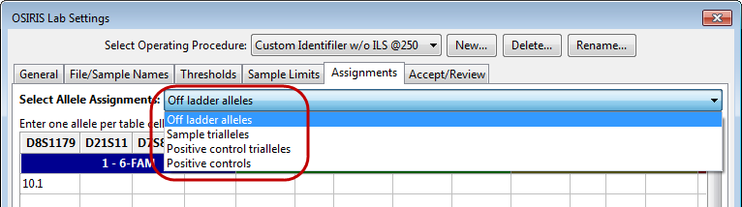

For each type of exception, the specific alleles can be designated for each locus. It is not necessary to add ladder alleles in the “Off ladder allele” assignments. While OSIRIS will work properly, it may slow performance. The following is an example for off-ladder alleles for D8S1179:

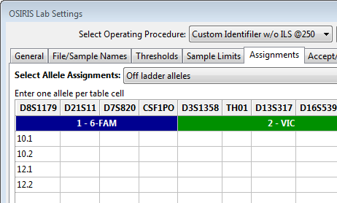

For sample trialleles, three alleles are entered in each cell so that each cell contains an accepted triallele as shown below.

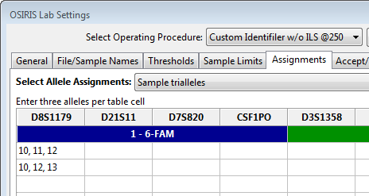

The “Positive controls” Allele Assignments table in the Figure below allows the user to define laboratory-specific positive controls. OSIRIS identifies laboratory-specific positive controls first by checking the file name (or sample name, if selected) for values listed in the positive controls “File Name Search” column in the figure below. The presence of a specified value within the file or sample name uniquely identifies a sample as the named positive control.

Specifying values for two different controls in which one value is contained in the other, may not produce the desired results. If both Joe10 and Joe102 are in the “File Name Search” list, Joe102 in the sample name may be matched as Joe10, because the value Joe10 is contained within Joe102. Unfortunately, the order in which control names are stored within OSIRIS may not be the same as the order they are listed in the test window. Therefore, for best results, choose values that uniquely identify their corresponding positive controls, such as Joe10 and Joe01.

Do not use one of the predefined standard kit positive control names (listed below) in either the Control Name or the File Name Search columns. OSIRIS already supports all of the default standard kit positive controls and the user can specify the one used in the analysis in the Lab Settings on the “File/Sample Names” tab “Positive Control” File Name Search Criteria in the “Standard Control Name” box. A sample that is identified as a positive control by means of the value on that tab, but that is not identified as a laboratory positive control, is automatically assumed to be the named standard positive control. It is not necessary to enter the laboratory positive value in the “Positive Controls” list in the File/Sample Names tab.

The value entered in the “Control Name” column will be displayed in the “+Ctrl” column of the analysis table. If a sample is identified on the File/Samples Names tab Positive Control list, it will be assumed to be the standard positive control, unless it is also listed among the laboratory specific positive controls on the Assignments tab Positive Controls shown below.

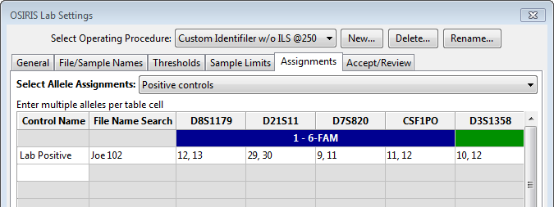

If a custom positive control has a triallelic locus, enter the three alleles in that locus in the “Positive controls” table. OSIRIS will determine whether the positive control alleles match the defined alleles in the table regardless of the number of alleles specified in a locus.

The “Positive controls triallele” table is not currently applied during analysis and should not be used.

#### Configure Editing – Acceptance/Review Tab

The “Accept/Review” section of the Lab Settings is used to determine how many people must accept data containing notices or the number of people required to review data that has been edited. As shown below, the default is 1 person to accept data with notices and 2 people to review data that has been edited. The default applies to each of the categories listed except where a specific value is given to one of the categories. Please note that the number of people needed to review edited data includes the person who is doing the initial analysis/editing, so the example below requires one person to accept alerts and a second person to review the editing done.

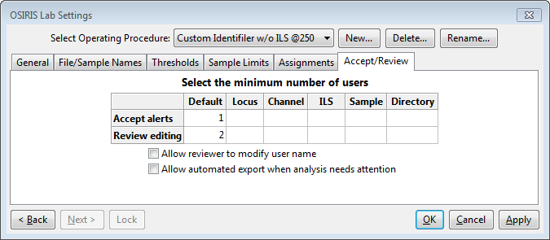

The “Allow User to Modify User Name” option allows the user to change his or her “User ID” name in the Sample editing window when accepting, reviewing, or editing data, by clicking on their user name.

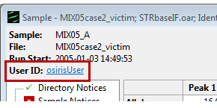

This is intended for situations where a single user is evaluating or validating the software and may want to be able to perform both editing and review as two different users. When the “Allow User to Modify User Name” tick box is cleared, the “User ID” defaults to the user’s login name and if more than one user is specified for accepting alerts or reviewing editing, the users performing those tasks must have different user names. This enforces laboratory policies that do not allow self-review. If the “Allow automated export when analysis needs attention” check box is checked, OSIRIS will run an automated export (such as data export for a LIMS) even if there are notices that require acceptance and review. If check box is cleared, automated data export will not occur when there are notices. Details about user defined file export are described in a later section.

Please note that all data for each sample must meet these thresholds before the data can be exported in the CMF format. Other export formats may need to meet these thresholds depending on how they are scripted and the parameters they require. If the checkbox labeled “Allow automated export when analysis needs attention” is not checked, then no automated user defined file export will be performed when any part of the new analysis file needs review. If this is not selected, it does not prevent the user from exporting data, but the user will be prompted with a warning.

Upon completion of the lab settings, the user must press the button labeled “OK” or “Apply” in order to save the settings.

When OSIRIS software is updated, the default kit Operating Procedures are also updated to reflect any changes in the newer version. However, customized Operating Procedures are *not* updated. OSIRIS retains all the Lab Settings and other parameters associated with the message book in customized Operating Procedures so that an analysis can be reproduced. The customized OPs are not erased when OSIRIS is uninstalled and reinstalled. As mentioned before, it is important that when OSIRIS is upgraded to a new version, the folder where it is installed must be the same as the previous version in order to retain these settings.

### Artifact Label Setup

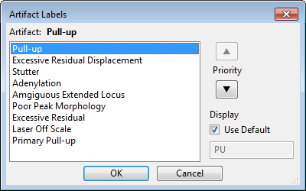OSIRIS marks peaks with artifact-specific labels for the nine types of artifacts listed in the figure, such as ‘ST’ for stutter. Users can change the default artifact labels in the Artifact Labels widow (Tools>Edit Artifact Labels). Select the artifact you want to change, uncheck the “Use Default” box, select the label and type a new label. Artifacts not listed are labeled with the generic ‘A’ label which cannot be changed.

Since a peak may have more than one type of artifact associated with it, such as pull-up and stutter, OSIRIS chooses which artifact label to use according to the default artifact label priority shown in the Artifact Labels list. Users can change the default priority by selecting an artifact and using the up/down arrows to move it in the list.

Changes made in the Artifact Labels window affect the display of any file opened in OSIRIS not just those files that were analyzed with changed labels and priority. Files analyzed with previous OSIRIS versions will also display the changes. Note that the display changes do not affect the analysis of the data. Allele labels, including the ‘OL’ in allele labels are not affected by changes made in the Artifact Labels window.

### Grid Colors

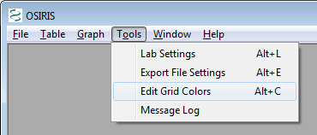There are many colors used to display the analyzed data in a table. These colors are used to indicate if the data in the table cell or the entire sample has been edited, has notices, or has been disabled. These colors can be modified as follows:

First select “Edit Grid Colors” from the “Tools” pull down menu to show the “Edit Grid Colors” dialog window.

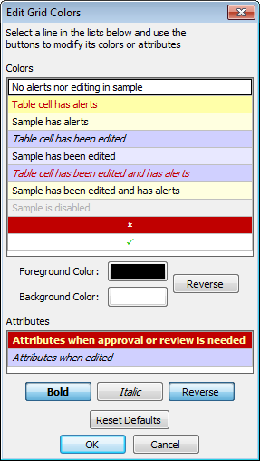The image on the left shows the default colors and attributes for the data in the table. To modify these colors, simply click on the color that you want to modify. The buttons below each table are updated to reflect the current selection and you can make modifications. If you click on one of the “color” buttons below the top list, a color dialog will appear and allow you to change the color. The “Reverse” button adjacent to the color buttons will swap the foreground and background colors. The “Attributes” table allows selection of attributes for table cells that need approval and table cells that have been edited. The attributes are bold, italic, and reverse. “Reverse” is used to reverse the foreground and background colors and is available only for cells that need approval because colors can be selected separately for cells that have been edited. All modifications are instantly reflected in the color and attribute tables and when the “OK” button is pressed; all analysis windows are updated to reflect these changes. Please note: The color settings are on a per-user basis and each user can set his or her preferences.

# Analysis

**Please refer to the** **Troubleshooting** **section** in Appendix I of this User Guide to resolve problems with your own analyses.

When an analysis is performed, one or more input folders containing either .fsa or .hid files are analyzed and the results are written to a new output folder for each input folder. File type is selected on the “General” tab of the “Lab Settings” dialog. The output data can be viewed in OSIRIS in the form of a table with peak information and graphical plots of the smoothed and raw electropherogram data. The tabular data can be exported to a CODIS Common Message Format (CMF) 3.2 file and the graphical data can be exported to a Portable Network Graphics (PNG) file which can then be imported into various applications including most word processing, spreadsheet, and presentation graphics programs or displayed on a web site. There is also an option to create export files with user-defined data formats as described in detail in Flexible Spreadsheet Export, the Export Setup Tutorial and Appendix E.

The type of analysis output depends on the type of analysis being performed. In allelic ladder-based STR analysis, such as with commercially available STR multiplexes that provide the allelic ladder, the output of the analysis consists of data containing alleles, loci, artifacts, peak area, and smoothed electropherogram data. In size-based fragment analysis, only an internal lane standard (ILS) size marker is required, and the analysis produces ILS-based sizing data, instead of loci and alleles, but also includes artifacts, peak area, and smoothed electropherogram data (as with ladder-based analysis). See A Tutorial for STR Analysis and A Quick Tutorial for Fragment Analysis for examples.

Users can select either STR allele analysis or size based fragment analysis by selecting the appropriate Operating Procedure (described below).

To begin an analysis, open the “Analyze Data” dialog window by selecting “New Analysis…” from the “File” pull down menu as shown below:

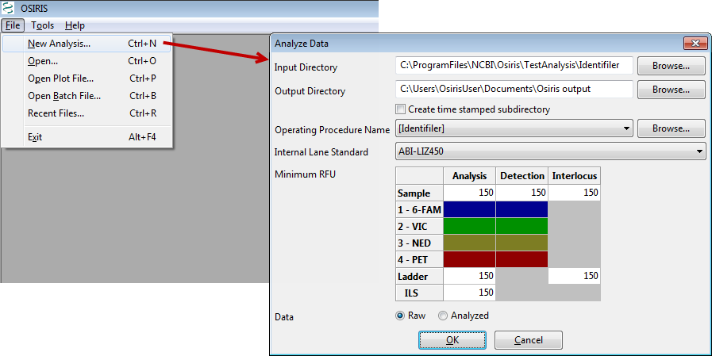

Following is a description of the parameters used for analyzing data:

**Input Directory**. This is the directory or folder which contains either .fsa (or .hid) files or contains subdirectories that have files to be analyzed. OSIRIS will begin looking in the specified directory and traverse all subdirectories searching for files to be analyzed. Each directory that contains one or more .fsa (or .hid) files will be analyzed. Only one file type can be analyzed per run, as specified in the Lab Settings.

**Output Directory**. This is the directory or folder that will contain the output files of the analysis. A subdirectory with the same name as the input directory will be created and if more than one input directory containing .fsa (or .hid) files is found, the output directory will contain the same hierarchy as the input directory tree. Each analysis will create several output files. OSIRIS will allow the user to view report and plot files, whose filenames have the extension of .oar and .plt, respectively. The report (.oar) file contains the tabular data for an entire directory and there is one plot (.plt) file for each sample. There are also various text files in the output directory with either the .txt extension for viewing in a text editor, or tab delimited (.tab) files which are better viewed with a spreadsheet program. The plot (.plt) files have the same name as their corresponding .fsa or .hid input files except for the file name extension. After editing, saving creates an edited report file (.oer). All other output files begin with the name of the output folder or directory, with some containing a suffix before the file name extension.

**Create time stamped subdirectory**. If this checkbox is selected, OSIRIS will create a new subdirectory in the output directory that is time and date stamped, which prevents an analysis from being overwritten on reanalysis.

**Operating Procedure Name**.   
STR allele Analysis: Select an Operating Procedure that contains the STR kit or marker set that was used to produce the data being analyzed. To see detailed information for the Operating Procedures, select the “Browse” button where you can also choose the desired Operating Procedure in the resulting dialog window.

Fragment Analysis: There are four default Operating Procedures for size-based fragment analysis in version 2.13 and higher. These defaults are named LaneStandardOnly_2, LaneStandardOnly_3, LaneStandardOnly_4, and LaneStandardOnly_5. The number in the name refers to the number of channels being analyzed. As with all the default Operating Procedures (OP’s), users can make a new OP based on a specific default in order to customize the settings. There are additional parameters in the Lab Settings that allow users to identify the lane standard and adapt the default channel assignments to their specific needs. These parameters are described in the Sample Thresholds section below. The default assignments are to assign OSIRIS display channel 1 to fsa/hid channel 1, OSIRIS channel 2 to fsa/hid channel 2, etc. The user must take care to assign the last OSIRIS display channel (e.g., channel 3 for a 3-channel lane standard-only analysis) to the fsa/hid channel that contains the internal lane standard. All fsa/hid file channel numbers must fall in the range of 1 through 8. If the user specifies an fsa/hid channel that contains no collected data, the analysis will fail.

**Minimum RFU**. Select the RFU thresholds for samples, ILS, ladder data, and interlocus peaks. Users can override the default threshold values (in the white boxes) for one or more channels by entering channel-specific thresholds in the colored boxes. The values that appear when the window is opened are specified in the lab settings. If the lab settings are set to not allow the user to override these parameters at the start of the analysis, then user input to these fields is disabled.

**ILS**. Select the appropriate internal lane standard for your data. This list is updated from the typing kit information when the Operating Procedure is selected. If the selected Operating Procedure does not allow the user to override the ILS, then this pull down menu is disabled.

**Data**. Select whether to obtain the raw or analyzed data from the .fsa files. If “Analyzed” is selected and there is no analyzed data in the .fsa file(s), the results will indicate this condition. If the selected Operating Procedure does not allow the user to override the setting, then this selection is disabled.

When the “OK” button is pressed, the analysis begins and a new window appears with the status of the analyses as shown below.

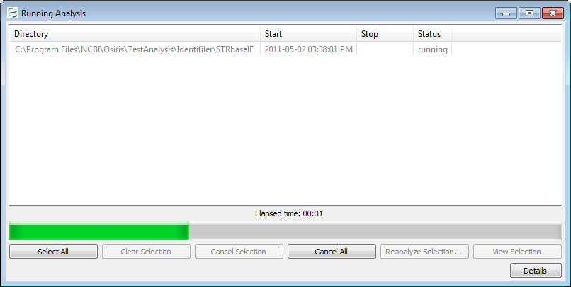

This window shows a list of each directory being analyzed; however because we selected a single directory our example shows only one item. The status column shows one of the following: pending, canceled, running, failed, or completed. If the status is pending or running, it can be canceled by selecting one or more rows and pressing the ‘Cancel Selection’ button. If the status is ‘failed’ or ‘completed’ the tabular and graphical data (.oar file) can be viewed either by double-clicking the item or selecting one or more items and pressing the “View Selection” button. In the lower right corner of the window is a button labeled “Details.” When pressed, the details of the selected analyses are displayed or hidden at the bottom of the window. Once the analysis is complete, the information is stored in a file in the output directory. This file is automatically named beginning with the name of the folder followed by the date and time and finally with the file extension .obr for OSIRIS Batch Report. This file can be viewed later to show the details and/or open the tabular (.oar and .oer) files. To retrieve an .obr file, select “Open Batch File…” or “Recent Files…” from the “File” pull down menu on the menu bar.

The “**Reanalyze Selection**” button will reanalyze the selected directory with the same laboratory settings as the original analysis, with any added changes made to the Minimum RFU, Internal Lane Standard, or Operating Procedure Name in the Analyze Data window described above. Note that changes made to the lab settings by editing the Operating Procedure used for the first analysis will not take effect using Reanalyze Selection. Edits to the Operating Procedure requires a New Analysis. , using the edited Operating Procedure.

# OSIRIS Report Files

The OSIRIS report files, also known as analysis files, contain information about the peaks found in the electropherogram data including alleles, peak area, RFU, base pairs, mean peak time, artifacts, and alerts of potential problems. The file extension for the report files created by OSIRIS is .oar for “OSIRIS Analysis Report.” The data in these files can be edited and saved with the file extension of .oer for “OSIRIS Edited Report.” To open a report file, select “Open” from the “File” pull down menu on the menu bar and search for the desired file. To open a recently viewed file, select “Recent Files…” from the “File” pull down menu. This will display a dialog window with up to 1000 recently viewed OSIRIS files of all types including report files. When a report file is opened, a window appears with split panes containing a table or spreadsheet in the top pane, optionally a graph in the middle, and alert info in the bottom. The borders between the panes can be moved by clicking and dragging with the mouse.

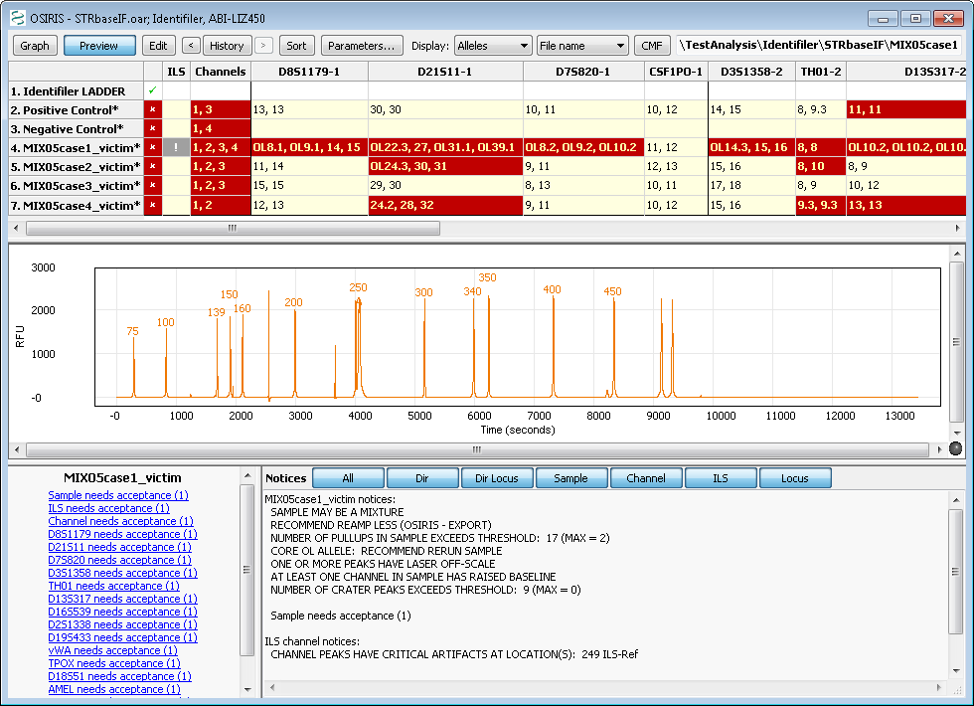

## Analysis Report Table

The output of our example analysis is shown above. Each row contains data for one sample. The first column contains an “**✗**” if any part of the sample needs attention and a check mark (**✓**) otherwise. The second column contains an exclamation point (**!**) if there are any alerts related to the Internal Lane Standard and is blank if there are no alerts. The third column contains the numbers of all channels that have channel level alerts. All other columns except for the rightmost column are used for locus information with a column for each locus. The locus column headings consist of the locus name, a hyphen followed by the channel number, and if there are any locus level directory messages, an asterisk (**\***) is also displayed. The order of the columns is by channel and then location or time of peaks within the channel. The vertical lines separating each column are black where two adjacent columns represent loci in different channels and grey otherwise. The rightmost column contains the name of the kit positive or custom positive control. The default color and attribute scheme for the table cells is as follows:

**White background, black text** The entire sample has no alerts.

**Yellow background, red text** The cell has one or more alerts.

**Pale yellow background, black text** The cell has no alerts, but the sample has one or more alerts. The sample may or may not have been edited elsewhere.

**Black italic text or ~, blue background** Thedata in the cell has been edited.

**Black text, light blue background** Theselected cell has not been edited, but the sample has been edited elsewhere, and the sample has no alerts.

**Red italic text, blue background** The data in the cell has been edited and it has one or more alerts.

**Grey text with a lighter grey background.** The sample has been disabled and will therefore be excluded if a CMF file is created. Disabled samples can also be re-analyzed.

**Bold Text with the foreground and** The cell needs attention, either alerts need to be reviewed

**background colors swapped** or the editing needs approval.

As mentioned in the “Grid Colors” section, this color schema can be modified on a per-user basis.

### Using Table Cells to Display Information

Clicking on various cells in the table displays different information in the preview graph and the two panes at the bottom. When the table has the keyboard focus, the user can use the keyboard arrow keys move quickly from cell to cell.

**The effect of clicking on a cell in the following columns:**

**Locus** Displays the zoomed locus in the preview graph (if activated) and the shows the sample’s notices and peak information below.

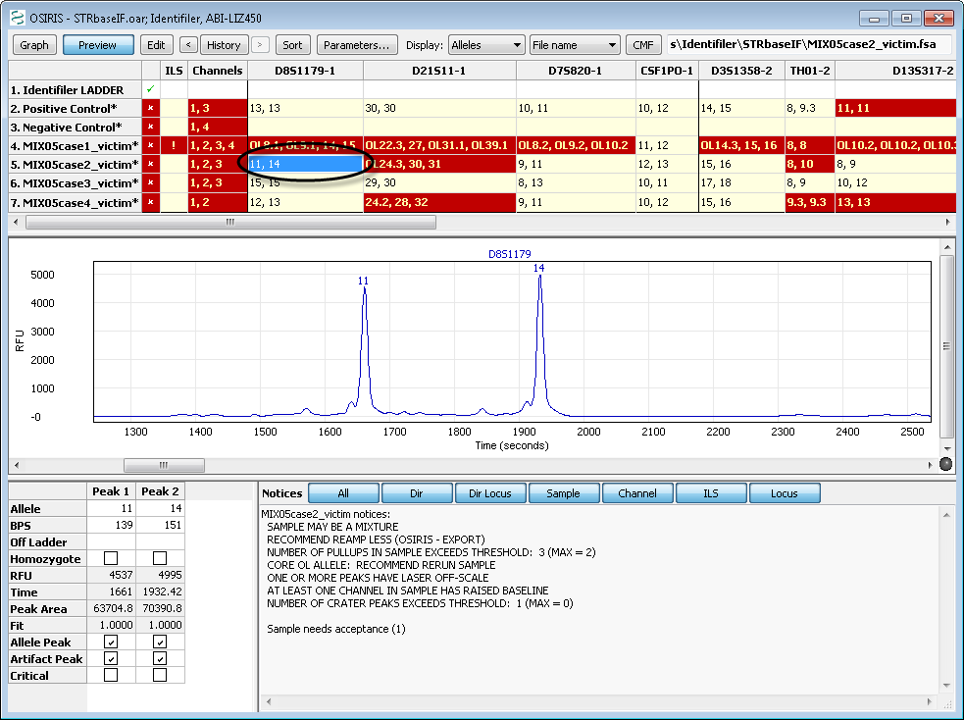

**Sample name, “✗”, “✓”, or “+Ctrl”** Displays all the channels for the entire profile in the preview graph, a summary of the sample’s notices in the lower right panel, and Acceptance and Review links with the required number in parentheses in the lower left panel.

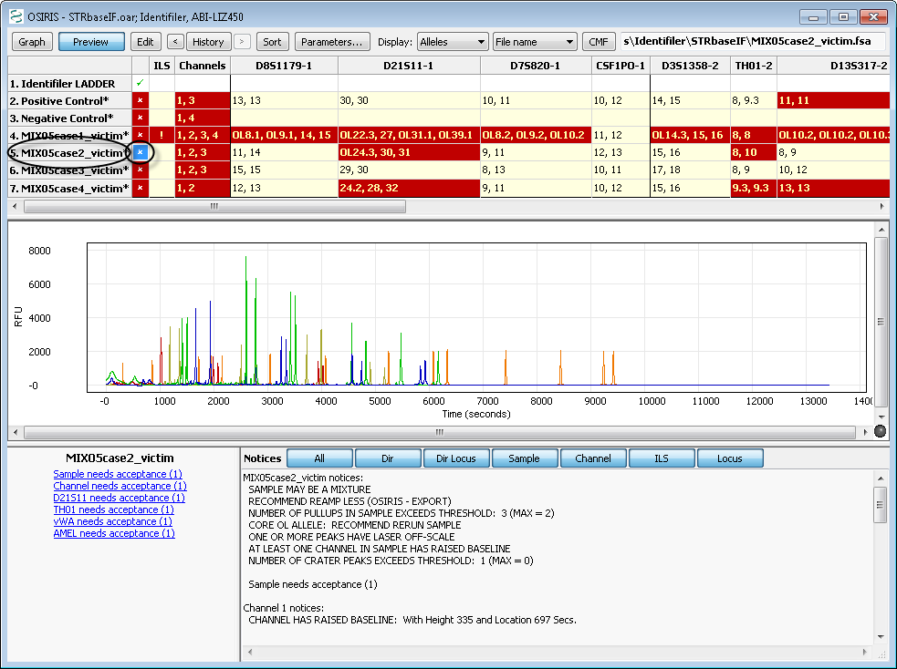

**ILS** Displays the ILS in the preview graph, a summary of the sample’s notices in the lower right panel, and Acceptance and Review links with the needed count in parentheses in the lower left panel.

**Channels** Displays only the channels for which there are notices in the preview graph, unless there are none, in which case it displays all channels. It displays a summary of the sample’s notices in the right hand notices box and Acceptance and Review links with the needed count in parentheses.

## Plot Preview Graph and Graph Menu

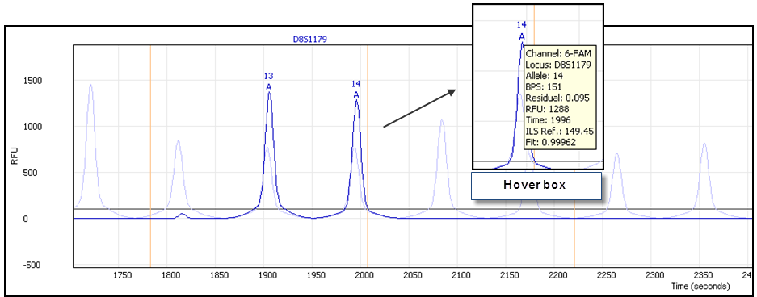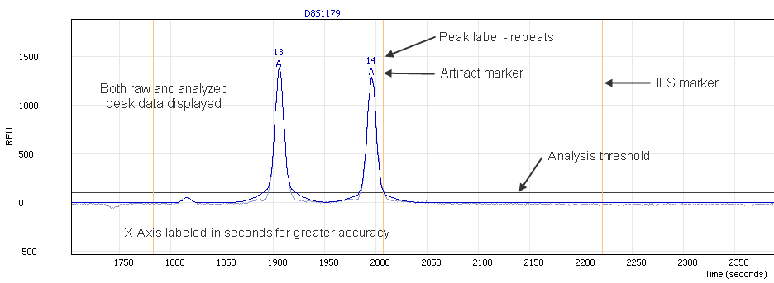The preview graph displays a wide range of sample information that is instrumental in sample review. The preview graph can be turned on and off either through the table menu or by clicking the preview button on the toolbar. As described above, clicking or selecting various table cells will show different aspects of the plot data in the preview graph, such as by clicking on a sample’s D8S1179 cell to zoom the preview graph to display that locus, as shown in the figures on the right. The preview graph can be set to display information helpful in sample review, including the raw and analyzed peak data, various peak labels, analysis and ILS thresholds (if different), artifact markers, ILS peak positions and the comparison ladder allele peaks. Hovering the cursor over peak labels and artifact markers will display a hover box with peak information.

Preview graph

Preview graph with unlabeled ladder peaks

Plot preview graph options can be found either on the “graph” menu or on the context menu that pops up as a result of right-clicking on the preview plot.

Following is a description of each option in the menu:

**Data.** This option allows the user to display raw plot data, analyzed plot data, and/or the comparison ladder alleles. The comparison ladder allele peaks can be helpful in evaluating migration issues, microvariants and other off-ladder peaks.

**Channel.** Allows the user to select one or more overlaid channel plots in order to evaluate peak alignment in different channels in the event of cross-channel artifacts such as pull-up or spikes. To see the plots as stacked plots, view the sample plot in the graph window as described in the “OSIRIS Plot Files” section.

**Show ILS.** Display or hide the ILS marker position lines.

**Show Minimum RFU.** Display or hide the analysis threshold lines. If the ILS analysis threshold differs from that of the sample, and the ILS and any other channel and displayed, both thresholds will show. OSIRIS does not display the detection threshold.

**Labels.** Displays or hides different sample peak allele labels including: Alleles, BPS, RFU, Time and Peak Area. When peak labels are visible, hovering the mouse cursor over the label will display detailed allele information.

**Artifacts.** Allows the user to choose whether and which artifact labels to display. When either Critical or All are selected, artifacts are marked with an “**A**”. The options are None, All and Critical. Critical artifacts should be visible during editing, because these are artifacts that trigger notices requiring human intervention. As with the allele labels, hovering the mouse cursor over an artifact label will display detailed artifact information. Hovering over artifact labels shows different information than hovering over allele labels.

**Show ladder labels.** Allows the user to display or hide the ladder allele labels when the comparison ladder is displayed.

**Max. ladder peak labels.** This option allows the user to select the maximum number of ladder labels to display when the comparison ladder is displayed. Choosing a reasonable number, such as between 20 and 30 can prevent the display from becoming visually too noisy and confusing. When the user zooms out and the number of ladder peaks exceeds the maximum, the ladder labels automatically disappear. When the user zooms in again, they reappear. If this option is left blank, all ladder labels will display.

## Table Toolbar and Menu

The toolbar at the top of the Table view window along with the “Table” pull down menu on the menu bar at the top of the OSIRIS window and the context (right click) menu have the following options: Graph, Preview, Edit, History, Sort, Parameters, Display and CMF. The menu also has items for accepting alerts, reviewing editing, disabling/enabling sample, and showing/hiding the toolbar.

The text box on the right side of the toolbar displays the original location and name of the ABI .fsa or .hid file used to create the analysis data in the highlighted row or cell of the table. This cannot be modified, but if the name is too long to be displayed in its entirety, the user can select the text box and move the cursor in order to expose the beginning or end of the file name.

Following is a description of each option in the toolbar and in the “Table” menu:

**Graph** button or **Display Graph**. This option will open the Graph view window with the electropherogram data of the selected sample. This is a separate window not to be confused with the plot preview below the table. If the selected cell is in a locus column, the plot(s) will be zoomed to the area of that locus; otherwise the entire plot will be shown, excluding primer peak data. The plot window will display one plot for each channel unless the Shift key is pressed. If the Shift key is pressed only one plot will be displayed. This is discussed in further detail in the next section, “OSIRIS Plot Files.” Double clicking any cell will display the graph, zoomed to the area of the locus. Single clicking a cell displays the locus in the preview graph below the table.

**Display Sample**. This option will display the Sample editing window, which allows editing.

**Display Sample and Graph**. This option will display the Sample editing window and the Graph view window, tiled to fit the entire OSIRIS window. The Graph view window will be zoomed to the locus selected in the table, or to the entire sample if the sample, ILS cell or Channels cell is selected.

**Preview** **button**. This option will show or hide a plot panel immediately below the table to show the peaks of the currently selected sample and locus. This plot is automatically updated when the user selects a different table cell.

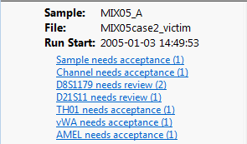**Edit button,** or **Edit Alleles, Notices, and Notes**. These options open the Sample editing window with the appropriate locus selected, allowing the user to edit notices and notes relevant to the selected cell. See Editing Peaks, Loci and Samples.

When a sample, ILS or channel is selected, hyperlinks display in the lower left notification area of the Table window that will allow the user to access the Sample editing window. Links that indicate that the locus, sample, or channel “needs acceptance” will open the Sample editing window. Links that indicate that a locus “needs review” will open the Approve Editing window.

**Edit Directory Notices.** This option will display the Sample editing window, which allows editing.

**Accept Alerts.** This option will display the Sample editing window, which allows editing.

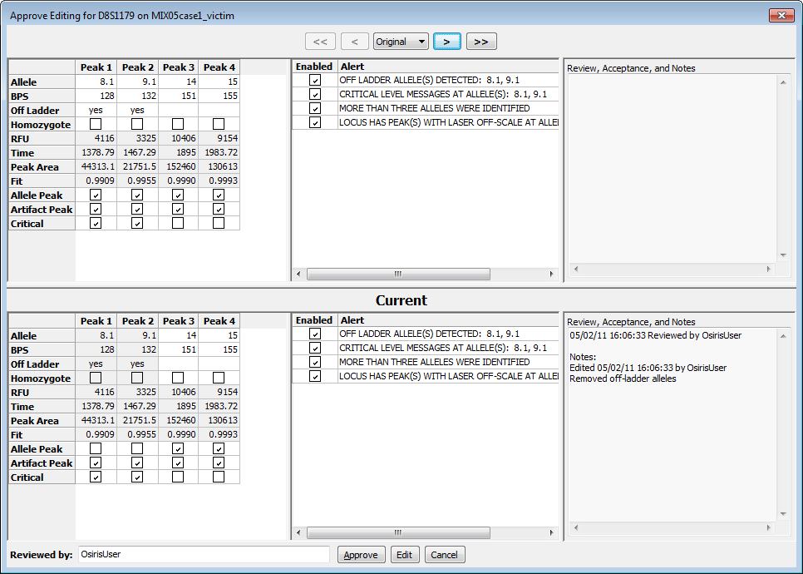**Review Editing**. This option opens the Approve Editing window, which allows a subsequent user to review editing of the directory, locus, sample, channel, or ILS alerts performed by the first user. This window can also be accessed through the sample review links displayed in the lower left window when the sample, ILS, or channel is selected. See Reviewing Editing and Analysis. Editing and review are reflected in the color of the cell or the removal of an asterisk (*). When acceptance and review is complete at all levels (Sample, Channel, Locus, ILS, etc.), the red cell containing an “X” changes to a green checkmark.

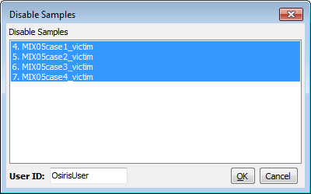**Disable (or Enable) Sample.** This allows the user do disable a sample or (re) enable a sample. The reason to disable a sample is that the analysis was not successful and it is desired to reanalyze only a few samples or if you wish to exclude it from a CMF file.

**Disable/Enable Multiple.** This displays a window, as shown on the right, which allows the user to disable or (re) enable multiple samples.

**History**. The history button or menu item is used to display the data as it was saved in previous versions of the file. The history button or menu item displays a menu with a list of date and times the file was saved along with “Original” and “Current.” The “Original” selection shows the original data obtained from the analysis before anything was edited. The “Current” selection shows the data with any editing performed since the last time it was saved. For the analysis window the first item in the history menu is one of the following depending on the selected cell or row: View Sample Notices, View ILS Notices, View Channel Notices, or Allele Edit History. This selection is enabled only for data that have a history of being edited and it displays a dialog window containing details of the editing performed and saved on the selected cell or sample.

The buttons adjacent to the “History” button are used to display state of the file at the previous and next times the data was saved. If any historic time other than “Current” is selected, the selected date and time is displayed in the window title.

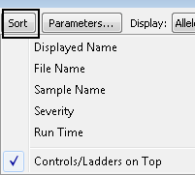**Sort**. This allows the user to sort the samples according to various criteria. “Displayed name” sorts by either file name or sample name depending on which is displayed in the names column of the table. “File name” and “Sample name” sort by those criteria respectively, independent of what is displayed in the names column of the table. When sorting by “Severity”, the actual severity is determined by the number of notices for the sample. A sample with no alleles found may be shown at the bottom even though it may be more severe than a sample with many alleles found, but that also has many notices. “Run Time” sorts samples by the time of analysis.

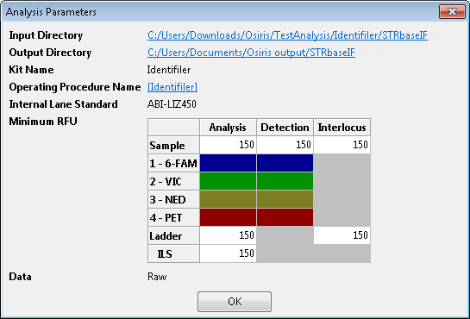In any of the sort orders, if “Controls/Ladders on Top” is selected, it causes them to sort to the top followed by the samples in the selected order.

**Parameters…** This button or menu item displays a pop-up window containing the parameters used for this analysis. The input directory and output directory are hyperlinked to enable the user to view the contents. The Operating Procedure is hyperlinked to a dialog window that shows all of the settings at the time the analysis was performed. Note that those settings are a historical record and cannot be edited. An example is shown on the right.

**Display.** The first pull down or submenu allows the user to display Alleles, BPS, RFU, Time, or Peak Area in the table cells. The second pull down allows the user to choose between displaying the file names or the sample names in the sample names column of the table.

**CMF** or **Export CMF File…** This option allows the user to export the data in a CODIS 3.2 Common Message Format (CMF) file. In order to export to a CMF file, all of the samples that are not disabled must not need attention and the directory level notices must be accepted or reviewed. Please note that if the analysis file has been edited, it must first be saved before exporting a CMF file. If it has not been saved, a window will appear to prompt the user to decide whether to save the file or cancel. When exporting a CMF file, a dialog appears with many options for the file and each sample. Following is an example:

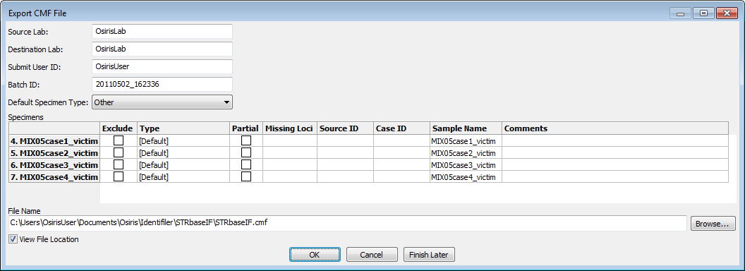

The Source Lab, Destination Lab, Submit User ID, and Default Specimen Type are automatically saved and used as the default for subsequent CMF files. Please note that the Submit User ID may not be editable depending on this option in the lab settings at the time of analysis. The Batch ID is automatically created using the current date and time. The table contains a row for each sample. The exclude column allows the user to exclude one or more samples. The “Type” is a drop down list of all available types of specimens. If “[Default]” is selected, then the selection for “Default Specimen Type” above is used. “Partial” is selected if one or more loci do not have any allele calls. This can be modified by the user. “Missing Loci” shows a list of all loci that do not have any alleles. “Source ID” and “Case ID” can be edited by the user. “Sample name” is by default the name of the sample taken from the name of the original ABI .fsa or .hid file and used in the analysis file. It is also used as the row label on the left, but for purposes of writing a CMF file, it can be edited in the “Sample name” column. The “Comments” column allows the user to enter any desired comments for any sample to be included in the CMF file.

Below the table, the user can specify the name of the output file, which by default is the name and location of the Analysis file except with the file extension changed to .cmf. To find another location or change the file name, the user can select the “Browse…” button to choose from a file dialog window. There is a checkbox labeled “View File Location.” If this is selected, a window with the location of the CMF file is displayed after the file is created in order to access the file from the computer’s operating or window system. The CMF file is created when the user presses the “OK” button. If the user presses the button labeled “Finish Later” then this window will close and return the user to the Analysis window but all changes will be saved and restored if “CMF” is selected again. This is useful if the user needs to examine the data again before exporting the CMF file. If the “Cancel” button is pressed, all changes will be discarded.

# OSIRIS Plot Files

The OSIRIS Plot Files have an extension of .plt and unlike the report files, they do not have edited file versions. All edits are stored in the .oer files. The plot files are used to display a graph of the raw, analyzed, and ladder electrophoresis data with labels for alleles, artifacts, and loci. The curve data and locus location are always obtained from the plot file, but the peak and artifact information can be obtained from either the plot file or a corresponding analysis file. If an analysis file is used to obtain the alleles and artifacts, then any changes made by the user are also reflected in the plot window. There are several ways to open a plot file. To open a plot file as a standalone file (without its corresponding analysis file) select “Open Plot File…” or “Recent Files…” from the “File” pull down menu on the menu bar and select the desired file. A plot file can also be opened from its corresponding report file by selecting the desired sample in the table of the Analysis window and selecting “Graph” from the tool bar if visible or by selecting “Display Graph” from the context menu (right click) or the “Table” pull down menu on the menu bar. It can also be opened by double-clicking on a cell or row label within a sample. If a graph window is opened from the analysis window, the peak data displayed in the graph window will be obtained from the report file and the names of the plot and report files will both appear in the title bar at the top of the window. When the graph is opened from the analysis window, the actual data initially displayed depends on the selected cell in the sample and whether or not the shift key is held down. It is important to understand that opening a .plt plot file as a standalone will not show editing and history. If the plot file has not been moved out the of the folder containing its associated report files, the editing and user changes may be viewed by selecting the “Table” button to open the analysis file. Following is a table illustrating different ways to open a graph window from the analysis file.

|  |  |  |
| --- | --- | --- |
| **Type of Cell Selected** | **Select “Graph” button or Double-click** | |
|  | **With**  **Shift key**   **Pressed** |
| **Locus** | One plot for each channel. Zoomed to selected locus and scrolled to ensure visibility of channel containing locus | One plot zoomed to selected locus |
| **ILS, Channels,**  **+Ctrl, ✗, ✓, or**  **entire sample** | One plot for each channel. Zoomed out but excluding primer peak data | All channels in a single plot. Zoomed out but excluding primer peak data |

Different methods of opening a graph window from the analysis window

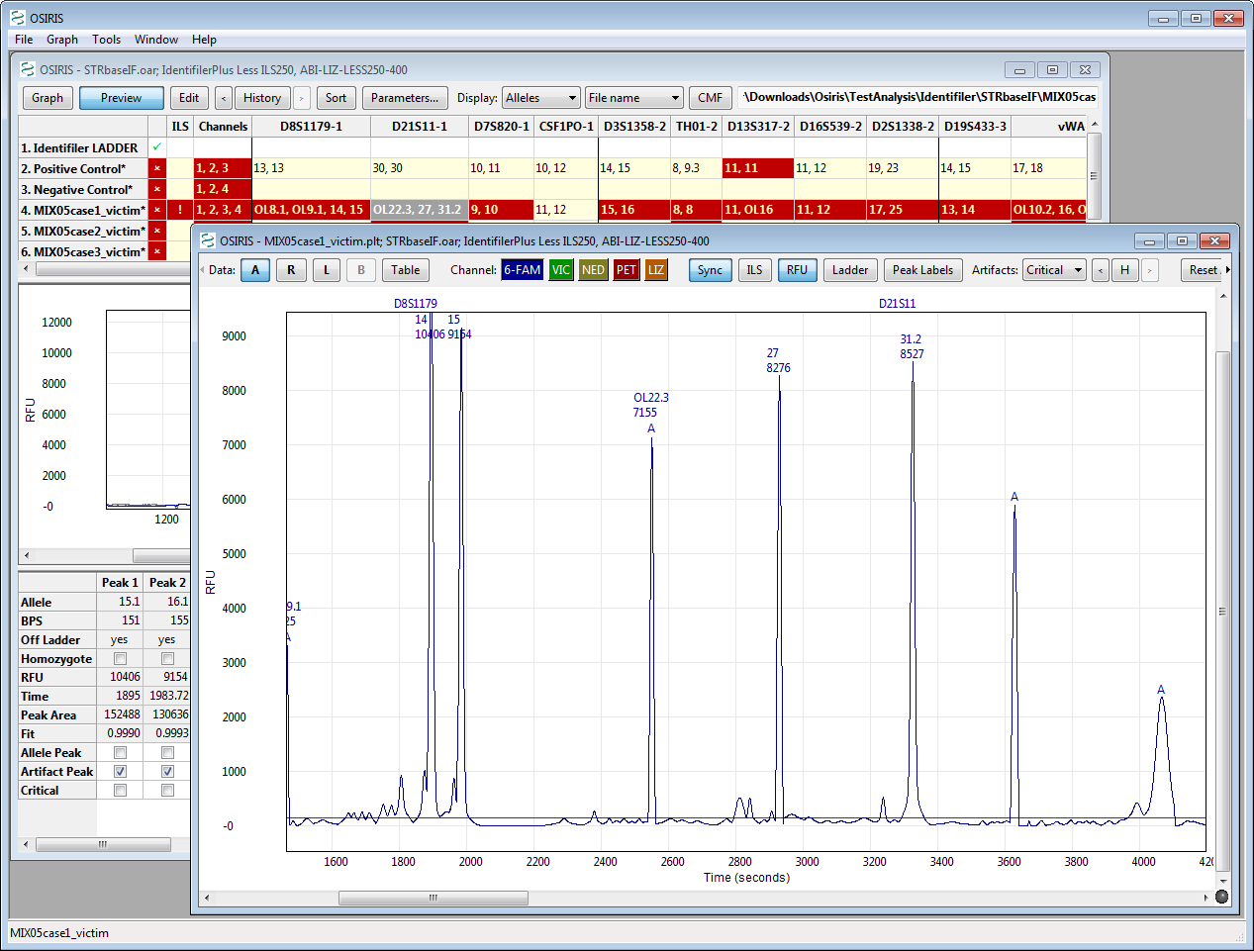

D21S11 is selected for MIX05case1_victim, shift key is pressed while pressing

the Graph button resulting in a single plot of channel 1 zoomed to D21S11.

The preceding image shows the result of selecting the D21S11 locus of sample MIX05case1_victim, holding down the Shift key and pressing the “Graph” button. The plot was zoomed to the selected locus and because the Shift key was pressed, only one plot was displayed. Note that two allele peaks displayed in the table are not shown in the plot, 22.3 (OL) and 39.1 (OL). This is because they are outside the range of the ladder for D21S11. These peaks can be shown by zooming out, a topic that will be discussed in detail later in this section.

## Allele and Artifact Hover Boxes

Holding the cursor over a peak label will display a pop-up hover box that displays information about the peak or artifact as shown in the figure below. The allele label hover box displays the channel dye name (where defined), locus, allele call (and off-ladder indication), locus base pair size (BPS), residual (shift measurement), time, peak area peak width (time), ILS base pair size, and peak fit. In addition to the information displayed in the allele hover box, the artifact hover box for a peak with no allele call displays the various artifact messages and the corrected RFU if the peak is a pull-up or a partial pull-up. If the peak has been assigned an allele call as well as an artifact call, some of the allele information is not duplicated in the artifact hover box. The allele position of the peak is displayed if the peak has not been assigned an allele call. See Definitions for descriptions of these terms and the difference between ILS Ref and BPS base pairs.

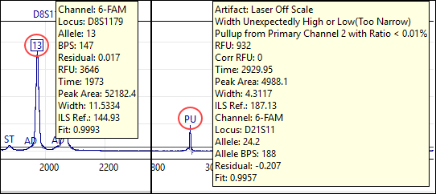

## Display Bases or Time on the x-axis

The x-axis of the plot in the graph view is labelled with time by default. To change the x-axis to bases instead of time, when in the plot window of the graph view, select “Graph” in the top menu then “Show ILS BPS X-axis”. To change the x-axis to bases instead of time when in the table view, select “Preview” in the top menu then “Show ILS BPS X-axis”. The base pair numbering uses ILS Ref. base pair, in reference to the size of the ILS marker peaks. When the display switches, peak positions will change slightly to maintain the linear display of the x-axis units. In the rare case that bases cannot be displayed for a particular sample, OSIRIS will default to time on the x-axis for that sample. Once the x‑axis selection is made, it will become the default for future graphs or previews until the user changes it.

## Graph Toolbar

The toolbar at the top of each plot and the “Graph” pull down menu on the menu bar have the following options: Data, Channels, Sync, ILS, RFU, Labels, Artifacts, History, Reset Axes, Multiple, Append, Parameters, and Close Plot (**X**). The menu also has items for showing or hiding the toolbars and scrollbars in the plot and the last selection of these items is used as the default when opening subsequent plot files.

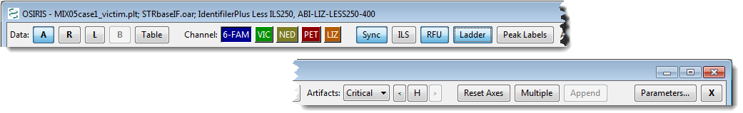

Following is a description of each option in the toolbar and menu:

**Data: Raw, Analyzed, Ladder, Baseline, Table.** The toggle buttons labeled A, R, L, and B are used to show or hide the curves for Analyzed Data, Raw Data, Ladder Data, and calculated Baseline Data. The Baseline Data button is only active if either the “Normalize Raw Data Relative to Baseline” or the “Test Adjusted Signal Heights Relative to Baseline” parameter is selected in laboratory settings at the time of analysis. The Raw Data button displays *normalized* raw data with the calculated baseline subtracted if the “Normalize Raw Data Relative to Baseline” parameter is selected at the time of analysis. If the shift key is pressed while selecting one of these options the selection will immediately be used for all plots in the window. The “Table” button shows the window with the report data and selects the row for the sample in the graph window. If there is no report file opened for this graph window, the user is prompted to select a report file or cancel. If a report file is selected, it is used for labeling alleles and artifacts. The “Graph” pull down menu has a submenu for each plot and each of these submenus has a “Data” submenu with entries for these options. In addition to this, the “Graph” pull down menu has a menu item labeled “Show Table” which performs the same action as the “Table” button.

**Channel.** There is a toggle button for each channel labeled with the channel name and its background color corresponding to the color of the channel and its plot. If the shift key is down when pressing a “Channel” button, then only that channel will be displayed with all other channels hidden.

**Sync** or **Synchronize Axes**. This toggle button or checked menu item is used to synchronize multiple plots when domain and/or range are modified. If this is selected, every time the view is changed, the view is updated on all other plots where this option is also selected. If the shift key is down when selecting this, the setting is updated in all plots in the window.

**ILS** or **Show ILS**. This option shows or hides vertical lines to indicate where the peaks are in the ILS channel. The color of the lines corresponds to the color of the ILS channel. If the shift key is pressed while selecting this option, the setting will be shown in all plots in the window.

**RFU** or **Show Minimum RFU**. This option shows or hides one or more horizontal lines to indicate the location of the minimum RFU selected when the analysis was performed. The actual lines are for the minimum sample and/or ILS RFU depending on the selected channels. If the shift key is pressed while selecting this option, the setting will be set in all plots in the window.

**Peak Labels**. The **Ladder** button on the Graph toolbar and the **Plot**->**Show Ladder Labels** on the menu show and hide the ladder labels. The loci are also displayed at the top of the plot unless “None” is selected. When the user clicks on a locus label, the plot is zoomed to the range and domain of that locus and if “Sync” is selected, all other synchronized plots are zoomed also. The **Peak Labels** button on the Graph toolbar and the **Plot**->**Labels** on the Graph menu determine how the alleles will be labeled. The options are None, or any combination of Alleles, BPS, RFU, and Time. If the shift key is pressed while selecting these options, the selection will be used in all plots in the window. When the cursor is placed over a label, a box appears with detailed information about the allele.

**Artifacts**. This option determines which artifacts are labeled: All, Critical, or None. The artifacts are labeled with an “A” and when the cursor is placed over the label a box appears with detailed information about the artifact. If the shift key is pressed while selecting this option, the setting will be shown in all plots in the window.

**H, History**. The history button or menu item is used to display the data as it was saved in previous versions of the report file. This is similar to the history option in the report window, except the button is labeled with the letter “H” in order to save space. The button or menu item displays a (sub) menu with a list of dates the file was saved along with “Original” and “Current.” The “Original” selection shows the original data obtained from the analysis before anything was edited. The “Current” selection shows the data with all editing (if any) performed since the last time it was saved. If the file has been saved many times, some of the dates may appear in the menu with a selection for “More…” which opens a dialog window that allows the user to select from all save points. If there is no report file opened for this plot window, the user is prompted to select a report file or cancel.

**Reset Axes, Show Primer Peaks**. When “Reset Axes” is selected, the plot is zoomed out to show all peak data. If the Shift key is pressed when selecting “Reset Axes” from the toolbar or if “Show Primer Peaks” is selected from the menu, then the plot is zoomed out to show all data including the primer peaks at the beginning of the plot.

**Multiple, Multiple Plots, Remove Other Plots**. When “Multiple” or “Multiple Plots” is selected, a separate plot is displayed for each channel. If the Shift key is pressed when selecting “Multiple” on the toolbar or if “Remove Other Plots” is selected from the menu, then all but the selected plot are removed.

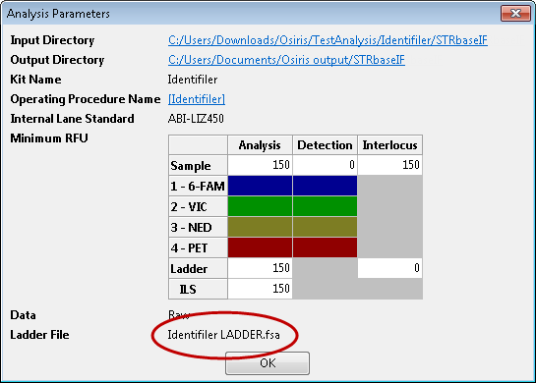**Append**. This option appends a new identical plot below the plot whose menu or toolbar is performing the action. The maximum number of plots is equal to the number of channels.

**Parameters…**  This button or menu item displays a pop-up window containing the parameters used for this analysis. The input and output directories are hyperlinked to enable the user to view the contents. The Operating Procedure is hyperlinked to a dialog window that shows all of the settings at the time the analysis was performed. Unlike in the Analysis window, when the Analysis Parameters pop-up is displayed from a plot in the Graph window it displays the ladder file associated with the analysis of that sample. An example is shown on the right.

**X, Remove Plot**. This option removes the specified plot from the window. If this “X” button is pressed on the toolbar while the Shift key is pressed, all other plots are removed in the same manner as pressing the “Multiple” button with the Shift key down or selecting “Remove Other Plots” from the menu. This feature is disabled when only one plot is displayed.

**Arrows.** If the toolbar is too narrow to accommodate all of its items, then an arrow is displayed at each end and the user can click on the arrow to shift the items on or off the visible portion of the toolbar as shown below.

Toolbar is shifted to the left, left arrow is grey and disabled

Toolbar is shifted to the right, right arrow is grey and disabled

## Resizing Plots

When viewing multiple graphs in a single window, the height of each graph may be too small. The height of each plot can either be fixed to fit into the window or resized to be larger with a new scrollbar added to scroll through the larger plots. This option is chosen by selecting “Resizable Plots” in the “Graph” pull down menu as shown on the right.

When this is selected, a sash or horizontal bar is displayed between each plot. The plot can then be resized by clicking and dragging this bar to the desired size as shown below.

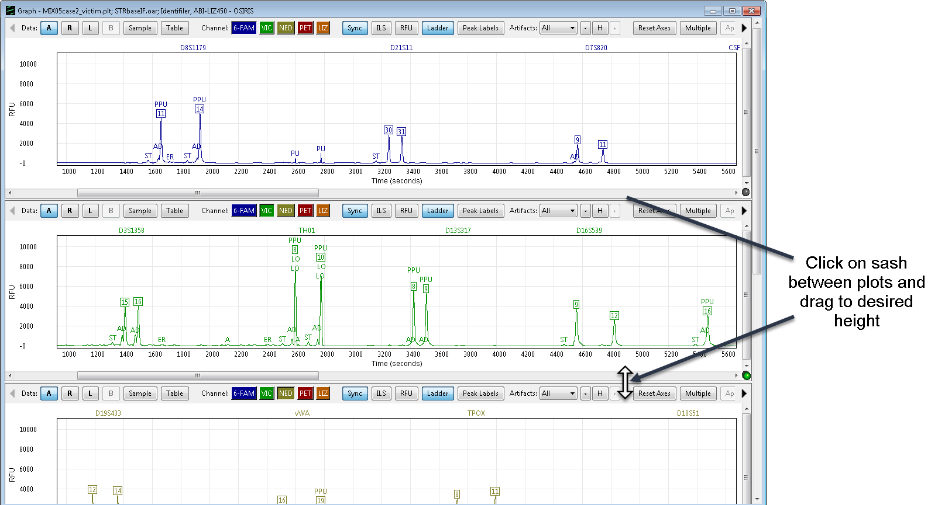After dragging the sash (or bar), **each of the plots** is resized to the selected height and a scroll bar is shown on the right if the total height of the stacked plots exceeds the height of the window.

Once the plots have been resized, the new size becomes the default size when opening a new graph window. **Please note:** On the version of OSIRIS for the Macintosh, there is no black line or marker displayed when dragging to resize the plot and the change does not appear until the mouse button is released.

## Export Graphic File

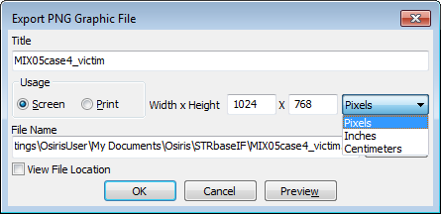The plots currently being viewed can be exported to a portable network graphics (PNG) file. A PNG file can be used with most software that will display or print graphic files including web browsers, word processing programs, spreadsheets, and presentation graphics. This is done by selecting “Export Graphic File” from the “File” menu on the menu bar. A dialog window will appear as shown on the right. The title is text displayed above the plots. Usage is selected to create a graphics file to be used by either on a screen or printed. The resolutions are 72 and 300 dots per inch (dpi) respectively. If you plan to include the graphic in a word processing file, it is recommended that “Print” is selected and that the units are either “Inches” or “Centimeters” are chosen with the approximate size selected. For applications that are primarily viewed on a screen, for example, spreadsheets or presentation graphics, “Screen” is recommended. The file name and “Browse” buttons are used for choosing where to save the file and the checkbox labeled “View File Location” when checked, will open a window displaying the folder containing the graphic file after it is saved. The “Preview” button allows the user to preview the graphic file before saving it. This is useful because it is likely that adjustments will be needed before saving a graphic file.

## Zooming and Panning the Graph

When viewing the graph, it is often desirable to zoom and/or pan to a particular locus or peak and there are several ways to do this.

**Reset Axes.** To view all of the allele peaks, select “Reset Axes” on the toolbar or from the plot submenu on the “Graph” pull down menu. This viewport will not include the primer peaks near the origin of the plot. To include primer peaks, hold down the Shift key when selecting the “Reset Axes” button on the toolbar or select “Show Primer Peaks” from the plot submenu on the “Table” pull down menu.

**Zoom To Locus.** To zoom to a particular locus, simply click on the locus name at the top of the plot. This will zoom the X-Axis to the range specified by the ladder and the Y-axis to accommodate all data in that range. This will not display adjacent interlocus peaks, but they can be viewed by clicking on the plot and pressing “a” on the keyboard. Keyboard options for setting the viewport are described later.

**Shift Axes.** To shift the X or Y axes, move the cursor over the axis labels and when the cursor changes to two arrows (up and down for the Y-axis, left and right for the X-axis) simply click and drag the mouse in the direction of the desired data to shift the range.

**Keyboard Control.** There are several keys that will change the viewport of the plot. Before using the keyboard it is important to first click on the plot in order to select it for receiving the keyboard input. The alphabetic keys must be lowercase. The keystrokes are as follows:

**Arrow/Cursor Keys** – Pan by a small amount in the direction indicated by the arrow.

**Page Up/Page Down** – Pan the Y-Axis up or down by a large amount.

**Home** – Center the plot around the origin (0,0).

**a** – Zoom out X-Axis (decrease peak width)

**d** – Zoom in X-Axis (increase peak width)

**x** – Zoom out Y-Axis (decrease peak height)

**w** – Zoom in Y-Axis (increase peak height)

**e** – Zoom in both axes

**z** – Zoom out both axes

**s** – Zoom out to show all data including primer peaks

**q** – Zoom out X-Axis, zoom in Y-Axis

**c** – Zoom in X-Axis, zoom out Y-Axis

Keyboard zooming centers on the middle of the plot displayed, so that it may be necessary to shift the axes as described above after keyboard zooming to center the desired data in the viewable part of the graph.

**Zoom to Rectangle.** Another method of zooming is to click and drag the mouse in order to draw a rectangle around the desired region. Following is an illustration:

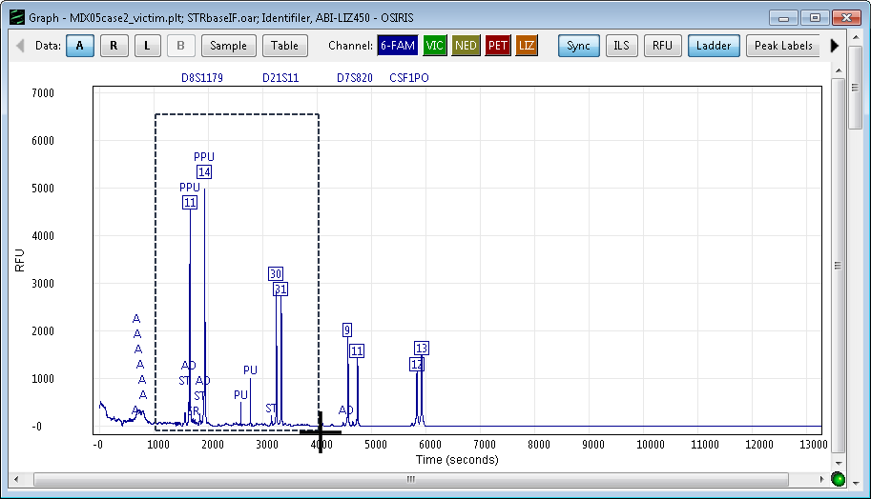

Click on a corner of the desired rectangular region and drag the mouse to see an outline.

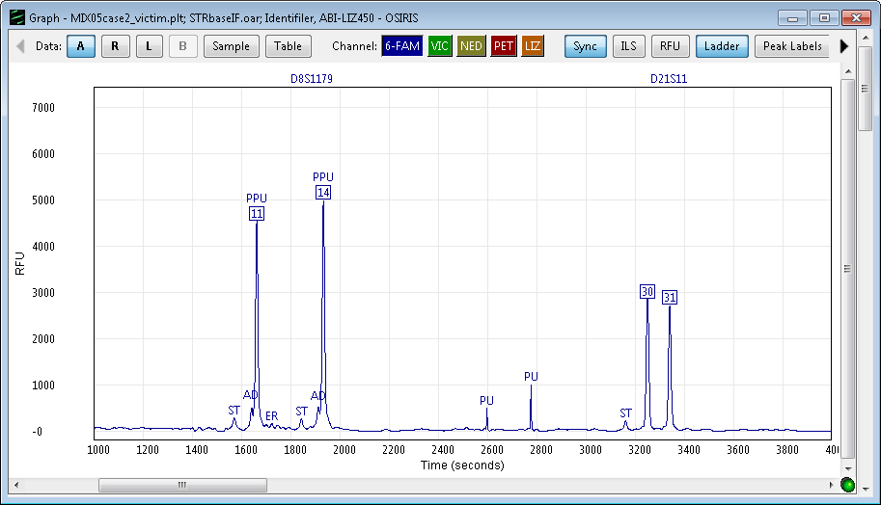

After the mouse button is released, the plot is zoomed to the selected region.

If the results are not as desired, simply reset the axes as described above and try again or use the keyboard **A** and **X** keys to zoom out the x- and y-axis respectively, as described above.

# Editing Peaks, Loci and Samples

OSIRIS can flag quality issues on peaks, loci, channels, samples and directories. Users can either edit these notices to remove them, when the user disagrees with the call, or they can accept them as reasonable.

Editing in OSIRIS allows the user to:

**Accept** alerts, notifications and artifacts, indicating that the user agrees with OSIRIS’s analysis.

**Edit** alerts, notifications or artifacts where the user disagrees with a part of the analysis.

**Review** edits made by a user.

OSIRIS can be set up for single user analysis, or analysis by one user, followed by review by a second user. (See Configure Editing.) This allows laboratories flexibility to use OSIRIS to enforce second analyst review within the software, have a duplicate analysis comparison by other software, to have a paper review by a second analyst, or have a single analysis, as appropriate to the type of laboratory.

OSIRIS creates an audit trail of user edits and changes. Once saved, the audit trail cannot be edited or undone. Changes are saved to the audit history on saving and exiting. Note that if changes are not saved on exit the edits made will be lost.

Peak artifacts are classified as either non-critical, or critical. Critical artifacts require review by an analyst as determined by the user’s settings. Non-critical artifacts do not require review. OSIRIS can distinguish situations where a peak consists of both artifactual signal and signal from an allele, such as the case where an allele peak contains some pull-up signal from a co-migrating peak in an adjacent channel.

Note that OSIRIS artifact and quality notices do not necessarily invalidate a sample or parts of the data.

Deleting artifact and quality notices is not necessary: editing is most efficient when artifacts and quality notices are accepted, which allows export of just the alleles.

Quality notices are handled either by accepting them or editing them, and are optionally reviewed by one or more analysts if applicable. Peaks may be edited either in the Plot Preview of the Table view or the Graph view by clicking on either an allele or an artifact label to open the Edit Peak window. The Edit Peak window is used to turn alleles and artifacts on or off. A window for editing more details is available and covered in Locus and Sample Editing below.

## Peak Editing

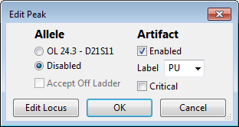

**Allele**

**The allele label and locus** – when selected, the peak is called as an allele and the allele label is present. If a peak lies in overlapping extended loci and the peak could belong to either locus, a selection for either locus is available, allowing the user to choose. (See Core/Extended/Interlocus Boundaries for a discussion of extended locus allele calling).

**Disabled** – when selected, the allele call is removed from the peak and from the table, and the allele call will not be exported.

**Accept Off Ladder** – when selected, the OL label is removed and the allele call is treated as a normal allele call. This change applies only to that single peak in that sample; it does not add that off-ladder allele to the accepted Off-Ladder Alleles table.

**Artifact**

**Enabled** – when selected, the artifact label will be displayed. Deselect to remove an artifact label.

**Label** – click the down arrowhead to display a drop-down list of defined artifact labels that can be selected for display, or create a one-time custom label by typing in the box. Note that only a single artifact label can be displayed. The user may decide to change the default artifact label in a case where a peak has multiple artifacts, such as both pull-up and stutter. This can also be used to create peak labels unrelated to artifacts, such as “male.” If a peak has multiple artifacts, the default label displayed is determined by the artifact label priority list in the Artifact Label Setup.

**Critical** – when selected, the artifact is critical and may require acceptance or review for OSIRIS to indicate that the sample no longer requires attention. Accepting artifacts is more efficient than marking them non-critical.

**OK** and **Cancel** will accept or cancel the changes. The **Edit locus** button opens the Sample editing window with the locus selected.

## Locus and Sample Editing

The Sample editing window can be opened at any time by pressing Ctrl+G (Windows) or ⌘+G (Mac). This will open the Sample editing window “tiled” in a vertical split screen with the Graph window. The size of the two windows is controlled by the width of the Sample editing window. To change the width of both windows, drag the right edge of the Sample editing window wider or narrower and press Ctrl+G again.

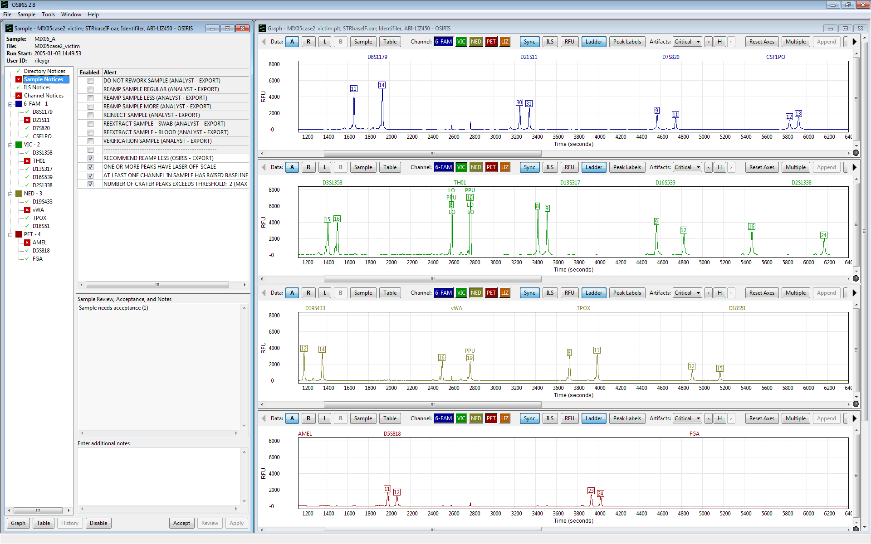

Users can also open the Sample editing window without tiling to fit the screen from:

* the Table view by selecting “Edit Directory Notices”, “Edit Notices and Notes” or “Accept Alerts” from the Table menu or by selecting any of the “needs acceptance” links that appear in the lower left pane of the Table view when the sample, ILS or channel are selected
* the Graph view by selecting “Edit Sample” from the Graph menu
* the Edit Peak window “Edit Locus” button

Pressing Ctrl+G when the Sample window is open will cause it to tile to fit the screen with the Graph window.

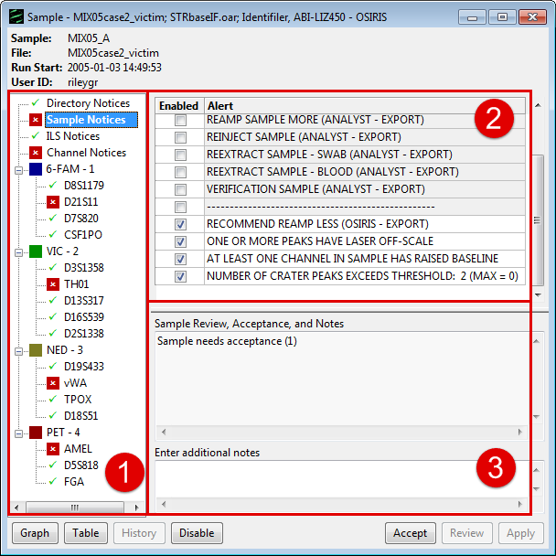The Sample window has a sample/locus tree (**1**), which allows the user to see which of the directory, Sample, ILS, channel, and loci still need attention, as indicated by the red X () or do not need attention, as indicated by the green checkmark (). Selecting entries with a red X allows the user to rapidly review the issues in the various loci, as well as at the Directory, Sample, ILS and Channel levels.

When Directory, Sample, ILS or Channel entries are selected in the tree, there will be two panes at the right: the alert pane (**2**) at the top, with quality notices, and the history pane (**3**) at the bottom, which shows the audit trail of editing, acceptance, review and notes entered by OSIRIS and the user. It also has a box at the bottom where the user may enter additional notes.

Double clicking a locus entry will zoom the graph widow to the locus selected. Double clicking Directory, Sample, ILS and Channel entries will zoom to display the entire graph.

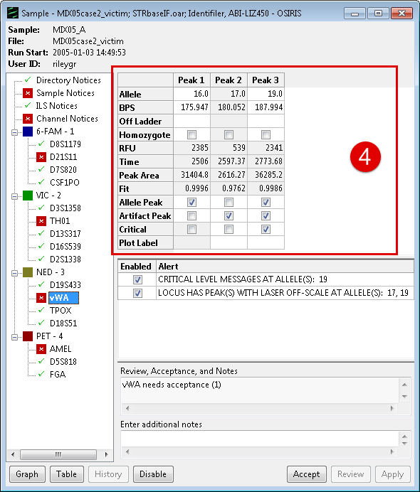When a locus entry is selected, a peak information pane (**4**) is displayed in addition to the alert and history panes. Information about editable peaks is displayed in the columns of this pane.

The **Graph** button displays the graph, if not already displayed, and zooms to the selected locus or zooms out if no locus is selected. Press Ctrl+G to Tile the Sample editing window with the Graph window to fill the screen.

The **Table** button displays the Table window.

The **History** button displays the history window

The **Accept** button is used to accept the alerts, notices and artifacts for the selected tree item.

The **Disable** button is used to set a sample to disabled. Disabled samples are omitted from CMF files created by OSIRIS. When creating user defined exports, disabled samples can be detected and processed accordingly.

The **Apply** button saves the changes made to the history. Edits and notes made in the sample window may be undone prior to selecting apply. Edits that have been applied or saved can be reverted by re-editing, but remain in the history audit trail.

The **Review** button opens the approval window so that a second user can approve the editing changes. (See Reviewing Editing and Analysis)

The user can choose to “Accept” notices at the Directory, Channel, Sample, *etc.* levels without disabling notices, including “Artifact” and “Critical” status Allele level notices. This will be reflected in the acceptability of the sample. If the user disables or edits any of the notices for a particular level (locus, sample ILS, etc.), the sample may then require Review as opposed to Acceptance.

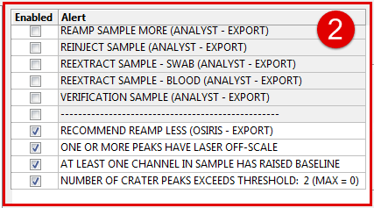

In the Alert pane (**2**), the user can enable, or disable any Directory, Sample, ILS, or Channel notices depending on the tree entry selected. In the example shown, the notices at the top, above the dashed line are analyst–selectable instructions that can be exported to a LIMS system to help automate the reanalysis of samples that need to be reworked. The notices below the dashed line are automated quality notices generated by OSIRIS.

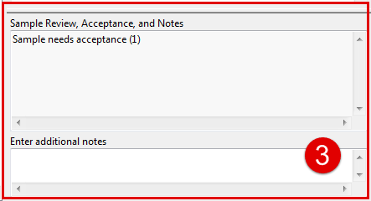

The history pane (**3**) contains an audit trail of edits, review and acceptance by users.

Entering notes in the “Enter additional notes” box may help explain the action taken for a later reviewer. Notes may be added at any time, as well as when a specific edit is made. The audit trail, including notes cannot be undone. Edits that have been applied or saved can be reverted by additional editing.

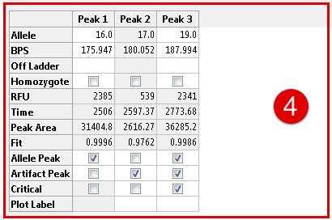

In the allele information pane (4), Homozygote, Allele Peak, Artifact Peak, and Critical checkboxes can be selected or deselected, and either “Off-ladder” or “Accepted” can be chosen from a dropdown list by clicking in the Off-ladder cell, as an alternative to editing peaks in the Peak Editing window. The Plot Label field will display the user-selected artifact label, if the default label has been changed. Clicking in the label box will show a dropdown list, from which a label can be selected. If both allele label and artifact label have been removed, either label may be added back here by checking the Allele Peak or Artifact Peak checkboxes.

## Reviewing Editing and Analysis

The Approve Editing window allows a subsequent user to review editing of the directory, locus, sample, channel, or ILS alerts performed by a previous user. The number of reviewers needed is indicated in the Lab Settings and includes the first person to perform the editing. This window can also be accessed through the sample review links displayed in the lower left pane in the Table view window when the sample, ILS, or channel is selected. The window that appears for reviewing the locus contains the history of the alerts, notices and notes for the locus as shown on the right.

When reviewing or approving editing, the user can approve, edit, or cancel. This is necessary if one or more users must review editing as indicated in the Lab Settings. Once the required number is obtained it is reflected in the Table view by the color of the cell or by the removal of an asterisk (*) after the sample name for sample level notices. When acceptance and review is complete at all levels (Sample, Channel, Locus, ILS, *etc.*) for a sample, the red cell containing an “X” changes to a green checkmark in the Table view. The default setting for approval does not allow the user to approve his or her own changes. This setting can be changed for evaluation or validation purposes. (See Configure Editing.)

## Disabling and Deleting Samples

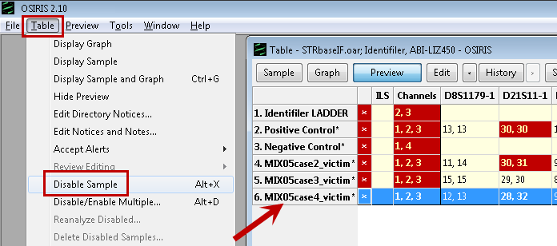Starting in version 2.10, if one or more samples was mistakenly included in an analysis, you may delete the sample(s) from the analysis without having to reanalyze. This preserves all the editing of the other samples. Samples are first disabled, then the disabled samples may be deleted.

To disable a sample, click the sample name in the Table to select the row. Then select Disable Sample from the Table menu. You may also disable a sample by pressing Alt-X or by right-clicking and selecting the option from the context menu. Multiple samples may be disabled at the same time by selecting Disable/Enable multiple from the Table menu or pressing Alt-D and selecting samples from the list with shift- or control-click of the mouse. If samples are inadvertently disabled, they may be selected and Enable chosen from the Table menu, or by pressing Alt-X again. To enable multiple disabled samples, select Disable/Enable multiple, select Enable from the dropdown list and choose the disabled samples to enable.

Delete the disabled sample from the analysis by selecting Delete disabled samples from the Table menu. Note: deleting a sample from the edited report .oer file of the analysis is permanent and cannot be undone. Sample deletion will not delete .fsa/.hid files and will not delete samples from the .oar file. If a sample is mistakenly deleted, the user can restart by opening the .oar file, which contains the unchanged original analysis, and redo the editing. A deleted sample can be reanalyzed separately by copying the sample and ladder/control .fsa/hid files to a different directory.

Sample deletion is indicated in the History audit trail as the number of samples deleted. Sample names are not included in the audit trail to preserve confidentiality. The original analysis (minus deleted samples) can be accessed in the edited .oer file using the History function. If the deleted samples contain confidential information that may not be shared, the analysis can be shared by including only the appropriate edited .oer, .plt, and .fsa/.hid files. This can be done automatically, reducing the possibility of error, by creating an OSIRIS Archive. See Sharing Your Data below.

# Sharing Your Data

Users may need to share their analysis data for the purposes of legal discovery, clinical review, sharing research, or troubleshooting. In version 2.10, an archive can be created and be sent to another OSIRIS user who can "Extract Analysis Archive" and view the analysis. This can be used for sending evidence to another party or for user support from NCBI.

## C:\Users\rileygr\AppData\Local\Temp\1\SNAGHTML3e893692.PNGCreating an Archive

To create an archive, complete the analysis on a folder, including deleting any samples that should not be in the analysis. Samples deleted from an analysis and their associated .fsa/.hid files are automatically not included when creating an archive.

Open the analysis you want to archive. Select Create Analysis Archive from the File menu.

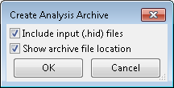Select the Include input files checkbox if you want to include the .fsa/.hid files in the archive. Select the Show file location checkbox to open the folder containing the archive after it is created. Note that if the .fsa/.hid files or their folder have been moved, OSIRIS will not find them. This message will then say “Cannot find input (.fsa/.hid) files.”

Select the folder where the archive will be saved and edit the archive File name, if desired. The archive will be saved with the OSIRIS Archive extension “.orz”.

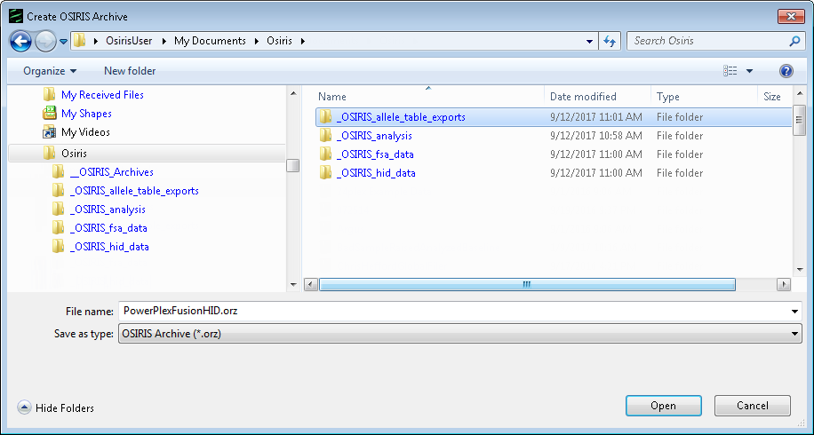

Archives may be sent to another OSIRIS user for review. OSIRIS Archives are a type of zip file. Some email systems may prevent sending or receiving certain types of file attachments. Check your email systems administrator regarding your e-mail security settings to determine how attachments are handled.

## C:\Users\rileygr\AppData\Local\Temp\1\SNAGHTML3f5aa7fe.PNGExtracting an Archive

Note that extracting Archive files requires OSIRIS version 2.10 or higher.

Save the archive in the folder where you want the extracted OSIRIS analysis to be. Select Extract Analysis Archive from the File menu.

Select the .orz archive you want to extract and click Open, or, simply double click the archive icon. Note that double clicking will open a new instance of OSIRIS.

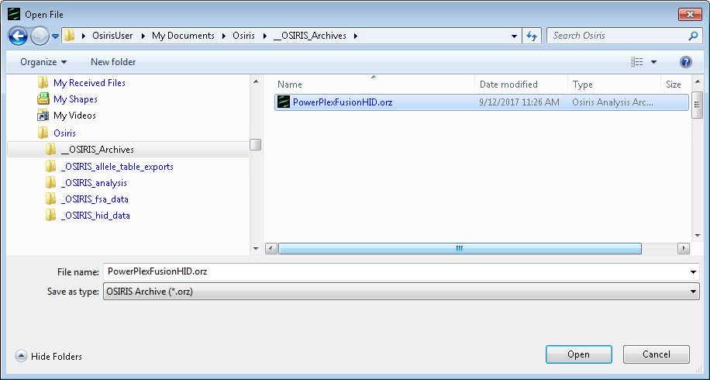

The user is prompted for the folder in which to extract the archive. The default location for the extracted analysis is a subfolder in the same location as the archive file. If .fsa/.hid files are included in the archive, they will be located in an /input folder. If no samples were deleted, the extracted archive contains an /output folder with the original analysis .oar file, the edited analysis .oer file, plot .plt files, and other files with information about the analysis and the parameters. If one or more samples have been deleted from the analysis, the extracted archive will not include the original analysis .oar, and any plot .plt and .fsa/.hid files associated with the deleted samples in order to maintain confidentiality and privacy. Open the edited .oer file if there is one. Otherwise, open the .oar file.

# OSIRIS Flexible Spreadsheet Export

OSIRIS version 2.13 and later contains a new export file named SpreadsheetUtils.xsl. which is allows many formats for tab delimited data export. With this flexibility comes an extensive list of options that this section explains. If more than one spreadsheet format is desired, the user use this file to create multiple exports with different options.

## Initial Setup

To set up the export, select Export File Settings from the Tools menu on the menu bar. When the following window appears, click on the button labeled “New”

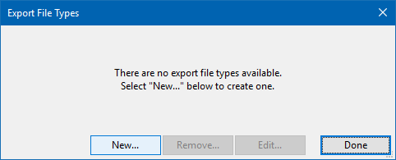

A window will appear prompting you to choose an XSL file. Open the Exports folder and select the file SpreadSheetUtils.xsl. The following window will appear:

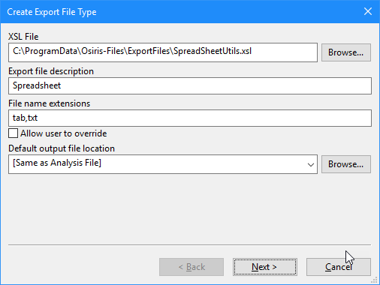

*If the SpreadSheetUtils.xsl file does not appear as above, copy the ExportsFiles folder, containing SpreadSheetUtils.xsl, to the site settings folder. To begin, select Show site settings folder… from the Tools menu on the menu bar. (If a folder is selected, double click it to open.)*

*For the Windows version of OSIRIS, find and open the Config folder in the OSIRIS installation folder. Copy the ExportsFiles folder to the site settings folder. To copy the file as opposed to moving it, hold down the Control or Ctrl key while dragging the file.*

*On the Macintosh version of OSIRIS, open the original OSIRIS distribution (.dmg file) and drag the OsirisXSL folder to this site settings folder if a folder of that name does not exist. If the XSL folder exists, open the OsirisXSL folders in the distribution and in the site settings folders and then copy (drag and drop) the file SpreadSheetUtils.xsl from the distribution to the site settings.*

The first item in the window is the name of the “XSL file”. Immediately below is the “Export file description.” This is the label that will appear on the File menu on menu bar when selecting an export. For example, if you keep the label “Spreadsheet” the File menu will display it as shown below:  
  
  
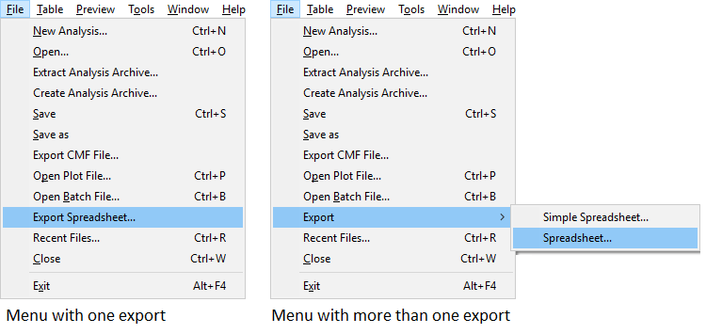

Below the description is a list of file extensions to use when saving the file. If the checkbox labeled Allow user to override is checked, the user can save the file with any name or file extension.  
  
The default file location can be a directory which can be chosen by the Browse… button, or one of two selections: [Same as Analysis File] and [Remember Last Location]. When saving the exported file, this is used as the default but the user can save the file anywhere.  
  
Once all of these setting are selected, click on the button labeled Next to configure a list of parameters defined in the export file, SpreadSheetUtils.xsl.

## Export Parameters

The parameters for this export appear in alphabetical order when configuring the export as well as when exporting OSIRIS data. For this reason, each parameter is prefixed with p followed by a 2 digit number in order to control the order they are displayed. Following is the initial window followed by an explanation of each parameter:

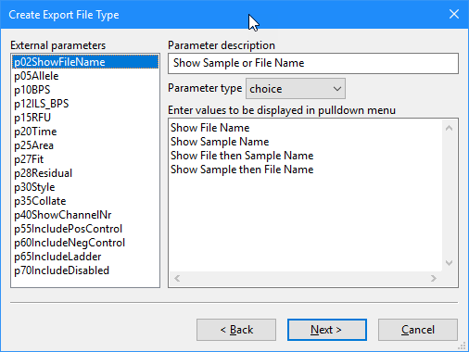

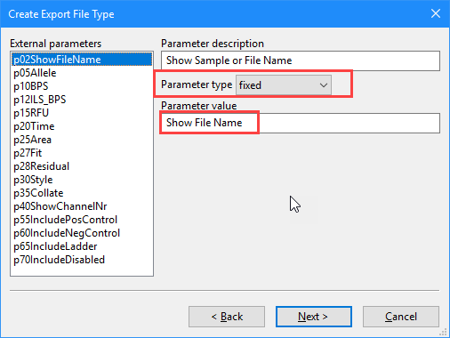p02ShowFileName

This parameter is used to determine whether to display the file name or sample name in the output file from the original .fsa or .hid file. Using the default setting, the user can select either or both from the list shown above. This option can be modified, for example, if it is never desired to display both, the last two options above should be removed. If it is desired to always use the same option, select Fixed from the pulldown menu with the label Parameter type and in the text box that appears, enter the desired option. For example, if you will always want to display the file name in the output file, enter the text “Show File Name” as shown here:

The following parameters allow you to determine which data types (parameters) should be exported and in which order.

p05Allele, p10BPS, p12ILS_BPS, p20Time, p25Area, p27Fit, p28Residual

These are the allele parameters and can be displayed for each allele in each locus. If the parameter should be always omitted from the output file, set the Parameter type to fixed and leave the Parameter value empty. If the parameter should always be included in the output file, set the Parameter type to fixed and the Parameter value to a positive integer. The left to right order of the selected parameters in the exported table is determined by the integer values from smallest to largest. The default setting, a blank and values 1 through 9, allows the user to select whether or not each parameter is included and the order to be selected when the exported file is created using a pulldown menu. This provides a lot of flexibility, however setting the order each time an export file is created may be cumbersome if the same export format will be used frequently. If the order should always be the same but inclusion of the parameters should be selectable when creating the output file, each parameter should have the Parameter type set to Checkbox with the single Parameter value giving the column number, as shown below:

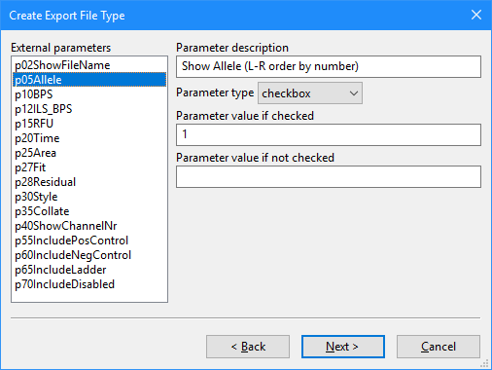For these allele parameters, when selecting checkbox for the Parameter type, a positive integer should be entered for Parameter value if checked and the box labeled Parameter value if not checked should be empty. As noted above, the left to right column order of the allele parameters is determined by the integer value used when the item is checked. If checkboxes are used for the allele parameters, it is recommended to remove “(L-R order by number)” in the box labeled Parameter description. The Parameter description is the text displayed adjacent to the check box in the export file creation window.

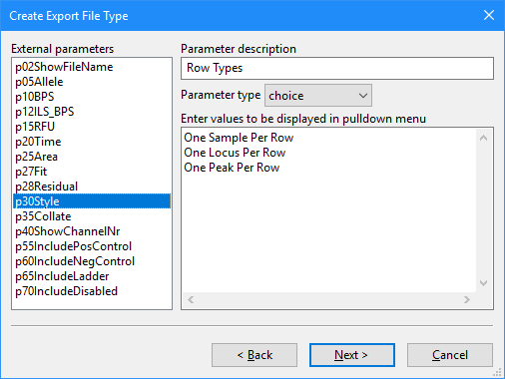p30Style

This parameter determines what data will appear in each row of the export spreadsheet. The available values are as follows:  
  
One sample Per Row: Each row of the output file contains all allele data for all loci for one sample.  
One Locus Per Row: For each sample, there is one row per locus and all allele data for that locus is in the rows.  
One Peak Per Row: For each sample, there is a row for each allele in each locus. For example, if the sample is male, the AMEL locus will have two rows, one for the X allele and one for the Y allele.   
If the same style will be used for every export, select Fixed for the Parameter type and set the Parameter value to one these three choices.

p35Collate

This parameter determines how to format the allele parameters. The choices are as follows:

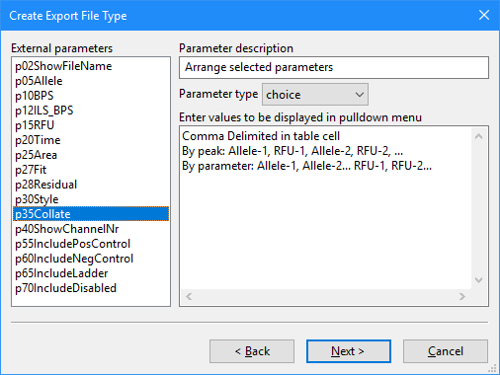 Comma Delimited in table cell: When using this option, the spreadsheet will have one column for each locus and allele parameter and all values for that locus will be in one table cell, separated by a comma.

By peak: Allele-1, RFU-1, Allele-2, RFU-2, ...: This option has a column for each peak and allele parameter and for any specific allele, all selected parameters be in adjacent ordered columns.

By parameter: Allele-1, Allele-2... RFU-1, RFU-2...: Like the previous option there is a column for each peak and allele parameter, but all data for a particular allele parameter is adjacent and followed by the next parameter (e.g., all the allele columns, then all the BPS columns, etc.). The last two collate formats are identical if the Style row format (described above) is set to One Peak Per Row. If the same option will always be used, it is recommended that the Parameter type is Fixed and the Parameter value set to one of the above values.

p40ShowChannelNumber  
If this parameter is set to a positive integer, when a locus name is displayed it will be followed by a hyphen and the channel number. The value should be 0 or empty when this is not desired and 1 otherwise. The Parameter type should be set to checkbox to make this optional when export file is created or Fixed otherwise.

The following parameters determine which sample types to include or omit in the export spreadsheet. Each should have the Parameter type set to fixed or checkbox and the Parameter values are 0 or 1 for omission and inclusion, respectively.  
  
p55IncludePosControl: Positive controls

p60IncludeNegControl: Negative controls

p65IncludeLadder: Ladder samples, **this exports** **many alleles**.

p70IncludeDisabled: Samples disabled by the user in OSIRIS.

## **Example**:

The image on the right illustrates an example of the setup where each parameter is set as a Choice or Checkbox. This window appears when the user chooses to create an export from an analysis. Any parameter set to fixed would not be displayed in this window.

For further customization, please contact the OSIRIS team at forensics@ncbi.nlm.nih.gov.

# Export Setup Tutorial

Following are two tutorials with instructions on implementing the two previous XSLT export file types supplied with OSIRIS. This section does not cover all of the details of the XSLT export feature, nor does it require any knowledge of the XSLT language. If you wish to modify these two XSLT files, it is strongly recommended that you first copy them to another location because they may otherwise be replaced if a newer version of OSIRIS is installed.

Exporting Spreadsheets

This tutorial contains instructions to implement the export of a tab delimited file containing the sample allele information from an OSIRIS analysis file that can later be opened from a spreadsheet application. First select Export File Settings from the Tools menu on the menu bar. When the pop-up window appears, select the button labeled “New…” and a dialog window will appear, prompting the user to choose an XSLT file. In the Windows version, find the “Config” folder in the OSIRIS installation and select the file: “tab.xsl.” In the Macintosh version, find the “OsirisXSL” folder in the directory containing the OSIRIS application and choose “tab.xsl.”

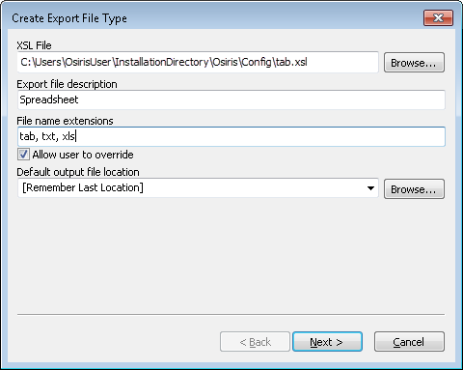Under the heading “Export File Description” enter the word “Spreadsheet” (or change to desired name). This description is used in the menu option that will be created in the File menu on the menu bar and will follow the word “Export,” *i.e.*, there will be an option in the File menu displayed as “Export Spreadsheet.” For the file name extensions, enter “tab, txt” (or other such as xls) to specify that the output files will have an extension of “.tab” or “.txt.” The box labeled “Allow user to override” is used to determine if the user can use a file extension other than that specified above when exporting a file. For the default output file location, the user can select “[Same as Analysis File], [Remember Last Location], or enter the full path of the default folder where the exported file should be saved. For now, select “[Remember Last Location].” Click the “Next >” button and the following will appear.

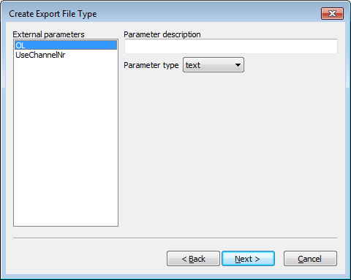The selected XSL file, tab.xsl, has two top-level parameters named “OL,” and “UseChannelNr.” They are configured as follows:

Select “OL” on the left, and under “Parameter description” enter “Indicate off-ladder alleles” and select “checkbox” for the “Parameter type.” Two text boxes will appear. For the first one labeled “Parameter value if checked,” enter the number 1. For the other, labeled, “Parameter value if unchecked” enter the number 0.

Select “UseChannelNr” from the list on the left. Under “Parameter description” enter “Indicate channel numbers in column headings.” For parameter type, as above, select “checkbox” and once again the two text boxes will appear. Enter 1 and 0 as described above.

Click the “Next >” button. At the top of the window is a checkbox. Make sure that it is not checked and click on the “Finish” button. The dialog for “Export File Types” will still appear. Click on “Done.” This export type has now been implemented. When an analysis file is open, this export option labeled “Export spreadsheet” will appear on the “File” pull down menu on the menu bar (as indicated below) or in a sub-menu labeled “Export” if more than one export type has been implemented.

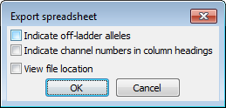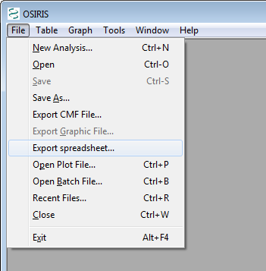Next, with an analysis file displayed, select “Export Spreadsheet…” from the “File” menu. A dialog window will appear prompting you to select the name of the file to be exported. After that is entered, a new dialog window will appear with the parameters as they were configured. This is shown on the right. The first two check boxes are for the parameters and the third checkbox labeled “View file location” is used if user wishes to open displaying the folder containing the output file. Upon pressing “OK” the export file will be created.

Extracting Samples

The other export type supplied with OSIRIS is the ability to export a new analysis file with only specific samples selected by the user. For example this would allow a laboratory to create an analysis file for a report or a discovery package that contains only samples that pertain to a specific case. It is assumed that the previous tutorial was implemented and therefore these instructions will be brief.

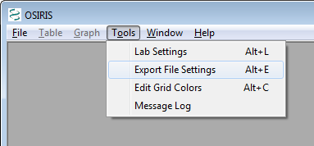First, select “Export File Settings” from the “Tools” menu on the menu bar. When the file selection dialog appears, choose the file: “extractSamples.xsl.” When the next dialog window appears, enter “selected samples” under “Export File Description” and enter “oer” under “File Name Extensions.” Do not check the box labeled “Allow user to override” and for “Default Output File Location” select “[Same as Analysis File]”**\***

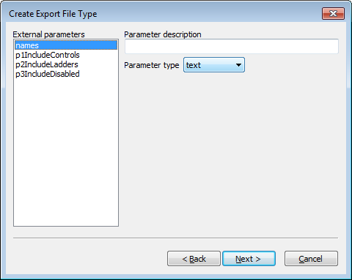Select “names” under “External parameters” and under “Parameter description” enter “Enter part or whole names of samples to export separated by commas.” Selected each of the other three parameters and for each select “checkbox” for the “Parameter type” and enter 1 and 0 for “Parameter value if checked” and “Parameter value if not checked,” respectively. Use the following table for the text to enter under “Parameter description” for each parameter:

|  |  |
| --- | --- |
| **External parameters** | **Parameter Description** |
| p1IncludeControls | Include positive and negative controls |
| p2IncludeLadders | Include ladder files |
| p3IncludeDisabled | Include disabled samples |

Click on the “Next >” button. In the next window, make sure the checkbox at the top this section is unchecked, and click on the “Finish” button. Then click “Done” on the “Export File Types” dialog window. Following are instructions for exporting two samples from the analysis file STRbaseIF.oar created from the tutorial section of this guide.

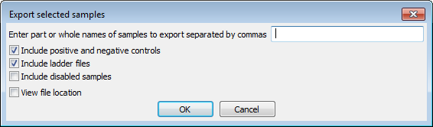Open the file STRbaseIF.oar. The easiest way to find it is to select “Recent Files…” from the “File” menu, find it in the list and select “OK”. Next, select “Export” then “selected samples…” from the “File” menu. A dialog window will appear prompting for a file name for the exported file. Enter a file name in the pre-selected folder and press the “Save” button. A new dialog window will appear as follows:

The first two checkboxes are selected by default because that represents the default value for the corresponding parameters in the XSLT file. In the text box at the top, enter “case1,case2” for the samples whose names contain “case1” or “case2.” Next, select the checkbox labeled “View file location” and click on the “OK” button. A window will appear with the folder containing the new export file. If you are using the Windows TM version of OSIRIS, drag the new file to the OSIRIS window to view. For the Macintosh TM version, double-click the file to open it. The new file should contain everything found in STRbaseIF.oar except for MIX05case3_victim and MIX05case4_victim because they were not specified.

|  |
| --- |
| **\***Since the output files being exported are analysis files with the .oer extension, they are intended to be opened with OSIRIS and should be in the same folder as the original analysis file because they will depend on the plot (.plt) files in the same folder. |

# OSIRIS Artifact Handling

OSIRIS mathematically fits curves to the raw data and then correlates those curves to peak and artifact signatures. This is discussed in detail in the following publication: *Goor RM, Forman Neall L, Hoffman D, Sherry ST., "A Mathematical Approach to the Analysis of Multiplex DNA Profiles." Bull Math Biol. 2010 Nov 20. [Epub ahead of print].* It is important to note that while OSIRIS is extremely proficient at fitting high quality DNA profiles, OSIRIS may have difficulty fitting or analyzing really poor quality data. In this case, OSIRIS will identify artifacts, but may not always be able to determine which specific artifact is occurring. The following information provides a guide to the user about how OSIRIS identifies and handles certain artifacts.

**Critical artifact**. Critical artifacts are conditions based on user-defined and OSIRIS software parameters that require human intervention. The user may choose to accept, edit, or rework the sample. Loci with critical artifacts are designated in the table as colored cells. Critical artifacts are visible in the preview graph and Graph view (as ‘A’ markers) if they are associated with a specific peak and either ‘Critical’ or ‘All’ Artifacts is selected. Artifact details appear when the cursor is hovered over the “A” marker. Critical artifacts that are not associated with a specific peak such as heterozygote imbalance and locus drop out display in the lower right-hand notification pane of the Table view.

Important: Notification of critical artifacts in a DNA profile does not necessarily indicate that data is invalid or unusable. The user must decide whether to accept, edit, or rework a sample profile based on laboratory protocols.

Non-critical artifact. Artifacts that are determined to not be significant based on user-defined parameters. For example, these include peaks below various user-set thresholds such as detection, stutter, adenylation, fractional filter, etc.; or that otherwise do not have an impact on profile quality. These artifacts do not trigger artifact notices, therefore they do not require human intervention. By default, non-critical artifacts are not visible in the table and are not visible in the preview graph. To view non-critical artifacts in the preview graph or Graph view, select “All” Artifacts from the menu or toolbar to mark the non-critical artifacts with an "A".

Non-critical artifacts include “restricted priority” artifacts such as peak height below minimum RFU or peak height below fractional filter. A “restricted priority” artifact forces the overall artifact level to be non-critical, regardless of any other artifacts that would normally result in the peak being designated as critical. By default, restricted priority peaks are not editable. However, there are “restricted priority” settings in the Sample Limits tab of the Lab Settings that allow restricted priority peaks both above and below minimum RFU to be edited.

**Noise Estimation.** Noise intrudes on the raw data signal from two sources. The first is so-called “shot noise” – the noise that arises from the various electronic and optical components that make up the electrophoresis system. The second source of noise arises from low level non-specific amplified DNA fragments, which typically appear as artifacts, addressed below. OSIRIS makes an estimate of the ‘shot noise’ toward the end of the electrophoresis run, when all of the DNA fragments have already run through the capillary. The noise estimate is an important to several OSIRIS analysis processes.

The OSIRIS algorithm for estimating the electronic noise is to start at the last 25 values of the raw data, and to perform a linear regression of that data, seeking the best linear fit. The algorithm stores the absolute value of the slope of that fit, together with the difference between the maximum raw data value in the interval and the minimum raw data value – the peak-to-trough maximum. The algorithm then tests the next seven 25-value intervals moving in time to the left, looking for the interval with the lowest value for the (absolute) slope, i.e. the flattest region. The peak-to-trough maximum for the interval that has the least slope is saved as the estimated noise for the channel. The average value for that interval is saved and used as the fixed offset for the channel. The fixed offset is subsequently subtracted from every raw data value in the channel and serves as a static baseline correction when dynamic normalization is not selected. Dynamic normalization involves computing a dynamically changing baseline and is discussed in the section on dynamic normalization.

Ladder/sample matching. If more than one ladder is included in the analysis directory, OSIRIS compares the spacing of the ILS of each ladder to the ILS spacing of each sample and uses the ladder with the best match for each individual sample. Should a ladder have critical artifacts, each associated sample will have a notice to alert the user. Click the Parameters button on the toolbar to view the ladder associated with a sample in the “Analysis Parameters” window.

Missing ILS peaks. If ILS peaks are missing, e.g. peaks below the analysis threshold, the sample analysis will fail and trigger an “ILS Contains Too Few Peaks” artifact notice. If the ILS is marginal (ILS peak spacing fit is less than 0.999), which can occur if there are artifact peaks in the ILS near the primer peaks, OSIRIS may analyze the sample but trigger a notification. Allele calls in a sample with marginal ILS may not be robust and should be evaluated with care by the user. If the ILS has artifacts that prevent its analysis, it will trigger an “ILS Could Not Be Analyzed” artifact notice. If no ladder has a usable ILS, the analysis will fail. A failed analysis can be opened to view the issues that caused the ladders to fail, which may allow reanalysis with parameters that will allow the ladders to analyze, such as lowering the ILS or ladder RFU thresholds.

**Peak tail fitting sensitivity** technical details. The curve-fitting algorithm basically focuses on the center of the peak. It narrows its fit to the part of the curve that is above a certain percentage of the peak height, which occurs at the mode, or center, of the curve, and to tail slopes above a certain percentage of the maximum peak slope, which occurs roughly halfway up the curve. The region of fit is determined by whichever of these two constraints occurs first. These percentages are part of the standard settings and may not be changed. Using 100% for the Percent of Standard Tail Height Threshold and Percent of Standard Tail Slope Threshold parameters below causes OSIRIS to use the default percentages. The effective percentages can be altered by changing those settings.

Excess residual. The “Excess residual” artifact occurs when the peak residual is greater than the “Max. residual for allele” value set by the user in the lab settings. It is caused by sample peaks not aligning exactly with the comparison ladder peaks. The “residual” is OSIRIS’s measure of what fraction of a base pair the calculated sample peak center is away from the ladder allele peak center. A residual of -0.098 means the peak is shifted 98/1000s base pair to the left of the ladder allele. Positive residual indicates a shift to the right.

OSIRIS analysis typically produces very small residuals because OSIRIS fits the best ladder ILS for each sample as described above. We suggest that the user start with the default setting of 0.25 base pair which typically does not result in excess residual. This creates a 0.5 base pair bin centered on the ladder peak, into which the sample peak must fall. To prevent misidentification of a microvariant, it is important that this setting not approach 0.5 base pair.

Pull-up and Spikes. Pull-up occurs when the color correction matrix is poorly matched to the data or when a peak’s signal intensity is outside the linear range of the matrix. Pull-up peaks are identified by OSIRIS as either “primary pull-up” – the overly high peak that OSIRIS determines to be causing the pull-up artifact in a neighboring channel, and the “pull-up” peaks in other channels which are caused by the primary peak. Pull-up can manifest in a wide variety of peak heights and analysis can be difficult, particularly in cases where a pull-up coincides with a real allele peak. The user should consider all aspects of all channels carefully if they intend to use allele calls produced from peaks that have pull-up.

Starting with OSIRIS version 2.9, pull-up is analyzed as a pattern rather than as individual peaks. If two peaks in the same channel have the same signal intensity, then those peaks will cause approximately the same amount of pull-up in other channels because the color correction matrix is applied the same to both peaks. Similarly, if one of the two peaks has a larger signal intensity than the other, it should cause more pull-up in other channels. OSIRIS uses this principle to detect patterns of pull-up in samples.

OSIRIS identifies two types of pull-up patterns: a pattern where the matrix is poorly matched to the data, and a pattern where the peak signal is saturated. Since both of those situations can occur in the same sample, OSIRIS is able to identify both patterns in a sample. OSIRIS depends on having enough peaks large enough to cause pull-up to identify a pattern. In samples where there are not enough of these peaks to generate a pattern, OSIRIS will default to analyzing pull-up on a peak-by peak basis as in previous versions. In the absence of a detected pattern, OSIRIS will label a comigrating peak as an uncertain pull-up. A sample peak information hover box message for a possible pull-up peak on channel 4 is: “Partial Pullup from Primary Channel (Uncertain Channels: 5)”. This means that the indicated channel 4 peak comigrates with a peak on channel 5, but there are too few channel 5 peaks that are tall enough to be primary pullup to generate a pattern.

This pattern-based pull-up analysis allows more robust artifact analysis, giving the user much more information about the pull-up peaks. OSIRIS estimates which channel is causing the pull-up, whether a part of an allele’s signal is due to pull-up from another channel, and the corrected RFU value for the peak if the pull-up RFU is subtracted. When determining whether a peak meets the Analysis threshold, OSIRIS uses the corrected RFU value to determine whether the peak would meet the threshold with the pull-up signal removed. The corrected RFU value is now available for use for testing Stutter and Adenylation thresholds, based on user specification in the Lab Settings. Hovering the cursor over a pull-up artifact label displays the pull-up information.

OSIRIS categorizes pull-up peaks into four categories: **pull-up** where the peak is calculated to consist entirely of pull-up signal, **partial pull-up** where the peak consists of both allele signal and pull-up signal (which can come from more than one channel), **uncertain pull-up** where a pull-up pattern cannot be determined, and **partial pull-up corrected below minimum RFU** where an allele peak with partial pull-up is calculated to have its allele signal height below the analytical threshold. Pull-up and partial pull-up corrected below minimum RFU are assigned non-critical artifacts. The others are critical or non-critical depending on user selections in the Lab Settings on the Sample Thresholds tab.

Two notable artifacts that are the result of pull-up are craters and sigmoids, or sigmoidal peaks. Both consist of two peaks, side-by-side. For craters, the two peaks are both positive and for sigmoids, one peak is positive and the other is negative. Even though OSIRIS detects negative peaks and uses them as part of its analysis of pullup, analyzed negative peaks are not displayed on either the preview or plot window. Therefore, to see a sigmoidal peak, users must turn on raw data when viewing a plot. Craters can result either from laser saturation or from negative pull-up (or pull-down) from a peak on another channel that coincides with an allele peak.

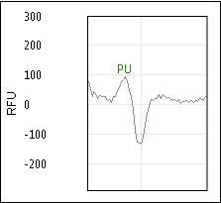

Sigmoidal peaks can result from pull-up between misaligned channels. In this case, application of the spectral color separation matrix can result in a signal that is partly positive and partly negative which we call a “sigmoidal peak”. The location of the peak is identified as the raw data zero crossing, between the positive and negative parts. OSIRIS identifies both types of artifacts as part of its cross-channel analysis algorithm.

In samples where the signal is very high and many peaks have saturated signal, analysis becomes very difficult and OSIRIS’S estimates may be less accurate. This is especially true when craters (split peaks) are involved because estimates of the true height of a crater peak are difficult to validate. If used, such samples should be interpreted with caution. Because pull-up is a complex phenomenon, OSIRIS’s estimates of which channel is causing the pull-up and the corrected RFU values should be used judiciously.

Some kits have markers with alleles that comigrate in different channels. In this case, a peak may contain both allele signal and pull-up signal. When a peak contains both signals, OSIRIS will trigger a “Partial Pullup” notice that comigrating-allele peaks consist of both allele signal and pull-up signal, possibly requiring human review, depending on whether the artifact is deemed to be critical or non-critical. The critical or noncritical priority of the “Partial Pullup” message, can be configured by the user in the lab settings interface with both “Make Pull-up at Allele Artifact Non-Critical” and “Make Laser Off-Scale Artifacts Non-Critical” settings. In any case, the user always has the option to edit the peaks and their artifacts to make the best use of the data.

Since both spikes and pull-up are cross-channel artifacts, they share many characteristics that can cause OSIRIS to alternatively identify a spike as a pull-up. But, spikes arise from a different set of conditions from standard pull-up and are therefore not included in the pull-up pattern analysis described above. However, spikes will trigger an artifact notice in either case.

Signal saturation. This occurs when the signal intensity saturates the CCD camera and the recorded signal intensity cannot increase further, which can cause a number of different artifacts. This will trigger a “Laser Off-Scale” artifact, which is used in calculating other artifact notices.

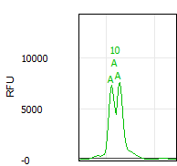Craters. A “crater” or “split peak” occurs when the primary peak signal is saturated and the pull-up peaks are so high that the matrix subtraction causes the center of the primary peak to pull down into a valley, as shown at right. OSIRIS tries to identify craters by finding closely spaced peaks that could be the edge of a crater, calculating the theoretical center of the possible cratered peak and comparing it to comigrating peaks in the other channels. When the data matches the crater signature, it will identify the side peaks as possible crater side peaks and will assign an estimated peak call to the calculated theoretical crater peak, which usually lies about midway between the side peaks. While this estimated peak is usually correct, this estimated allele call should be evaluated with care, as this is OSIRIS’s estimation of what the allele peak would be, not an actual allele peak. Craters trigger locus notifications and artifact markers on the crater peak edges and center.

Off-ladder alleles. Alleles that are apparent microvariants, or are higher or lower than the ladder alleles at each locus, are marked “**OL**” with the calculated allele call, such as **OL12.1**. Off-ladder alleles will trigger a critical LOCUS artifact notice. However, the peak itself will not be marked with an “A” on the sample graph unless the off-ladder allele also triggers a critical ALLELE artifact notice in *addition* to the off-ladder “OL”. Alleles designated as “accepted” by entry in the Assignments tab of the Lab Settings will not trigger an OL artifact.

Interlocus peaks. Interlocus peaks fall between the defined locus boundaries and trigger a critical artifact. OSIRIS will discriminate between interlocus pull-up peaks and genuine off-ladder interlocus peaks and trigger appropriate notifications.

Core locus peaks that also fall in an adjacent Extended locus. When a peak falls in the area covered by both the Core of one locus and an adjacent Extended locus, the peak will be flagged with an artifact. If the peak is on-ladder for one of the core alleles and does not have “excessive residual” in comparison to that matching core ladder allele, then the peak is flagged with a non-critical artifact. If the peak in question is off-ladder or has excessive residual in comparison to the core ladder alleles where it falls, it will be flagged with a critical artifact. Off-ladder alleles that have been designated as accepted in the Assignments tab of the Lab Settings will be treated the same as on-ladder alleles. The effect is to require review of alleles that are off-ladder or shifted in relation to the core allele, but not require review in the case that the allele is a good match for the core allele. OSIRIS allows the user to assign the peak to the adjacent (extended) locus on the basis of other information such as peak numbers and peak heights in either case.

Adenylation. (Non-critical artifact) OSIRIS will identify and filter peaks one base pair shorter than the allele (N-1) with a peak height below the user-set adenylation threshold. Minus-A “Adenylation peaks” above that threshold will be called as an off-ladder allele and trigger a locus artifact notice. Minus-A peaks that fall above the adenylation threshold can be detected using the heterozygous peak imbalance threshold.

Raised baseline. Before analysis, OSIRIS assesses the baselines at the right end of the plot of each channel and normalizes them so that they are zero. However, it is still possible for there to remain raised baselines to the left or center of the plot. If this occurs, OSIRIS may fit curves to smaller deviations in the plot data than when the baseline is at a normal level because OSIRIS fits the analyzed data to a baseline which is expected to be zero. This can result in small peaks that appear larger in the analyzed data than they are in relation to the elevated baseline in the raw data, minor peaks that are broader in the analyzed data than in the raw data, and minor analyzed data peaks that are fitted to small deviations in the raw baseline. This does not occur to a significant extent in high quality data, and rarely is significant enough to trigger the critical artifact notice “Channel Has Raised Baseline”. When raised baseline artifact notices occur, it can be informative to view the raw data (if not viewed simultaneously) to evaluate the baseline quality. When OSIRIS fits the analyzed data to the raw data, it tests each “peak” to determine whether the curve or a straight line has a better fit. If the straight line is a better fit, the fitted line is tested to determine if it lies above the “Raised Baseline Threshold”, set on the “Sample Thresholds” tab of the lab settings user interface. There are two different values that can be set, the threshold that will apply to sample data channels and the threshold that will apply to ILS data. If a fitted straight line exceeds its designated threshold, then a critical “Raised Baseline” artifact will be triggered, requiring human attention.

**Dynamic Baseline Normalization.** Dynamic baseline normalization eliminates many of the artifacts associated with raised baseline by calculating the dynamic baseline from the raw data and subtracting that from the raw data to give normalized raw data. (See Appendix H. Dynamic Baseline Analysis)

**Baseline Relative messages.** When the “Test Adjusted Signal Heights Relative To Baseline (Overridden by below)” parameter is selected, and, the “Normalize Raw Data Relative To Baseline (Overrides above)” parameter is deselected, a peak that is above the analysis threshold without baseline corrected RFU but below the analysis threshold *with* baseline corrected RFU will trigger a critical “Baseline Relative Below Minimum Analysis RFU” message to indicate that the peak would have been below threshold with the correction, but not without. Similarly, with the above parameter selections, peaks whose baseline corrected RFU falls within the stutter criteria will trigger a critical “Baseline Relative Stutter” artifact and peaks whose baseline corrected RFU falls within the adenylation criteria will trigger a critical “Baseline Relative Adenylation” artifact.

Excessive noise. When OSIRIS fits the analyzed data to the raw data, it is possible that a sequence of data points cannot be fitted with acceptable accuracy as either a data peak or as a known artifact. If the sequence of data has sufficient height, OSIRIS will trigger a critical “Excessive Noise” notification on the channel. The notification does not localize the excessive noise detected, so the user should evaluate the profile carefully; it can be informative to evaluate the raw data to ensure that curves in the raw data are identified. The user can choose to test above the analytical threshold or between the analytical and the detection thresholds, by checking a box labeled “Test for Presence of Excessive Noise Above Analysis Threshold (checked) or below (unchecked)”. This test, which applies to all sample channels, can be disabled on the “Sample Thresholds” tab of the lab settings user interface by clearing the “Enable Test for Excessive Noise” checkbox.

Low copy number. OSIRIS should be carefully validated if a laboratory is intending to use it for identification and quality control of peaks below approximately 50 RFU. OSIRIS is configured to allow a Min. Analysis Threshold setting of 5 RFU. Note that elevated baselines will have a more significant effect on peaks with low RFU.

Peak shape. If peak shape does not fit the double-Gaussian peak signature well, it triggers an artifact notice. Peak shape fit data can be viewed in the allele hover box, but not in the artifact hover box. Peak fit less than 0.99 may indicate data quality issues. The minimum accepted fit is 0.98. Critical artifacts at a specific peak will trigger a “Critical Level Messages At Allele(s):” notification in lower right notification pane of the Table view, in addition to the ‘A’ marker at the peak.

Stutter. (Non-critical artifact) OSIRIS will identify and optionally filter peaks that fit the stutter artifact signature. OSIRIS determines whether peaks fall below standard stutter thresholds set by the user for both minus stutter (N ‑ 1 repeat, also referred to as “back” stutter) and plus stutter (N + 1 repeat, also referred to as “forward” or “positive” stutter). Both can be set as a default for all loci or individually on a per locus basis. If both the default value and a locus value are set, the locus value will override the default.

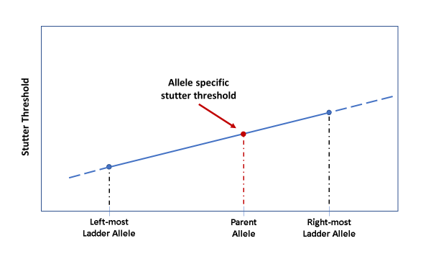As of Version 2.11, a new locus-specific option, allele‑specific stutter thresholds, exists for both standard minus stutter and plus stutter. The user can set a stutter threshold for the left-most ladder allele of a locus and a second (larger) threshold for the right-most ladder allele of the locus. OSIRIS will then compute the stutter threshold for an allele based on straight line interpolation, for core ladder alleles, and extrapolation, for extended locus alleles. The line is determined from the first stutter threshold at the left-most ladder allele for the locus and the second threshold at the right-most ladder allele for the locus. (See Core/Extended/Interlocus Boundaries for definition of core ladder and extended locus). This linear formula for calculating allele-specific stutter thresholds has been found to give a more accurate threshold estimate than the constant stutter threshold available as the only option in previous OSIRIS versions.[2] The allele-specific threshold must be input separately with locus-specific coefficients for each locus that will use this option. Any combination of stutter threshold options – default constant threshold, locus-specific constant threshold, or allele-specific thresholds within a locus - across loci are acceptable to OSIRIS.

Plus stutter occurs very infrequently in most loci. A few loci have a higher occurrence and are also subject to bracket stutter, where additive plus and minus stutter between alleles separated by two repeats (i.e., between 10 and 12) result in a higher than normal stutter peak between them. The plus stutter threshold may help to address both situations. When bracket stutter occurs, e.g., the 11 peak between 10 and 12 alleles, OSIRIS will use the sum of the plus and minus stutter peak proportions to determine whether the bracket peak is stutter. For example, assume that the 10 allele is 1000 RFU and the 12 allele is 2000 RFU, with the minus stutter threshold set at 0.1 (10%) and the plus stutter threshold set at 0.02 (2%). The combined plus and minus stutter threshold to which the 11 peak would be compared would be 220 RFU ([0.1x2000]+[0.02x1000]). Labs should determine appropriate stutter threshold values for their system. Stutter peaks that fall above the stutter threshold can be detected using the heterozygous peak imbalance threshold.

Some loci have so-called non-standard stutter, that are not one repeat from the parent allele. Bracket stutter as described above may include a mix of standard and non-standard stutter peaks. Non-standard stutter thresholds can be specified as explained above in the Lab Settings Thresholds section.

Heterozygous peak imbalance. Peak height ratio that is lower than the minimum heterozygote balance threshold will trigger a “Heterozygous Imbalance Detected” artifact notice.

Heterozygous allele dropout/Homozygote peak too low. When a homozygote peak height falls below the user-defined minimum homozygote peak height threshold, then OSIRIS will trigger a “Single Peak Detected, Height Inappropriate for Homozygote” artifact notice. In that case, if there is also a peak in the locus whose height is below the analysis threshold, but above the detection threshold, then OSIRIS will trigger an additional “Locus Has Peaks Between Detection and Analysis Thresholds” artifact notice. If the homozygous peak is *above* the minimum homozygote peak height threshold and the locus contains a peak whose height is under the analysis threshold but over the detection threshold and that peak is not a known artifact (“stutter”, etc.), then only the latter message will be triggered.

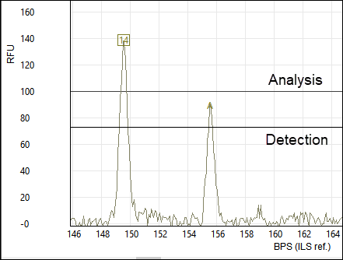

# Definitions

**Artifact**. Non-allelic signal. Allele peaks can coincide with artifact signals such as stutter and pull-up. See Artifact Handling section.

**BPS**. Locus base pair. The peak size in bases as compared to the base pair length of the ladder allele fragment. The locus base pair is highly reproducible. This size may not correlate exactly with the internal marker size measurement (ILS Ref), which is a measure of migration and can be affected by differences in sequence, dyes and length modifiers between the ladder and ILS fragments.

**Corr. RFU**. The estimated RFU value for a peak after it has been corrected for coinciding pull-up signal. Corrected RFU values can be lower when the coinciding pull-up signal is removed, or higher when compensated for coinciding negative pull-up (pull-down) signal.

**Fit**. A correlation between the analyzed data and the raw data, evaluated at peaks.

**Curve fit unacceptable** or **Curve fit marginal**. Peaks that have poor shape will have an artifact flag of either “Curve fit unacceptable” or “Curve fit marginal”.

**Peak** **area**. The area under the fitted analyzed DNA peak curves.

**Peak height**. Peak height is calculated from the fitted analyzed DNA peak curves. See RFU and Corr. RFU.

**Peak width**. Peak width is calculated at half height of the fitted analyzed DNA peak curves.

**RFU**. Relative fluorescence units. A relative measure the intensity of DNA signal intensity. RFU is calculated from the fitted analyzed DNA peak curves to give the peak heights.

**Residual**. Residual is a measure of sample peak shift from the center of an allele as calculated using the best comparison ladder.

**Residual displacement.** This is a measure of the degree to which peaks within a locus migrate together. For a given peak, it is computed as the difference between the residual of that peak and the residual of the tallest peak in the same locus.

**Critical level artifact:** An artifact that OSIRIS reports as requiring user attention and resolution (based on user specifications). Non-critical artifacts are reported for information only and require no action on the part of the user. Note: all locus/channel/sample/directory level artifacts are critical.

**Restricted priority**. A restricted priority peak flag overrides the priority of all other artifacts to cause the peak’s other artifact flags to be non-critical. Restricted priority peaks may not be edited unless the user has allowed it in the Lab Settings (see Restricted Priority Editing Options).

**Time**. This is the laser scan number. If a scan is performed once per second, then this value represents the run time, in seconds.

**ILS Ref**. Internal marker base pair. The relative base pair size in relation to the migration of the internal lane standard size marker. ILS Ref and BPS may not correlate exactly. See BPS.

**Primary pull-up.** This is a peak that causes pull-up in other channels.

**Partial pull-up.** This is a peak that comigrates with a primary pull-up peak in another channel. It is a genuine allele peak having a height that has been modified by pull-up signal, but whose corrected height is still above the analysis threshold.

**Core locus.** This is the range of alleles that includes the smallest allele and the largest allele in the locus ladder.

**Interlocus peak.** A peak that lies either between two core loci, or to the left of the first core locus in the channel, or to the right of the last core locus in the channel.

**Extended locus.** These are inter-locus peaks and that are defined as accepted possible alleles associated with the locus. These can arise either as “virtual” alleles from a set of bins and panels files or as known alleles referenced on STRBase which are defined in the Kit Definition Lab Settings, or as user definitions within OSIRIS on the Assignments tab of the Lab Settings. If Extend Loci To Neighboring Locus is selected in the lab settings, the extended loci will include the areas between loci and extend beyond the top and bottom of the ladder.

**Ambiguous extended locus allele.** An allele that lies within the overlapping extended locus of the loci to its right and left.

**Laser off-scale:** A peak that has been measured to have off-scale signal, that is, the signal saturates the charged coupled device (CCD) for measuring RFU fluorescence intensity. These peaks’ RFU heights are not proportional to the actual amount of DNA contributing to the signal.

**Low signal to noise in peak:** A situation in which the signal to noise ratio in the channel causes two or more fitted peaks in a locus to receive the same allele call.

**Poor morphology peak:** a peak having a low signal to noise ratio (see above) that is an ambiguous extended locus allele. This artifact is not in reference to the shape of the peak curve. Peaks that have poor shape will have an artifact flag of either “Curve fit unacceptable” or “Curve fit marginal”.

**Sigmoidal pull-up:** a pull-up peak that resembles a sine wave, with one node positive and the other negative, which occurs when the spectral matrix is applied to primary pull-up and pull-up signal that does not exactly coincide.

**Locus morphology:** the actual spacing of ladder alleles as compared to the ideal ladder allele spacing based on repeat base pair size.

# Appendices

## Appendix A. Program Elements

OSIRIS can be thought of as having four major elements: the compiled software that does the majority of the peak identification, curve fitting and measurements, the Message Book which applies quality assessment rules, the user interface and Operating Procedures that include the lab settings, and kit and ladder definitions.

### Compiled Software

Within OSIRIS, there is an important distinction between what is hard-coded and what is under user-control. Hard-coded measurements include such items as determining whether a signal height is above or below the user-specified minimum RFU. In all such threshold tests, even though hard-coded, the magnitude of the threshold itself is user-specified.

The conditions for peak identification are quite complex, however they involve the following elements: raw data RFU height, raw data RFU baseline level, changes in the slope of the baseline and curve fit. If the raw data rises to within about 10% of the detection threshold, OSIRIS will look for a change in the average slope of the data. Where OSIRIS finds a change in the slope of the raw baseline, it will begin curve fitting. Curve fitting involves comparison of the data to a straight line and various other curves to determine the best fit. When OSIRIS has found a curve that has an appropriate fit (>0.98) it applies other tests, including comparison to the threshold, to determine whether to continue analysis of the peak. The result is that OSIRIS will identify quite small peaks with fairly high accuracy. However, at very low detection or analysis thresholds, OSIRIS will sometimes ignore small peaks because of poor fit, or identify as small peaks deviations in the slope of the baseline because it matches an accepted fit.

When OSIRIS finds a data point above the Approximate Minimum Detection threshold (about Detection Threshold minus 10%), it checks to determine whether the baseline is falling. Under those circumstances it continues its peak identification algorithm. OSIRIS works from right to left on the dataset to identify peaks.

### Message Book

OSIRIS Version 2.0 introduced a MessageBook structure and software support to enable users to modify quality assessment rules and customize their own, new messages. In Version 2.xx, the major focus of user control is in this MessageBook configuration file, which is the repository for all of the new OSIRIS so-called “smart messages.”

The new smart messages for the OSIRIS program transfers the rule-based analysis from hard code to user control, at least to an extent that is consistent with ease of use. Because typical users are not programmers, the means to modify the smart messages must be transparent to subject matter experts without requiring computer tools expertise. We have tried to balance user control over sample diagnostics with ease of use.

In the Message Book, we have created an XML based language for expressing most of the rules to be used in analyzing multiplex DNA samples. The language is straightforward and broad in scope due to the liberal use of Boolean logic expressions for making decisions about whether a condition applies, whether to report the condition, and in what priority to apply the consequences. Smart messages are fully user-configurable. The value of being able to define new smart messages derived from the values or the data of other smart messages, is that, using these new messages, we are now able to build sophisticated interpretations of sample data, and we can customize the reporting of these interpretations.

As of version 2.3, the centralized \Osiris\Config\LadderSpecifications\MessageBook.xml file is the message book used for all analyses.

### Operating Procedures and Kit definitions

Operating Procedures are located in the Volumes subdirectory of the site folder. Their names and location can be found by clicking the folder icon button in the Lab Settings window.   
To zip a folder, Right click>Send to>Compressed (zipped) folder (Windows) or Control-click>Compress (Macintosh).

**Description**

Operating Procedures contain the marker set kit definition and the user’s lab settings. A pre-defined Operating Procedure for each supported kit or marker set is provided with OSIRIS. The predefined Operating Procedures are indicated by square brackets in the list in Lab Settings and cannot be modified. Users can create customized Operating Procedures using an existing Operating Procedure as a template. When performing an analysis, an Operating Procedure must be selected. Custom Operating Procedures created by the user are located in a new folder whose name begins with “V” followed by the date and time of creation. An Operating Procedure consists of four files whose names are prefixed with the folder name:

V-20110323-112549_access.txt

V-20110323-112549_LabSettings.xml

V-20110323-112549_MessageBookV4.0.xml

V-20110323-112549_StdSettings.xml

The _access.txt file is an administrative file that OSIRIS requires while processing. The _LabSettings.xml file contains the selected kit and customized settings and thresholds for the Operating Procedure. As of Version 2.3, the _MessageBookV4.0.xml file is no longer the active message book, but must still be present OSIRIS to function properly. The centralized \Osiris\Config\LadderSpecifications\MessageBook.xml file is the message book used for all analyses, removing the need to upgrade custom Operating Procedures when upgrading OSIRIS to a new version. The _StdSettings.xml file contains parameters governing curve fits and ILS and ladder locus spacing requirements. These values should not be changed. The Microsoft Windows TM version of OSIRIS stores the Operating Procedures in the site\Volumes folder in the OSIRIS installation folder. The Macintosh version of OSIRIS stores Operating Procedures in the Osiris-Files/Volumes folder which is either in the same folder as the OSIRIS application (parent folder of Osiris.app) or in the /Libraries folder if OSIRIS is installed in the /Applications folder. If OSIRIS is installed in the /Applications folder, it may be necessary to log in as administrator to set up and to change Operating Procedures.

Note that the /Volumes directory will not be created until the user creates a new Operating Procedure.

### Kit definitions

The elements of the kit definition found in several files. The ladder information file contains the list of ladder loci and ladder alleles, along with information that guides the ladder analysis algorithm in its search for ladder loci. The ladder information file also contains information specifying which ILS’s it accepts. The ILSandLadderInfo.xml file specifies the characteristics of each ILS, along with a list of ladders supported by OSIRIS. The lab settings options available to the user are stored in the lab settings file, residing either in a default or custom Operating Procedure. See Appendix G for instructions on defining new kits and additional information on each element.

#### **Elements Defined:**

ILS

Ladder

Positive Control allele values

Primer peaks

Minimum size setting

Alleles

Core locus

Extended locus

Interlocus

#### **Positive Controls Defined in Default Operating Procedures**

Common commercially available positive control allele values are defined in OSIRIS so that the positive control profile can be validated. This allows the user to select a predefined default positive control, as determined by the Positive Control strings on the File Names tab in the Lab Settings, rather than having to enter it as a custom Positive Control on the Assignments tab.

Beginning with Version 2.5, positive control alleles are stored in a centralized file to allow any of the defined positive controls to be used with any kit. The positive controls contained in Defined in OSIRIS are 9947A, 9948, K562, 2800M, and DNA007. For a standard positive control to be recognized, one of these names must be used in the Standard Control Name box found at the bottom of the Positive Control File Name Search Criteria on the File/Sample Names tab of the Lab Settings. If a locus is part of a marker set but is not defined in the table for the named positive control, a locus-level artifact message will be displayed saying that the positive control locus could not be found. This change has no impact on the specification or analysis of positive controls defined by the user on the “Assignments” tab of the lab settings.

OSIRIS determines which samples are positive controls and which control values to use for validation by looking for one of the positive control string names from the Positive Control strings on the File Names tab, then matching the found string against an internal table of all the predefined and custom positive control strings. If none of the predefined or custom positive strings are found, then OSIRIS validates using the default positive control that is entered in the “Standard Control Name” box of the “Positive Control” on the File Names tab of the Lab Settings.

**Positive Control Loci and Alleles**

| Locus 9947A 9948 K562 DNA007 2800M 3657 | | | | | | |
| --- | --- | --- | --- | --- | --- | --- |
| D3S1358 | 14,15 | 15,17 | 16 | 15,16 | 17,18 |  |
| D16S539 | 11,12 | 11 | 11,12 | 9,10 | 9,13 |  |
| AMEL | X | X,Y | X | X,Y | X,Y | X,Y |
| TH01 | 8,9.3 | 6,9.3 | 9.3 | 7,9.3 | 6,9.3 |  |
| TPOX | 8 | 8,9 | 8,9 | 8 | 11 |  |
| CSF1PO | 10,12 | 10,11,12 | 9,10 | 11,12 | 12 |  |
| D7S820 | 10,11 | 11 | 9,11 | 7,12 | 8,11 |  |
| vWA | 17,18 | 17 | 16 | 14,16 | 16,19 |  |
| FGA | 23,24 | 24,26 | 21,24 | 24,26 | 20,23 |  |
| D8S1179 | 13 | 12,13 | 12 | 12,13 | 14,15 |  |
| D21S11 | 30 | 29,30 | 29,30,31 | 28,31 | 29,31.2 |  |
| D18S51 | 15,19 | 15,18 | 15,16 | 12,15 | 16,18 |  |
| D5S818 | 11 | 11,13 | 11,12 | 11 | 12 |  |
| D13S317 | 11 | 11 | 8 | 11 | 9,11 |  |
| D2S1338 | 19,23 | 23 | 17 | 20,23 | 22,25 |  |
| D19S433 | 14,15 | 13,14 | 14,14.2 | 14,15 | 13,14 |  |
| D10S1248 | 13,15 | 12,15 |  | 12,15 | 13,15 |  |
| D22S1045 | 11,14 | 16,18 |  | 11,16 | 16 |  |
| D2S441 | 10,14 | 11,12 |  | 14,15 | 10,14 |  |
| D1S1656 | 18.3 | 14,17 |  | 13,16 | 12,13 |  |
| D12S391 | 18,20 | 18,24 | 23 | 18,19 | 18,23 |  |
| SE33 | 19,29.2 | 23.2,26.2 |  | 17,25.2 | 15,16 |  |
| Penta E | 12,13 | 11 | 5,14 |  | 7,14 |  |
| Penta D | 12 | 8,12 | 9,13 | 11,12 | 12,13 |  |
| D6S1043 | 12,18 | 12 |  |  | 12,20 |  |
| DYS391 |  | 10 |  | 11 | 10 |  |
| DYS576 |  | 16 |  | 19 | 18 |  |
| DYS570 |  | 18 |  | 17 | 17 |  |
| DYS389I |  | 13 |  | 13 | 14 |  |
| DYS439 |  | 12 |  | 12 | 12 |  |
| DYS389II |  | 31 |  | 29 | 31 |  |
| DYS438 |  | 11 |  | 12 | 9 |  |
| DYS437 |  | 15 |  | 15 | 14 |  |
| DYS19 |  | 14 |  | 15 | 14 |  |
| DYS392 |  | 13 |  | 13 | 13 |  |
| DYS393 |  | 13 |  | 13 | 13 |  |
| DYS390 |  | 24 |  | 24 | 24 |  |
| DYS385 a/b |  | 11,14 |  | 11,14 | 13,16 |  |
| DYS448 |  | 19 |  | 19 | 19 |  |
| DYS481 |  | 24 |  | 22 | 22 |  |
| DYS549 |  | 13 |  |  | 13 |  |
| DYS533 |  | 12 |  | 13 | 12 |  |
| DYS635 |  | 23 |  | 24 | 21 |  |
| DYS643 |  | 11 |  |  | 10 |  |
| DYS458 |  | 18 |  | 17 | 17 |  |
| DYS456 |  | 17 |  | 15 | 17 |  |
| Y-GATA-H4 |  | 12 |  | 13 | 11 |  |
| Yindel |  |  |  | 2 |  |  |
| DYS627 |  |  |  | 21 |  |  |
| DYS460 |  |  |  | 11 |  |  |
| DYS518 |  |  |  | 37 |  |  |
| DYS449 |  |  |  | 30 |  |  |
| DYF387S1 |  |  |  | 35,37 |  |  |
| QS1 | 1 | 1 | 1 | 1 | 1 |  |
| QS2 | 2 | 2 | 2 | 2 | 2 | 12 |
| DXS7132 | 12 | 13 | 13 |  |  | 13 |
| DXS7423 | 14,15 | 14 | 17 |  |  | 12 |
| DXS8378 | 10,11 | 11 | 10 |  |  | 7 |
| DXS10074 | 16,19 | 18 | 17 |  |  | 19 |
| DXS10079 | 20,23 | 19 | 17 |  |  | 29.2 |
| DXS10101 | 30,31 | 32 | 31 |  |  | 20 |
| DXS10103 | 17 | 18 | 17 |  |  | 34 |
| DXS10134 | 35,36 | 34 | 32 |  |  | 25 |
| DXS10135 | 21.1,27 | 22 | 27 |  |  | 27 |
| DXS10146 | 28 | 29 | 29 |  |  | 23.1 |
| DXS10148 | 22.1,23.1 | 23 | 23.1 |  |  | 13 |
| HPRTB | 14 | 14 | 13 |  |  |  |

The standard positive controls located in the Operating Procedure standard settings files are no longer read. The centralized file was created from a table of loci found in standard positive controls. Software to generate the centralized XML file from the allele table is included in the OSIRIS source repository.

#### **Core/Extended/Interlocus Boundaries**

The following diagram illustrates the concepts “Core locus”, “Extended locus” and the “Interlocus”. *It does not reflect the actual kit definition boundaries.* The core locus is bounded by the top and bottom ladder alleles as can be seen in all three loci. The extended locus extends to the right and left of the core locus. It may overlap the adjacent extended locus as seen to the right of D13S317 *and* the core of the adjacent locus as seen to the left of D16S539. The extended locus *may not* extend beyond the core of an adjacent locus. The interlocus lies between the extended locus of two neighboring loci (e.g., white box between D16S539 and D2S1338) and above the top and below the bottom locus extended loci (e.g., to the right of D2S1338). The interlocus area beyond the leftmost locus in the channel is bounded by the base pair value in the user-defined “Ignore artifacts smaller than” setting in the “Thresholds” tab of the lab settings. The interlocus area beyond the rightmost locus in the channel is bounded by the kit-defined range of the analysis, or, optionally, by the parameter “Max ILS-BP For Extended Locus” on the Sample Limits tab (see below).



The interlocus area is analyzed by OSIRIS, to ensure that off-ladder alleles that fall outside of a defined locus cannot be ignored. However, alleles in the interlocus area will not be called and cannot be assigned to a locus by the user. Alleles that fall into the extended locus will be called as off-ladder alleles and can be edited.

OSIRIS will call alleles that fall into overlapping extended locus as off-ladder and where possible, assign them to the locus that makes the most sense based on base pair residual displacement (i.e., peak shifting), the number of alleles in the loci to the right and left, whether an allele is an accepted off-ladder allele in one of the neighboring loci, whether an allele is an integral number of repeats from one of the neighboring loci but not the other, and whether the allele is a stutter or below fractional filter in one of the neighboring loci but not the other. If a peak falls within the extended locus of one or more loci, it will trigger an artifact notice. Whether the artifact is critical or not depends on various factors. See the Appendix F. Artifact List.

Where the extended locus overlaps the core of an adjacent locus, OSIRIS will assign a peak in the core overlap to the core locus. A peak that falls on-ladder in a core locus and is overlapped by the extended locus of the locus adjacent will not be marked as off-ladder (and will receive a non-critical artifact stating it could belong to an adjacent locus). If it falls off-ladder in the core, it will be marked as off-ladder and receive a critical artifact indicating that it could belong to an adjacent locus. In any of these cases, when the ambiguous allele is reviewed, the user may assign it to either adjacent locus. Overlapping the extended locus with the extended and core locus of the neighboring locus gives the user the flexibility to assign rare off-ladder alleles to the appropriate locus. See the National Institute of Standards and Technology (NIST) STRBase website for a list of off-ladder alleles that have been reported by users ([http://www.cstl.nist.gov/div831/strbase](http://www.cstl.nist.gov/div831/strbase/)).

Users can modify extended locus options for all of the loci at once in the laboratory settings “Extended Locus Options” parameter on the Sample Limits tab.

Please contact us at [forensics@ncbi.nlm.nih.gov](mailto:forensics@ncbi.nlm.nih.gov?subject=New%20kit%20in%20Osiris) for assistance with modifying kits or adding new kits to OSIRIS.

## Appendix B. Site Folder Locations and Upgrading

The site folder contains all of the Operating Procedures and Export configuration files.

### Site Folder location

Windows:

OSIRIS 2.10.2 and earlier versions stored site settings including Operating Procedures in the /site subdirectory of the OSIRIS installation directory. If OSIRIS is upgraded to version 2.11 or newer in the same location, the /site subdirectory will continue to be used. New installations of OSIRIS 2.11 and higher store the site settings in a different location depending on the location of the installation. For a single user installation, i.e. if OSIRIS is installed in a user’s own directory (C:\Users*username\...*) the site settings will be in that user’s application data folder in C:\Users*username*\AppData\Roaming\Osiris-Files. If OSIRIS is installed for all users on a single PC, for example, C:\Program Files (x86), the site settings will be in C:\ProgramData\Osiris-Files. If OSIRIS is installed on a network drive, the site settings will be in the sample subdirectory as the OSIRIS installation. For example, if OSIRIS is installed on N:\Software\Osiris-2.12 the site settings will be in N:\Software\Osiris-Files.

Macintosh:

OSIRIS 2.10.2 and earlier stored site settings in one of two various locations depending on the installation location. If OSIRIS was installed in the /Applications folder or a subfolder of it, the site settings were in /Library/Application Support/Osiris-Files, otherwise the site folder was in the same directory as the OSIRIS application. If OSIRIS is upgraded to version 2.11 or newer, it will search for the site folder in these locations and continue to use them if found. New installations of OSIRIS 2.11 and higher store the site settings in a different location depending on the location of the installation. For a single user installation, i.e. if OSIRIS is installed in a user’s own directory (/Users/*username*/*...*) the site settings will be in that user’s application support folder in /Users/*username*/Library/Application Support/Osiris-Files. If OSIRIS is installed for all users on a single Macintosh, for example, /Applications, the site settings will be in /Users/Shared/Osiris-Files. If OSIRIS is installed elsewhere, for example, on a network drive, the site settings will be in the sample subdirectory as the OSIRIS installation as was done in prior versions. For example, if OSIRIS is installed in /net/server/Software/Osiris-2.12 the site settings will be in /net/server/Software/Osiris-Files.

If you wish to view your site settings folder, run OSIRIS and from the menu bar select Tools then Show site settings folder…Note: If OSIRIS for Windows and Macintosh are installed in the same subdirectory on the same network drive, they will share the same site settings folder.

Upgrading to Version 2.12 or later from an earlier version

When upgrading or evaluating a newer version, please backup your custom Operating Procedures to avoid unintended changes or loss. When installing an updated version of OSIRIS you can use the same location of the site settings as the prior version or change it to use the newer location. To use the newer location do the following:

1. If any version of OSIRIS is running, close it.
2. For Windows, rename the site subdirectory in the OSIRIS installation folder so that OSIRIS will not use it. For example, if change the name from site to site-backup. For Macintosh, locate the Osiris-Files folder as noted in the previous section above and rename it. For example, change it from Osiris-Files to Osiris-Files-Backup.
3. Run OSIRIS 2.11 or later.
4. From the menu bar select the Tools menu, then Show site settings folder…When you see the folder highlighted, double click to open it.
5. Quit OSIRIS.
6. Return to the old folder found in Step 2 above. Open the folder and copy the entire contents into the current folder found in Step 4 above.

Run OSIRIS 2.11 or later and check if your custom Operating Procedures and exports are present.  
Note:

An Operating Procedure created in a current version of OSIRIS may be copied into a previous version and used for analysis.  If any current Operating Procedure’s settings are changed in OSIRIS versions earlier than 2.11, all the novel settings specific to the current version will be lost.  Starting with version 2.11, Operating Procedures created in future versions cannot be modified in version 2.11 to prevent loss of novel settings that have been added in the newer OSIRIS version.

### Permissions for Site and Volumes directory

The ability to make changes to laboratory settings in Operating Procedures and to create new custom Operating Procedures depends on the user having Write permission for the site settings Volumes directory described above to allow the user to create new files and modify existing files. If the user has administrative privileges, they can set write privileges via the menu: Tools>Access site settings so that only that user or a group defined in Windows or Macintosh may make changes to Operating Procedures. Unauthorized changes can be prevented by creating a group in Windows the includes only individuals authorized to make changes.

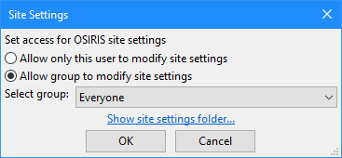

If you do not have administrative permission and a systems administrator is unavailable to help with these settings please contact us at [forensics@ncbi.nlm.nih.gov](mailto:forensics@ncbi.nlm.nih.gov?subject=OSIRIS%20Permissions%20Request) and put “OSIRIS Permissions Request” in the subject line. Please include your operating system version, your OSIRIS version, and the directory or folder path where you have installed OSIRIS.

### Determining OP names in file folders

The name of a custom OP is not obvious from the name of the folder in which it is stored, which is labeled with the date, “V-yyyymmdd-hhmmss”, like C:\Users\OsirisUser\programs\Osiris\site\Volumes\V-20111018-152317. The names.bat batch file allows Windows users to see a list of the folders and the associated OP names located within them. This file needs to be located in the \Osiris directory. The batch file can be launched from Windows explorer by double clicking, or from the command line where output can be piped to a file:  
>cd C:\Users\OsirisUser\programs\Osiris  
>names.bat > OP_names.txt  
The resulting file can be viewed in WordPad or a word processor. Notepad does not display the linefeeds well.

|  |
| --- |
| ***names.bat*** |
| @echo off cd %~d0%~p0 cd site\Volumes if ERRORLEVEL 1 GOTO ERROR mode con cols=133 lines=40 findstr /S /C:"<VolumeName>" *LabSettings.xml cd ..\.. GOTO DONE :ERROR @echo Cannot find volumes directory :DONE pause |

Mac users may open the V-yyyymmdd-hhmmss_LabSettings.xml file with a text editor and find the <VolumeName> tag to determine the OP name.

## Appendix C. Sample Rework

OSIRIS predicts and recommends sample reanalysis that would improve the quality of DNA profiles that have artifacts. The user can override these recommendations during editing, allowing the user to determine which, if any, rework is preferred for any individual sample or for an entire run. The user-selectable rework options are listed in the Artifact List (See Appendix F.) in the Sample and Directory categories. All of the rework options in the Directory category are user-selected; OSIRIS does not recommend rework for entire batches. Both software-recommended and user-selected rework options can be exported to either a LIMS or to a manual list to aid in sample re-queuing.

The following describes the logic underlying OSIRIS sample rework recommendations.

There are a number of OSIRIS-recommended rework options for individual samples incorporated into the MessageBook (version 4.0). These are: *Recommend Reamp Less*, *More*, *Regular* (or *Reinject*) and *Recommend Reamp With Human Review*. The latter does not export to the LIMS.

The software’s decision between reamp negative and reamp positive depends in part on whether any peak in the sample exceeds a user-specified threshold we call the overload limit. Neither the reamp negative nor the reamp positive recommendation is made for samples that are actually ladders. The reamp regular recommendation applies to ladders whose ILS fails.

**Reamp negative**

The computation that a reamp negative should be recommended is made if (except for ladders):

* [The sample has had at least one locus drop out -*that is, no alleles were found for at least one locus* AND there is at least one allele in the sample which exceeds the overload limit threshold]…OR
* The sample has excessive pull-up -*user-specified threshold* AND at least one sample allele has height above the overload limit…OR
* The sample has an excessive number of craters -*user-specified threshold*…OR
* At least one sample peak has been measured to have laser off-scale -*when preset is configured to use this information*.

**Reamp positive**

The computation that a reamp positive should be recommended is made if (except for ladders):

* [The sample has had at least one locus drop out that is, no alleles were found for at least one locus AND there no alleles in the sample which exceed the overload limit threshold] OR **At least one locus is under-amped** -*see below*…AND
* The sample is not a ladder.

The computation of the reamp positive recommendation depends on whether or not **At least one locus is under-amped**. This occurs if:

* [One or more loci has peaks between analysis and detection thresholds AND EITHER (no genotype was found for that locus OR the locus is homozygous with a peak that is below an acceptable threshold) OR (locus has peaks below the analysis threshold that are not known artifacts -*e.g., stutter*- AND the locus is homozygous)]…OR
* [The “amplify more on homozygote problem” preset is specified AND (no genotype was found OR there was a problem with the height of a homozygote)]…AND
* The sample is not a negative control.

**Reamp ambiguous**

In case both recommend reamp positive and negative are true, neither are reported. Rather, a “reamp ambiguous” is reported and human review is required.

**Reamp regular/Reinject**

The computation that a reamp regular should be recommended is made if:

* The sample contains “too many” excessive residuals-*user-specified threshold*…OR
* The percent of excessive residuals is too large *user-specified threshold*…OR
* The ILS analysis failed.

Reamp regular is only reported if neither reamp positive nor reamp negative is true. Reinjection is recommended instead of reamp regular based on the user selection in the lab settings.

During edit mode, the user can override any of these recommendations by selecting from the list of alternative rework commands. OSIRIS will allow the selection of only one of the rework commands for any given sample. The user can also choose to select a single rework command to apply to the entire plate.

## Appendix D. Quality Assurance and Automation Uses

Custom reports from OSIRIS can be scripted by the user, giving flexibility that allows a wide variety of different quality information to be exported in a broad array of formats. (See Appendix E.) These reports can be configured to export automatically upon analysis of a folder. This makes it possible to automate OSIRIS information collection for assessment of not only sample quality, but also process quality. See the discussion of the Sample Threshold settings for descriptions of Sample QC versus Process QA parameters. Typically, the process QA parameters target batch issues or the *severity* of sample quality issues, rather than individual sample artifacts. Please contact the OSIRIS team with suggestions about additional parameters you feel would be useful in this program ([forensics@ncbi.nlm.nih.gov](mailto:forensics@ncbi.nlm.nih.gov?subject=Lab%20Settings,%20Other%20Thresholds)).

OSIRIS can also export samples from one analysis file into another, allowing discovery or sorting samples into good/artifactual analysis files. The following are examples of ways that OSIRIS could be used with custom user-scripted exports (example #3 has already been accomplished):

1. **Automate real-time checking of control samples in a high throughput laboratory.***Example*: A laboratory running multiple plates per day wants to analyze the controls as each capillary electrophoresis run is completed, both so that process problems can be identified before too many samples are in the pipeline, and to allow early re-queue of samples needing rework, reducing turnaround of problem plates and speeding up completion of high priority samples. To address this, the lab configures OSIRIS to analyze one or more batches and automatically export a file with notifications of control sample artifacts without requiring an analyst to review all controls. The artifactual controls can then be evaluated to determine the issue so that there can be early intervention to rectify the problem.
2. **Accelerate acceptance and export of high quality samples.***Example:* A convicted offender testing laboratory wants to speed up the acceptance and export to LIMS of high quality samples without issues. After validation of OSIRIS as an expert system, the laboratory configures OSIRIS to analyze and automatically export the controls and all high quality samples without issues for import to the LIMS system without need for analyst review. A second automatic export is configured to export all samples requiring attention to a new project file for analyst review.
3. **Automate selection of the better of two injections***Example:* A convicted offender testing laboratory does not quantitate template DNA before amplification and wants to automate selection between the better of 5 and 10 second injections. The laboratory configures an export to select the better of the two injections and report which samples failed both injections. The laboratory analyzes with OSIRIS, runs the export to select and export the successful injections, then an analyst reviews samples without a successful injection.
4. **Automate sample reanalysis.***Example:* A laboratory wants to automate reanalysis of samples that gave poor quality profiles, to reduce turnaround time. The laboratory configures OSIRIS to analyze and automatically export sample rework recommendations either to LIMS or to a manual list for re-queuing.
5. **Monitor Color Matrix performance.***Example:* A laboratory wants to monitor color matrix performance to detect performance degradation before significant numbers of samples require rework. The laboratory configures OSIRIS to automatically export a QA report of samples with pull-up and saturated data (laser off scale) artifacts. The laboratory imports this report into LIMS or a control chart spreadsheet to monitor the proportion of pull-up artifacts to saturated data artifacts to determine when the matrix performance begins to degrade, before a significant change is noted by the analysts.
6. **Monitor capillary/array performance**.  
   *Example:* A laboratory wants to monitor capillary performance in their capillary arrays to maximize array value and minimize sample reanalysis. The laboratory configures OSIRIS to analyze and automatically export a QA report giving each capillary’s peak morphology quality data (peak fit). The laboratory imports this into LIMS or a control chart spreadsheet to monitor changes in peak fit to discover impending capillary failure.
7. **Monitor Sample /extraction quality.***Example:* A convicted offender laboratory wants to monitor the quality of submitted samples and the DNA extraction. The laboratory configures OSIRIS to analyze and automatically export a QA report of artifact data regarding samples with too little, too much, and degraded/inhibited DNA to monitor sample/extraction quality.
8. **Monitor Contamination.***Example:* A laboratory wants to automate continuous contamination monitoring. The laboratory configures OSIRIS to analyze and automatically export a QA report of contaminated negative controls and negative controls with peaks that are above the detection threshold but below the analysis threshold, to monitor both obvious contamination and sub-analytical contamination.

## Appendix E. User Defined File Export

OSIRIS provides the ability to customize exporting of data from an analysis file to any text or xml format. This allows users to create exports for their laboratory’s unique needs. Examples of customized exports include files in a format that can be imported into the laboratory’s LIMS system or into specialized spreadsheet applications, files formatted for upload into CODIS (“Export CMF file…” on the File menu), files formatted for a user-designed display, OSIRIS analysis report files which can be viewed in OSIRIS containing the samples pertaining to a particular case for discovery (included with OSIRIS), and text files or tables for inclusion in a report. Since the information that can be included in an export is only limited by the information in the analysis file itself, exports can be designed with a wide variety of user applications including automation, process control, reporting, and any other uses that may arise. Contact the OSIRIS team with questions and suggestions regarding scripting custom exports ([forensics@ncbi.nlm.nih.gov](mailto:forensics@ncbi.nlm.nih.gov?subject=Writing%20Export%20Scripts)).

OSIRIS exports data from an analysis file using the [XML Style Language Transforms](http://www.w3.org/TR/xslt) (XSL, XSLT) version 1.0. This is implemented with the [libxslt](http://xmlsoft.org/XSLT/) open source library from the [GNOME](http://www.gnome.org/) project and includes the [exslt](http://exslt.org/) extensions. The actual XSLT language syntax is beyond the scope of this document but is documented in many books and web sites; however **no technical expertise is required to implement the use of an existing XSL file**. A tutorial for implementing two export file types supplied with OSIRIS can be found in the Export Setup Tutorial.

The input XML for the XSL transform is the analysis file, whether it is an .oar or .oer file. The format of the analysis file is described in the XML schema file, OsirisAnalysisReport-2.0.xsd. This file can be found in the Config\xsd subdirectory in the OSIRIS installation directory in the Microsoft Windows TM version of OSIRIS and in the Contents/MacOS/Config/xsd subdirectory of Osiris.app on the Macintosh TM.

The XSL file can have top level parameters (using the <xsl:param> tag) which can be configured in OSIRIS to provide a user interface to set these parameters. Two <param> names are reserved, they are inputFile and outputFile, which if implemented are automatically set to the full path of the analysis and exported file names, respectively.

The XSL tag, <xsl:message> can be used to notify the user when there is a problem. The output produced by these tags is displayed if there is a failure in the export or if there is no output at all. Also, whether or not the export fails, the output is also logged and can be viewed in the message log which is the last item in the “Tools” menu on the menu bar.

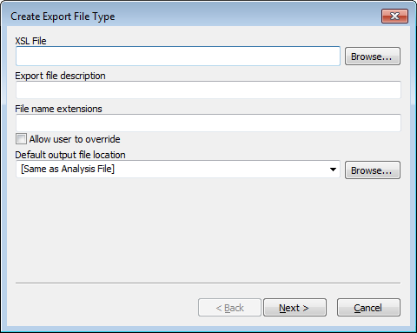To create, modify, or delete an XSLT export file type, select “Export File Settings” from the “Tools” menu on the menu bar. A window will appear with a list of all configured export file types or text stating that none exist. From here, the user can select “New…” to create a new file type or select one from the list and then select “Edit…” or “Remove…”

When creating or editing an export file type a ‘Wizard’ dialog window is used to configure an XSLT export type. The first panel is shown on the right. The needed information is as follows:

Export File Description**.** This is text displayed in the File menu or the Export submenu in the file menu for this export type. If there is one export type defined, it will appear after the word “Export” in the file menu. If two or more are defined, there will be an “Export” submenu in the file menu listing all of the export types.

File Name Extensions. This is a comma separated list of file name extensions of the output files to be saved. Some examples are: txt, xml, tab, csv. The checkbox labeled “Allow user to override” is used to allow these selections to be overridden when saving a file.

Default Output File Location. This is the folder that will serve as the default when exporting a file. This can be a specific folder which can be navigated by clicking on the browse button or one of two predefined values. One predefined value is “[Same as Analysis File]” which will use the location of the analysis file used for input as the default location. Another predefined value is “[Remember Last Location].” If this option is used, the location where the last exported file was saved will serve as the default next time a file is exported.

XSL File. This is the full path of the XSL file used in the transform.

Once these parameters are entered, select the “Next >” button to proceed to the next panel shown below:

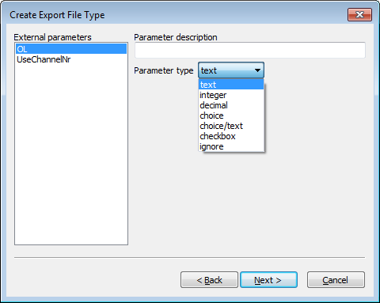This panel allows configuration of all of the top-level parameters (<xsl:param> tags) in the XSL file, if any, except for the two reserved parameters, inputFile and outputFile, which are described at the beginning of this section. Each parameter is given a description and type. The Parameter description is the label used in a dialog when exporting a file. The Parameter type is one of: text, integer, decimal, choice, choice/text, or ignore and filename. If ignore is selected, then this parameter will not be set when exporting data. If text is selected, then the user will be able to enter any text when exporting. If integer or decimal are selected, the panel then allows a valid numeric range. When the user exports data, a number can be entered which is validated and not be accepted if it is out of range. The choice type displays a multi-line text box that allows a list strings values to be entered. When the file is exported, the user can choose one the strings from a drop down list to be passed as the parameter. The choice/text option is like the choice option except the user can optionally type a value for the parameter that is not in the drop down list. Upon exporting data, when the dialog window for the entry of parameters appears, each is set to its default value as extracted from the XSLT file.

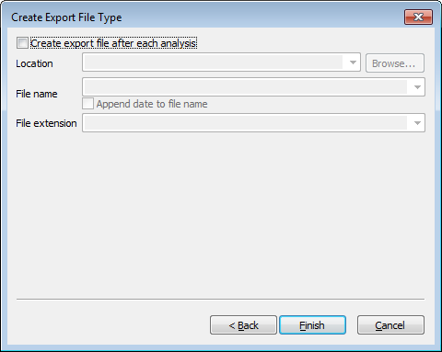After configuring the parameters, the “Next >” button will go to the third and last panel. This panel is used for configuring an automated export after each analysis. This is illustrated on the right. If the checkbox at the top is selected, then an attempt to export the file is performed after each analysis. There is, however, one caveat. If the Operating Procedure used in the analysis does not allow automated export when the analysis results need attention due to critical messages, the export is not performed. Three other parameters are used when an automated export is used. The first one is the Location of the output file. The user can select “[Same as Analysis File]” or the Default Output File Location entered in the first panel if it is a directory. Otherwise the user can enter the full path of an existing directory and/or use the browse button to search for one. The “File name” is the name of the file to be saved, not including the file name extension, or can be set to “[Same as Analysis File]” from the dropdown list. If the checkbox below is checked, the date and local time will be appended to the file name in order to ensure that no existing file is overwritten. The File extension can be selected from the dropdown list which contains all file extensions entered in the first panel or the user can enter a new file extension. Please note that when performing an automated export with this option, all of the top level parameters are not set by OSIRIS and therefore use their default values. Once this is completed clicking on the “Finish” button will save the export type and close the dialog window, returning the user to the “Export File Types” window, which can be closed by clicking on the “Done” button. All changes should be immediately reflected in the “File” menu on the menu bar when viewing an analysis file.

## Appendix F. Artifact List

The following is a list of messages and of artifacts that OSIRIS tests, whether or not the artifacts are Critical or Non-Critical, whether they export when performing an export to LIMS, and their priority. Critical artifacts display a user notification and require user intervention. Non-critical artifacts can be displayed in either of the graphical views and information about them is available through the hover box, but they do not produce user notifications and do not require user intervention.

(Note: X = critical; * = whether critical computed at run time; ^ = whether to display computed at run time; E = LIMS export; Priority = selection level for LIMS export when there are multiple export artifact options)

| **Artifact** | **Display Artifact Conditional** | **Artifact Critical** | **LIMS Export** | **LIMS Priority** |
| --- | --- | --- | --- | --- |
| **Signals:** |  |  |  |  |
| Pull-up at Extraneous ILS Peak |  |  |  |  |
| Curve Fit Unacceptable |  | X |  |  |
| Laser Off Scale | **^** | X |  |  |
| Curve Fit Marginal |  |  |  |  |
| Spike |  | X |  |  |
| Blob |  | X |  |  |
| Partial Pullup | **^** | * |  |  |
| Pullup |  |  |  |  |
| Partial Pullup Corrected Below MinRFU |  |  |  |  |
| Primary Pullup |  |  |  |  |
| Peak Is a Possible Unreported OL Allele |  | X |  |  |
| BELOW MINIMUM ANALYSIS RFU |  | * |  |  |
| Unexpected Peak in ILS |  |  |  |  |
| Peak Height Above Maximum Threshold |  | X |  |  |
| Conflict OSIRIS Below Min RFU; Raw Data Above |  | X |  |  |
| Conflict: Raw Data Below Min RFU; OSIRIS Above |  | X |  |  |
| Conflict: OSIRIS Above Max RFU; Raw Data Below |  | X |  |  |
| Conflict: Raw Data Above Max RFU; OSIRIS Below |  | X |  |  |
| Stutter |  |  |  |  |
| Peak to Right of ILS |  |  |  |  |
| Adenylation |  |  |  |  |
| Inter-locus Ladder Peak |  | X |  |  |
| Unexpected Peak in Ladder Locus |  | X |  |  |
| Width Unexpectedly High or Low |  | X |  |  |
| Low Signal to Noise in Peak |  |  |  |  |
| Signal Height Below Minimum Fractional Filter Height |  |  |  |  |
| Signal Height Below Minimum Pullup Fractional Filter Height |  |  |  |  |
| Below Fractional Filter (Left) |  |  |  |  |
| Below Fractional Filter (Right) |  |  |  |  |
| Below Pullup Fractional Filter (Left) |  |  |  |  |
| Below Pullup Fractional Filter (Right) |  |  |  |  |
| Signal Is an Inter-Locus Pull-up |  |  |  |  |
| Signal Is an Inter-Locus Pull-up with Poor Fit |  |  |  |  |
| Unassigned Inter-Locus Peak |  | * |  |  |
| Ambiguous Extended Locus Allele (Left and Right) |  | * |  |  |
| Identity As Interlocus Crater Ambiguous |  | X |  |  |
| Possible Ambiguous Extended Locus Peak Assigned to Locus |  | X |  |  |
| Ambiguous Extended Left and Core Locus Allele (Assigned to Core) |  | X |  |  |
| Ambiguous Extended Right and Core Locus Allele (Assigned to Core) |  | X |  |  |
| Peak Height Below Min Interlocus RFU |  |  |  |  |
| Possible Crater |  | X |  |  |
| Possible Crater Side Peak |  | X |  |  |
| Possible Valid Off-Ladder Extended Locus Allele (Left) | **^** | * |  |  |
| Possible Valid Off-Ladder Extended Locus Allele (Right) | **^** | * |  |  |
| This Peak Has Restricted Priority |  |  |  |  |
| Initially Considered As A Possible Crater |  |  |  |  |
| Initially Considered As A Possible Crater Side Peak |  |  |  |  |
| Extraneous Peak for Positive Control |  | X |  |  |
| Base Pair Residual Exceeds Threshold |  | X |  |  |
| Possible Extra-Ladder Allele [peak is stutter or adenylation to interlocus peak that may represent an allele] |  | X |  |  |
| Extraneous Peak Within AMEL Locus | **^** | X |  |  |
| Peak Exceeds Injection Overload Threshold | **^** | X |  |  |
| Unexpected Peak in Negative Control | **^** | X |  |  |
| ILS Peak May Be Incorrect: Too Short |  | X |  |  |
| Baseline Relative Below Minimum Analysis RFU | **^** | X |  |  |
| Baseline Relative Stutter | **^** | X |  |  |
| Baseline Relative Adenylation | **^** | X |  |  |
| Ambiguous Extended Locus Peak (Left and Right) With Poor Morphology |  | X |  |  |
| Possible Sigmoidal Pull-up |  |  |  |  |
| Unlikely Allele Peak: Excessive Residual Displacement |  | * |  |  |
| Unlikely Allele Peak Left: Excessive Residual Displacement Left |  | * |  |  |
| Unlikely Allele Peak Right: Excessive Residual Displacement Right |  | * |  |  |
| ILS Shoulder Peak | **^** |  |  |  |
| Shares Allele Bin in Core Locus |  | * |  |  |
| Shares Allele Bin in Locus to the Left |  | * |  |  |
| Shares Allele Bin in Locus to the Right |  | * |  |  |
| Redundant Peak |  |  |  |  |
|  |  |  |  |  |
| **Locus:** |  |  |  |  |
| Locus Has Peaks Between Detection and Analysis Thresholds | **^** | X |  |  |
| Locus Has Peak(s) with Laser Off-Scale |  | X | E | 10 |
| One or More Peaks Above Maximum Threshold |  | X | E | 11 |
| Locus Contains Too Few Peaks [Ladder] |  | X |  |  |
| Poor Locus Morphology [Ladder Locus Spacing] |  | X |  |  |
| Locus May Have Unreported Off-Ladder Alleles |  | X |  |  |
| Setup Error: Number of Peaks Unavailable for Locus |  | X |  |  |
|  |  |  |  |  |
| Relative Height Imbalance [Control Peaks] |  |  |  |  |
| AMEL Is Misaligned [not used yet] |  | X |  |  |
| X Allele for AMELOGENIN Could Not Be Found |  | X | E | 10 |
| Locus Contains Crater(s) |  | X | E | 11 |
| Positive Control Locus Mismatch |  | X | E | 10 |
| No Genotype Was Identified | **^** | X | E | 10 |
| Unexpected Peaks in Neg Ctrl Locus |  | X | E | 13 |
| Unexpected Number of Peaks [Ladder] |  | X |  |  |
| Heterozygous Imbalance Detected | **^** | X | E | 12 |
| Heterozygous Imbalance May Be Result of Pullup At Allele(s) |  | X | E | 12 |
| Single Peak Detected, Height Inappropriate for Homozygote |  | X | E | 12 |
| Locus Contains Peaks with Excessive Residuals |  | X | E | 13 |
| AMEL Contains One or More Extraneous Peaks |  | X | E | 11 |
| One or More Interlocus Peaks to Right of Locus | **^** | X | E | 10 |
| One or More Interlocus Peaks to Left of Locus | **^** | X | E | 10 |
| Associated Ladder Locus Has Critical Artifact(s) |  | X |  |  |
| Three Alleles Were Identified | **^** | X | E | 10 |
| More Than Three Alleles Were Identified |  | X | E | 10 |
| Off Ladder Allele(s) Detected |  | X |  |  |
| Critical Level Messages At Allele(s) |  | X | E | 10 |
| Unexpected Peak(s) in Sample Locus |  | X | E | 13 |
| This Locus May Be Under-Amped |  | X | E | 15 |
|  |  |  |  |  |
| **Channel:** |  |  |  |  |
| Lane Standard Requires Analyst Review: Spacing Is Marginal |  | X |  |  |
| Channel Has Raised Baseline |  | X |  |  |
| Channel Has Excessive Noise Above Analysis Threshold |  | X |  |  |
| Channel Has Excessive Noise Above Detection Threshold |  | X |  |  |
| Channel Has Excessive Noise: Peaks May Be Unreported | **^** | X |  |  |
| ILS Spacing Does Not Meet Expected Parameters |  | X |  |  |
| ILS Contains Too Few Peaks |  | X |  |  |
| Unable to Read FSA Channel |  |  |  |  |
| Cannot Separate ILS Primer Peaks |  | X |  |  |
| ILS Neighbor Filters Remove Too Many Peaks |  | X |  |  |
| ILS Fractional Height Filter Removes Too Many Peaks |  | X |  |  |
| ILS Relative Heights Inconsistent with Expected Heights |  |  |  |  |
| Unexpected Peaks in Channel [Negative Control] |  |  |  |  |
| Positive Control Locus Not Found in Set |  | X |  |  |
| Critical Level Messages At ILS Peak(s) |  | X |  |  |
| Negative Control Channel Contains No Primer Peaks |  |  |  |  |
| Channel Peaks Have Critical Artifacts |  | X | E | 16 |
| Ambiguous Extended Locus Channel Peaks |  | X | E | 10 |
|  |  |  |  |  |
| **Sample:** |  |  |  |  |
| ILS Could Not Be Analyzed |  | X | E | 4 |
| Sample Requires Analyst Review: Marginal Lane Standard |  | X | E | 5 |
| At Least One Channel in Sample Has Raised Baseline |  | X | E | 9 |
| At Least One Channel in Sample Has Excessive Noise: Peaks May Be Unreported |  | X | E | 9 |
| The Allelic Ladder Type Is Not Recognized |  | X |  |  |
| Unable to Read FSA File |  | X |  |  |
| Named Positive Control Not Found |  | X |  |  |
| One or More Positive Control Locus Not Found in Set |  | X |  |  |
| One or More Negative Control Channels Contain No Primer Peaks |  | X | E | 6 |
| One or More Peaks Have Laser Off-Scale |  | X | E | 10 |
| Sample Has At Least One Homozygote That Is Too Short |  | X |  |  |
| Associated Ladder Has Critical Artifact(s) |  | X |  |  |
| Sample May Be a Mixture |  | X | E | 6 |
| Total Number of Homozygous Loci [Exceeds Threshold] | **^** | X |  |  |
| Total Number of Tri-allelic Loci [Exceeds Threshold] |  | X |  |  |
| Number of Pullups in Sample Exceeds Threshold | **^** | X |  |  |
| Number of Excessive Residuals in Sample Exceeds Threshold |  | X |  |  |
| Percent of Alleles with Excessive Residuals Exceeds Threshold |  | X |  |  |
| Percent of Pullups Exceeds Threshold | **^** | X |  |  |
| Number of Stutter Peaks Exceeds Threshold | **^** | X |  |  |
| Number of Adenylation Peaks Exceeds Threshold | **^** | X |  |  |
| Number of Off-Ladder Alleles Exceeds Threshold |  | X |  |  |
| Negative Control Requires Analyst Review |  | X | E | 6 |
| Allelic Ladder Could Not Be Analyzed |  | X | E | 6 |
| Core OL Allele: Recommend Rerun Sample |  | X | E | 7 |
| Too Many Excessive Residuals: Recommend Rerun Sample |  | X |  |  |
| Sample Could Not Be Analyzed |  | X |  |  |
| Number of Crater Peaks Exceeds Threshold |  | X |  |  |
| Number of Spikes Exceeds Threshold |  | X |  |  |
| At Least One Allele Exceeds Amplification Overload Limit | **^** | X |  |  |
| Locus Dropout For At Least One Locus |  | X |  |  |
| Recommend Reamp Less (OSIRIS – Export) | **^** | X | E | 3 |
| Recommend Reamp More (OSIRIS – Export) | **^** | X | E | 3 |
| Recommend Reamp Regular (OSIRIS – Export) | **^** | X | E | 3 |
| Recommend Reinject (OSIRIS – Export) | **^** | X | E | 3 |
| Recommend Reamp With Human Review (No Export) | **^** | X |  |  |
| At Least One Locus May Be Under-amped | **^** | X |  |  |
| Color Correction Matrix Expected But Not Found – Using Uncorrected Data |  | X |  |  |
| Color Correction Matrix Wrong Size – Using Uncorrected Data |  | X |  |  |
| ----- |  |  |  |  |
| Reamp Sample Regular (Analyst - Export) |  |  | E | 1 |
| Reamp Sample More (Analyst - Export) |  |  | E | 1 |
| Reamp Sample Less (Analyst - Export) |  |  | E | 1 |
| Reinject Sample (Analyst - Export) |  |  | E | 1 |
| Reextract Sample - Swab (Analyst - Export) |  |  | E | 1 |
| Reextract Sample - Blood (Analyst - Export) |  |  | E | 1 |
| Do Not Rework Sample (Analyst - Export) |  |  | E | 1 |
| Verification Sample (Analyst - Export) |  |  | E | 1 |
| Best Sample To Ladder Fit Does Not Meet Expectations:  Confirm Sizing. | **^** | X | E | 6 |
|  |  |  |  |  |
| **Summary Locus:** |  |  |  |  |
| Number of Sample Loci with Craters Exceeds Threshold |  | X |  |  |
| Percent of Loci with Craters Exceeds Threshold |  | X |  |  |
|  |  |  |  |  |
| **Directory:** |  |  |  |  |
| No Allelic Ladder File Identified |  | X |  |  |
| Default Protocols Are Overridden |  | X | E | 0 |
| Reagent Kit Not Recognized |  | X |  |  |
| More Than One Reagent Kit Identified in Directory |  | X |  |  |
| Could Not Find Named Population Marker Set |  | X |  |  |
| Could Not Find Named Internal Lane Standard |  | X |  |  |
| No Positive Control Found In Directory |  | X |  |  |
| No Negative Control Found In Directory |  | X |  |  |
| Named Positive Control Not Found |  | X |  |  |
| Total Number of Samples with Excessive Pull-up Exceeds Threshold |  | X |  |  |
| Percent of Samples with Excessive Pull-up Exceeds Threshold |  | X |  |  |
| ----- |  |  |  |  |
| Re-amp All Regular |  |  | E | 2 |
| Re-amp All Less |  |  | E | 2 |
| Re-amp All More |  |  | E | 2 |
| Re-inject All |  |  | E | 2 |

## Appendix G. Adding a New Kit

### New Kit

Users wishing to add a new kit should contact the OSIRIS team and provide the following information:

1. ABI Panels file containing the following:
   1. For each locus –
      1. Locus name
      2. Dye color
      3. Base pairs in 1 repeat (e.g., TH01 = 4, Penta D = 5)
      4. List of ladder alleles (repeat sizes)
2. ABI Bins file containing:
   1. For each locus –
      1. Locus name
      2. First virtual or extended (i.e., not a ladder peak) allele name with ILS bp (center of GeneMapper bin)
      3. First ladder allele name with ILS bp (center of GeneMapper bin)
      4. Last ladder allele name with ILS bp (center of GeneMapper bin)
      5. Last virtual or extended (i.e., not a ladder peak) allele name with ILS bp (center of GeneMapper bin)
3. Kit name
4. Number of dyes (channels)
5. Official kit dye name for each channel
6. List of colors for each dye channel
7. Default maximum expected number of alleles per locus (i.e., 2 for heterozygotes, 1 [or more] for Y and X-STRs)
8. Exceptions to default in 7 (e.g., most loci are heterozygotes but one locus is a Y-STR)
9. Default loci identified as Y-STRs (true/false) (e.g., true if most loci are Y-STRs)
10. Exceptions to default in item 9 (e.g., all loci are Y-STRs except AMEL)
11. List of loci which never have alleles outside of the core ladder locus (e.g., AMEL)
12. List of loci that are quality determination loci (e.g., Qiagen QS1)
13. ILS:
    1. If the ILS is not already included in OSIRIS, ILS name(s) and details including the number of peaks and peak sizes in base pairs
    2. If already included in OSIRIS, ILS name(s)
    3. ILS channel number
14. ILS Family Name for Ladder Version 2.7 marker sets
15. Standard positive control name (e.g., 9947A), if available. If not available, new positive control name with associated allele names.
16. Channel mapping if displayed channel number is not the same as the fsa file channel number

## Appendix H. Dynamic Baseline Analysis and Normalization

OSIRIS now features a dynamic baseline analysis that detects and approximates the true baseline and then normalizes the raw data by subtracting the approximated raw baseline from the raw data. We call the entire process of estimating the dynamic baseline followed by dynamic baseline correction, “normalization” or “baseline normalization”. This is distinct from the process of estimating a static correction to the baseline that is performed at the beginning of every analysis. Correcting the static baseline is described below.

Once the raw data has been normalized, peaks can be fit in the usual manner and the heights and areas of the fit peaks will be accurate with respect to their true values. We emphasize that the OSIRIS analysis is a two-phase process – (optional) normalization, followed by allele peak and artifact analysis. Removing the static baseline precedes both of the following phases.

The first, normalization, phase includes the following processes:

* raw data filtering (if specified)
* fitting peaks to the (possibly filtered) raw data
* estimation of baseline sample points
* fitting an approximating curve to the baseline sample points
* subtracting the baseline estimation curve from the original (unfiltered) raw data
* discarding the peaks fit during this normalization phase.

The second, allele peak analysis, phase includes:

* fitting peaks to the unfiltered normalized raw data, if normalization was selected, and to the original raw data, if not
* proceeding with the analysis of these peaks for allele and artifact detection.

If normalization is not selected in the Lab Settings, only the second phase is performed after static baseline removal. Ladder files and sample internal lane standard channels are subject to static baseline correction but are not analyzed for dynamically baseline normalization.

Non-normalized data with baseline (blue) that is subtracted to normalize:

When the blue estimated baseline is subtracted the normalized raw baseline will be flat.

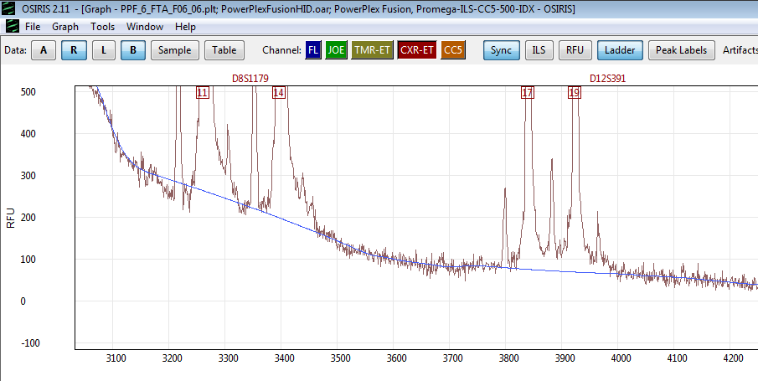

If the user does not choose dynamic baseline analysis, or normalization, OSIRIS behaves as it did in prior versions; it determines the static baseline at the right-hand end of the raw data for each channel, then uses that as the constant, or static, baseline (or zero) for the entire set of data points in that channel by subtracting it from all raw data values for the channel. One output of this process is an estimation of the noise level in each channel. This noise does not include DNA fragment-related artifacts, which are handled elsewhere, but only electronic noise, generated by the operation of the laser and other equipment in processing the sample. For OSIRIS, the per-channel noise is defined to be the maximum peak-to-trough displacement at the right-hand end of the raw data for each channel. For the more detailed algorithm, see “Noise Estimation”. The estimated noise level is used throughout the analysis, notably for curve-fitting and for shoulder detection.

The usual course of sample analysis, after determining the static baseline from the raw data, as described above, is to perform the following:

* fit mathematical curves to the ILS channel peaks
* analyze the ILS
* fit mathematical curves to the peaks of each remaining channel
* analyze the remaining channels according to the type of data set (ladder or sample).

When OSIRIS fits a mathematical curve to a raw data peak, the mathematical curve extends all the way down to the analytical baseline, except in situations where two peaks are close to each other, in which case the mathematical curves intersect before reaching the analytical baseline, so never reach zero. This type of baselining works quite well for high quality data where the raw data baseline is essentially flat across the data that encompass the loci of interest. However, when the raw baseline rises significantly above the analytical baseline, typically at the left of the electropherogram, small peaks in the raw data will be fit with a mathematical curve that extends all the way to the zero analytical baseline, which can be significantly below the raw baseline surrounding the peak, resulting in very small raw peaks fit with curves that have artificially elevated RFU values and wide bases. Additionally, where the raw baseline is elevated above the analysis threshold, small deviations in the raw data may be fit as curves.

This issue can be corrected in datasets where the raw baseline is significantly elevated by choosing dynamic normalization: dynamically approximating the true baseline from the raw data and subtracting it from the raw data so that the raw data has a zero baseline. That allows improved curve fitting and improved peak height and area calculation. The rest of this appendix describes options for normalization.

### Raw data filtering:

Sometimes, the noise level in the raw data interferes with OSIRIS’ ability to fit peaks reliably, especially if there is an elevated baseline. In this case, the algorithm may become confused between noise and an actual peak. Filtering provides a way for the algorithm to precondition the data prior to estimating the baseline. All filtering algorithms rely on the principle that replacing a raw data value with an average of nearby raw data values tends to flatten the noise, or reduce its intensity. An averaged elevated baseline tends to remain elevated at the same (average) level as the original raw data, but with less peak-to-trough noise.

OSIRIS offers a choice of three different filtering algorithms. The first is a simple so-called low pass filter that effectively averages a raw data value with previous values included within a user-specified window. We call it a single pass filter. This filter is effective at reducing noise but has two disadvantages. The first is that it tends to lower peaks and move them to the right. (A peak that occurred at time t in the raw data plot, will occur at some later time in the filtered raw data plot.) The second disadvantage is that, even though the filter generally reduces high frequency noise, it can also introduce artifactual high frequency noise on occasion.

The second filter, called a triple pass filter, is similar to the first, except that it is repeated three times with successively decreasing window widths. This filter overcomes the second disadvantage of the first filter. It no longer introduces high frequency noise, and therefore, if the user wishes to use a low pass filter, the triple pass filter is the one to select. Even so, the triple pass filter, like the low pass filter, lowers peaks and moves them to the right.

The third filter, introduced in Version 2.11, keeps peaks in their original position. We call it the averaging-in-place filter. It averages a raw data value with the values within a specified window to the left and to the right. In addition, unlike traditional filters, in creating a plot of filtered values, the averaging-in-place filter compares the averaged raw data value to the original raw data value. If the difference between the two exceeds a user-specified threshold, then that point is at or near an actual peak and the filter simply copies the original raw data value into the plot of filtered values. In other words, not only are peak *locations* left unchanged, peak *heights* are left unchanged by the averaging-in-place filter. Testing has shown that, of the three filters, the averaging-in-place filter provides the best environment for subsequent baseline estimation.

Note that, regardless of which filtering algorithm is selected (if any), raw data filtering affects only the estimation of the baseline and subsequent normalization. The raw data values that are subject to final analysis of alleles, artifacts and other quality issues are not filtered. They consist of the original raw data with a baseline normalization curve subtracted.

### Detecting the true baseline:

Fitting mathematical curves to the peaks of each channel and analyzing the internal lane standard (ILS) produces all the information that OSIRIS needs to estimate the dynamic baseline. The internal lane standard channel is not tested for dynamic baseline. The curves fitted to peaks in the non-ILS channels are locations where the raw data is above the raw baseline. By contrast, regions in between the peaks, where the peak-fit curves extend down to zero, should correspond to raw baseline data regions. Therefore, these regions contain evidence of the raw data dynamic baseline.

Since some peaks are close enough to each other that the peaks sides overlap and prevent the raw data from falling all the way back to the raw baseline, OSIRIS needs to test the areas between peaks for wide enough stretches of raw baseline to use for approximating the overall dynamic baseline shape. Where raw peaks are close to each other, the analytical peak-fit curve values may also not reach zero between peaks. To test for acceptable stretches of raw baseline between peak edges, OSIRIS uses a user-specified parameter called the Baseline Estimation Threshold, which has a default value of 1 RFU (analyzed). For example, at the default setting, all raw data points corresponding to analyzed values below 1 RFU can be used as baseline samples to estimate the calculated baseline. Starting at the time of the left-most ILS peak, such baseline-worthy intervals are collected, and the raw data are sampled. These intervals are collected all the way to the end of the collected data in the run. Since the raw data is noisy, a single raw data point is of little value. Therefore, a sample at a point consists of the average of that point together with a significant number of neighboring points.

The set of times and samples calculated above are used as “knots” to define a cubic spline approximation to the raw baseline curve. Because of the smoothness of the curve, together with the distance between knots, along with the averaging technique for calculating the sample values, this dynamic baseline curve is not responsive to the high frequency noise in the raw data – minor deviations in the noise do not cause a change in the baseline curve. To help condition the endpoints of the cubic spline and maintain curve accuracy, extra knots with zero values are added beyond the ends of the collected data in the run, both to the right and the left.

The cubic spline curve is then evaluated at each one second interval and the value is subtracted from the raw data to produce a raw data curve that has an essentially zero-average baseline. Since the original peak-fit curves no longer fit the dynamically normalized data points, all of the peak-fit curves are recalculated for the peaks in the non-ILS channels. The OSIRIS analysis now proceeds with the new peak-fit curves and the original ILS.

As an option, the user can choose to subtract only the non-negative values of the cubic spline baseline from the raw data rather than both positive and negative, where the cubic spline dips below zero, but the result of that may be a normalized baseline that is less than zero in some regions, rather than a zero baseline, with the ultimate consequence that some very small peaks in the regions with negative baseline may not be analyzed because they will be below the analysis threshold.

## Appendix I. Troubleshooting and FAQ

### Troubleshooting

| **Problem** | **Solution** |
| --- | --- |
| My analysis failed | The most common cause of analysis failure is selection of the wrong kit or ILS definition in the Operating Procedure. Ensure that the correct kit and ILS combination is selected in the Operating Procedure being used for the analysis. |
| Any time your analysis fails you can select the “Details” button to find troubleshooting information. Selecting “View Selection” or double clicking the failed run will open the ladder, if it could be found and partially analyzed. Click the ladder sample name to view all the channels of the ladder in the Preview pane or double click the ladder sample name to view it in the Graph View to determine the presence of artifacts and peaks and whether the locus and ILS peaks are below the analytical threshold. |
| No ladder sample was present, or the file name did not contain the ladder file search string. OSIRIS requires a ladder for analysis.  OSIRIS must have at least one acceptable ladder for the analysis to succeed. If the expected ILS or ladder allele peaks are below the analysis threshold or not present (e.g., cut off in collection) the ladder will fail to analyze. By opening a failed analysis, it may be possible to examine the ladder peaks to determine if the ladder was the reason the batch failed. |
| Artifact peaks made it impossible to analyze the ladder ILS. Sometimes this can be alleviated by adjusting the ILS analysis thresholds. Otherwise re-prepare or re-inject the ladder. |
| The ladder’s ILS peaks are below threshold. Adjust the ILS analysis thresholds. Otherwise re-prepare or re-inject the ladder. |
| The ladder’s peaks have artifacts or are below threshold. Sometimes this can be alleviated by adjusting the Ladder analysis thresholds. Otherwise re-prepare or re-inject the ladder. |
| I can’t select .fsa/.hid files to analyze on the Mac | When starting a new analysis, if you browse to a folder containing .fsa or .hid files, the files themselves will be grayed out and cannot be selected. However, selecting the folder containing the files is allowed. OSIRIS analyzes all the files in the selected folder and any subfolders. |
| My .hid/.fsa analysis failed | The Operating Procedure must be set for the correct file type on the General tab of the Lab Settings or the analysis will fail because no files of the expected type are present. If you select the failed run and click the details button, at the bottom of the list there will be a “Project did not meet expectations…No satisfactory ladder found…Ending” error message. Make sure that the correct file type is selected and reanalyze. Analysis of a directory tree with multiple file types will succeed only in those subfolders containing the expected file type. |
| I installed OSIRIS, but I can’t find the \Volumes or \site directory. | The Volumes directory is not created until the user creates the first custom Operating Procedure using one of the default Operating Procedures as a template. You can find the location of your \Volumes directory in your site folder. The site folder should be automatically created unless the user does not have the necessary write privileges. See Appendix B. Site Folder location for detailed information. |
| I can’t edit the Operating Procedure | To edit an Operating Procedure, you must have write permission to the site settings folder and its subfolders. To view this folder, select “Show site settings folder...” from the “Tools” menu on the menu bar. If the user does not have an account with administrative permissions, an administrator account will need to change the permissions. See Appendix B, Permissions for Site and Volumes directory for more information. |
| You cannot edit default Operating Procedures (shown in brackets) such as *[PowerPlex 16]*. Make a new Operating Procedure that can be edited using one of the defaults in brackets as a template. |
| You cannot edit Operating Procedures opened through the “Parameters” button. These are static copies associated with the analysis file you are viewing. This are the historic record of the settings used for a specific analysis. |
| The Operating Procedure is locked while being edited by any user and cannot be edited by a second user or used for an analysis. Ask the user editing the Operating Procedure (OP) to close it or select a different OP.  In Version 2.9.1 and earlier, an OP could not be edited if it was recently used based on the file’s time last accessed. This feature has been removed because on many systems this time is not accurate. With version 2.11 or newer, an Operating can be locked by any one user if that user has file permissions. If the Operating Procedure is updated, while an analysis elsewhere on the network is using it, the analysis will use the prior version. |
| If you are operating on a network or in a forensic or clinical laboratory, your OSIRIS administrator may have limited write permissions on the Operating Procedure directories to prevent unintended changes. Contact your OSIRIS administrator. |
| I can’t figure out the name of an Operating Procedure in the folders listed in the Volumes directory | In Windows, run the *names.bat* batch file to find the Operating Procedure name associated with each folder in the Volumes directory. In new installations you may need to move the *names.bat* file into the directory containing the \Volumes directory (C:\ProgramData\Osiris-Files). Alternatively, the date and time are part of the folder’s name, where *V-****20110323-112549*** was created 2011-03-23 at 11:23 AM. |
| My file says that it may have been modified outside of OSIRIS | Modification of OSIRIS analysis files (.oar, .oer, .plt) with software other than OSIRIS will cause this message. This is designed to protect the integrity of the data. |
| If the output is saved on a network drive, the time on the computer containing that drive should be in sync within one minute of the time on the computer running OSIRIS otherwise OSIRIS may give this message even if the file has not been edited. It is highly recommended to synchronize the network by using a designated computer as the time server, possibly by using Windows Time Service on Microsoft Windows or Network Time Protocol (NTP) on the Macintosh. |
| I can’t edit peaks that are “Restricted priority” | Set the Restricted Priority Editing Options in the Lab Settings Sample Limits to allow editing of restricted priority peaks. |
| Some artifacts do not display on the electropherogram plot in the graph window | Check which artifact display option you have selected. “None” displays no artifacts on the graph. “Critical” will not display non-critical artifacts. |
| Artifacts associated with the locus, channel, sample or directory do not display on the graph, only artifacts associated with peaks. |
| OSIRIS is not finding one of my very low level peaks | If OSIRIS is not fitting low-level peaks, you can adjust the sensitivity of peak fitting. By reducing the noise threshold or decreasing the area threshold for peak identification, you can virtually eliminate minor unfitted peaks. There may be a trade-off where more noise is fit as peaks. (See Curve Fit Options.) |
| The ladder peak labels don’t always display | The **Ladder** button on the Graph toolbar and **Show Ladder Labels** on the menu show and hide the ladder labels. |
| To prevent clutter on graph displays, OSIRIS allows the user to set the maximum number of ladder peak labels that will display. When the number of ladder peaks on the graph exceeds the user-defined Max. ladder peak labels (Graph menu), OSIRIS dynamically turns off the ladder label display. As the user zooms in and the number of ladder peaks falls below the setting, the labels automatically reappear. |
| What happens when my peak falls in the core of one locus and the extended locus of the adjacent locus? What are “Extended locus” error messages? | If a peak is a good match for the corresponding core locus ladder allele, it is flagged with a non-critical artifact. If it is not a good match for the core locus ladder allele, which might be an indication that it really could belong to the adjacent extended locus, then it is flagged with a critical artifact. See Core and Extended locus artifact discussion and Core and Extended locus boundary discussion. |
| OSIRIS doesn’t open when I double click an OSIRIS file (Windows) | If OSIRIS is installed by unzipping the exe installer rather than installing with the .msi download file or if it is installed on the network, then you must associate the OSIRIS file types with the program. Do a web search for “change the default application to open a file” for instructions for changing the program used to open a file. You will need to repeat the change for each of the files with extensions of .oar, .oer, .plt and .obr that you want to open by double clicking. |
| OSIRIS no longer asks if I want to exit the program | When you close OSIRIS, you get a prompt “Do you want to exit OSIRIS?”. When you check the “Don’t show this window again” box, that prompt no longer displays, rather OSIRIS immediately closes. The prompt can be reset by editing the osiris.xml file in:  Windows XP - C:\Documents and Settings*username*\Application Data\.osiris  Windows 7, 8, 10 - C:\Users*username*\AppData\Roaming\.osiris  Macintosh - /Users/*username*/.osiris for older installations or /Users/*username*/Library/Preferences/.osiris  You may have to go to this folder from Finder by selecting “Go to folder…” from the “Go” menu on the menu bar. Make sure that Finder is the foreground application.  Open osiris.xml with Notepad or another text editor and remove the line containing: <CheckBeforeExit>false</CheckBeforeExit>.  (this is around line 36-40) and save the file. The next time you close OSIRIS, you will get the prompt again. |
| How do I put/stop putting all the analysis files in the input directory? | To put all the files produced by the analysis into the input directory containing the .fsa or .hid files, use the same path for both input and output when starting a New Analysis. To put them into a different directory, use a different path. OSIRIS defaults to the last path used for both input and output, so it remembers the last locations. Selecting the “Create time stamped subdirectory” tick box in the New Analysis window prevents overwriting a previous analysis. |
| Help will not open in OSIRIS | Some configurations of Microsoft Windows 10 will not open the OSIRIS Help document from within the program when the Microsoft Edge browser is the default reader for PDF files. The simplest solution is to select an alternate PDF reader: In File Explorer, open the folder where OSIRIS is installed. Right click the OsirisHelp.pdf file and select “Open with >” then “Choose another app” from the pop-up context menu. Select a different PDF reader or a different browser that can open PDF files, check the “Always use this app to open .pdf files” checkbox, and click "Ok". |

### FAQ

1. Can I analyze .hid and .fsa file types?  
   *Yes. The Operating Procedure must be set for the appropriate file type. See General – .fsa and .hid files in Lab Settings.*
2. Can I enter a new kit in OSIRIS?  
   *Yes. See Appendix G for instructions. Contact us for help or advice.*
3. Can I use a different ILS?  
   *Several different ILS are defined for various kits. Note that some of those are actually one ILS, but use more or fewer of the peaks, in case not all peak data gets collected. If the ILS you use is not defined for the kit you use, see Appendix G for instructions on defining a new ILS. Contact us if you need help.*
4. What do I do if my multiplex has no ladder available?   
   *You can either construct a ladder, or you can use a DNA sizing ladder to add a new kit. See Appendix G or contact us for help.*
5. How fast is OSIRIS?  
   *OSIRIS should process 2 to 4 samples per second, depending on the number of artifacts in the samples and the speed of your computer/network. So a plate of 98 samples with controls should take 30-60 seconds to analyze. If it runs significantly slower than that on your system, contact us for advice.*
6. How many samples can OSIRIS process at once?  
   *OSIRIS will process at least 800 samples in a single batch (single directory). OSIRIS will process an essentially unlimited number of batches in a single processing run. This has been tested with approximately 10,000 samples in 110 directories (plates) in a single analysis that took approximately 1 hour 20 minutes.*
7. How many users can use OSIRIS at the same time?  
   *This is limited only by the number of client computers you have and the speed of your network and server. Generally, it should be “lots.” Additionally, each user is creating a separate instance of OSIRIS running on the local client, so multiple users will not affect the speed of operation except as limited by sample data flow across the network to and from the server if the sample data and OSIRIS output is being stored on the server. A single user can run separate instances of OSIRIS on the same computer at the same time (Windows only), allowing different analyses or tasks to be performed simultaneously. Multiple analyses can also be run from a single OSIRIS process (Windows and Macintosh).*
8. Is there any fee for OSIRIS software or use?  
   *No. OSIRIS is free and open source. No license or fees are required.*
9. Is OSIRIS source code available?  
   *Yes. OSIRIS source code is available at GitHub:* [*https://github.com/ncbi/osiris*](https://github.com/ncbi/osiris)*.*
10. Can I modify OSIRIS, build it into my front end or incorporate it into my own software?  
    *OSIRIS is open source and public domain software. You may do anything your heart desires. In any work or product derived from this material, proper attribution to the authors as the source of the software would be appreciated.*

Contact us: [forensics@ncbi.nlm.nih.gov](mailto:forensics@ncbi.nlm.nih.gov?subject=Question%20regarding%20FAQ).

## Appendix J. Other Information Output to Analysis Files

### The Comment Field

The ABI .fsa and .hid files can have a comment field for each sample (marked with the tag CMNT). OSIRIS Version 2.11 now reads that field and copies it to the output OSIRIS .oar file with the XML tag <Comment>. This allows users to provide detailed identifying information about samples beyond the file or sample name strings. By inserting additional information in the input file under the CMNT tag, users can customize data exports. An example would be adding a comment, such as the CODIS specimen type, to the comment field when generating the ABI Genetic analyzer loading template so that it is passed into OSIRIS and can be used when generating a CMF file in OSIRIS.

### The Information Field

Because of new data output to the .oar/.oer files, OSIRIS can now be used as a powerful tool to aid in process control. A new element contains measured and calculated quantities that provide insight into the state of the run. These values can be followed over time using control charts spreadsheets or other process control software to anticipate process quality irregularities or instrument failure. Following is a list of the data that can now be exported for each sample:

1. **Maximum linear pull-up coefficient**, an indication of the accuracy of match of the color separation matrix to the sample being analyzed. An accurate color spectral color separation matrix will eliminate essentially all pull-up that is not due to sample overloading. An increasing trend in values could indicate the need to regenerate the matrix.
2. **Maximum non-linear pull-up coefficient**, an indication of the degree to which the sample was overloaded or over-amplified. The non-linear pull-up coefficient is calculated for situations where the peak height data is out of the linear range, i.e., when peak heights are very high, or the CCD camera is saturated (laser off scale), which in extreme cases leads to craters (split peaks). An increase over a range of samples could indicate process control issues with extraction, quantification, amplification or sample preparation.
3. **Maximum error** (sample to ladder), a measure of the alignment between sample and chosen ladder. A general increase could indicate peak shifting due either to temperature control problems or other issues.
4. **Width of last ILS peak**, an indication of possible degradation of a capillary’s performance.
5. **Sample locus total area ratio max locus to min locus**, the ratio of the total area under the peaks in the locus with the largest area to the area of the locus with the smallest area is an indication of possible DNA degradation or PCR inhibition, where the loci with smaller target PCR products tend to amplify preferentially. Y-STR loci, most of which have a single peak in unmixed samples, are considered separately. Changes over a range of samples could indicate sample collection, storage, or extraction issues.
6. **Sample Y-linked locus total area ratio max locus to min locus**, the ratio of the total area under the peaks in the locus with the largest area to the area of the locus with the smallest area. Same as 5, but for Y-linked loci.
7. **Starting temperature**
8. **Max minus min temperature**, together with 7, a measure of temperature control. Changes in run temperature indicate conditions that could lead to allele peak shifting.
9. **Starting voltage**. Unexpected changes in voltage, current or power may indicate the beginning of analyzer failure or the use of incorrect analysis run profiles.
10. **Max minus min voltage**, together with 9, a measure of voltage control
11. **Starting current**
12. **Max minus min current**, together with 11, a measure of current control
13. **Starting power**
14. **Max minus min power**, together with 13, a measure of power control
15. **Run date,** the date of the run
16. **Run time,** the time of the run
17. **Capillary number,** lane or capillary of run
18. **Injection seconds,** number of seconds of injection
19. **Injection voltage,** voltage of injection (in volts)
20. For each channel:
    1. **Noise**. Measured steady state peak to trough noise at the right end of the collected data. A change in the trend of noise values could indicate issues with the Genetic Analyzer’s laser, CCD camera, alignment, or the color separation matrix.
    2. **Channel locus total area ratio max locus to min locus**, could give an indication of possible DNA degradation or inhibition. Choosing the correct channel may make this metric more sensitive by excluding a kit’s preferentially amplified loci, in favor of more evenly amplified loci, or could be used to include a locus known to be more sensitive to inhibition.
    3. **Channel Y-STR locus total area ratio max locus to min locus**, an indication of possible DNA degradation or inhibition calculated with STR loci

## Appendix K. Privacy Information

### Privacy Statement

OSIRIS is a desktop tool working on your computer with your own data. Your sample profile data is processed on your computer and is not sent over the internet.

For quality monitoring, OSIRIS version 2.12 sends some information about usage statistics back to NCBI. This information is limited to use of the tool, without any sample, profile or batch data that would reveal the context of your analysis.

### Opt-out of Statistics Collection

You can opt-out of statistics collection by doing the following:

Open OSIRIS.

Open the Tools menu and uncheck Allow Usage Reporting.

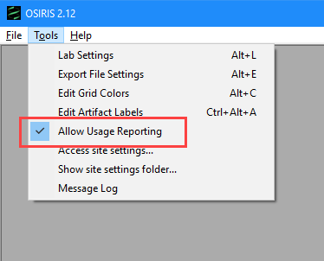

OSIRIS will immediately stop reporting statistics.

Technical Details

Quality information sent includes: operating system, OSIRIS session open and close, errors and crashes, analysis time and marker set, window open and close. If a “Debug” folder is created in C:\Users*user_name*\AppData\Roaming\.osiris, OSIRIS will create usage logs that include the quality information sent, on lines that begin with “usage stats: PING:”. If necessary, deleting the *pinger.vbs* communication module will not interfere with normal OSIRIS operation. Note that Windows operating systems may reinstall a deleted file if the software is installed with the .msi installer.

## Appendix L. A Quick Tutorial for Fragment Analysis

This is a quick overview on using OSIRIS for fragment analysis. The files shown in the examples illustrated in this instruction are included with your OSIRIS download.

When you open OSIRIS, you will see the following window. The logo disappears after a moment.

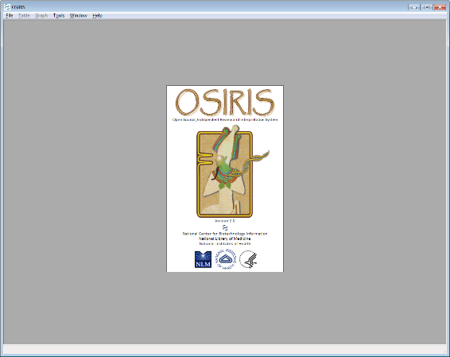

OSIRIS performs analyses on samples in .fsa or .hid files. When an analysis is performed, one or more input folders containing either .fsa or .hid files are analyzed, and the results are written to a new output folder for each input folder. File type is selected on the “General” tab of the “Lab Settings” dialog.

To begin an analysis, open the “Analyze Data” dialog window by selecting “New Analysis…” from the “File” pull down menu as shown below.

When the “Analyze Data” dialog box appears, the user can enter the specific information and click “OK” to begin the analysis. Note that different minimum RFU Threshold values may be set for Samples, Ladders and ILS (internal marker). The drop-down menus detail the kits and standards that OSIRIS currently recognizes. The Operating Procedure Name refers to the kit and many other settings which are described in detail in the Laboratory Settings section.

The illustrated example below uses IdentifilerTM data files created by NIST which are provided with the OSIRIS software download. This tutorial analyzes the samples using the OSIRIS fragment analysis as if they were a user-designed multiplex. The NIST data files are located in a subdirectory named “TestAnalysis.” When using the Windows™ version of OSIRIS, it is a subdirectory of the directory where OSIRIS was installed. When using the Macintosh™ version, it is a subfolder in the folder containing the OSIRIS application. Note that file names on the Mac will not be selectable: select the *directory* to be analyzed.

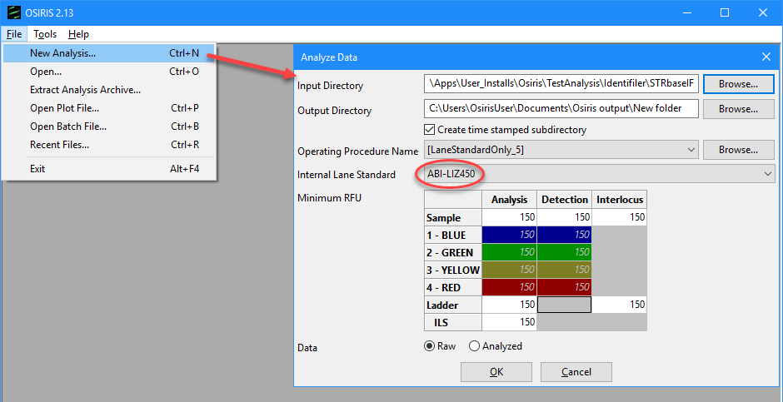

1. Start a new analysis. Select File>New Analysis from the menu. For the **Input Directory, select \TestAnalysis\Identifiler\Identifiler_Artifacts** in the directory where you installed OSIRIS (located in the C:\Apps\User_installs\NCBI\Osiris directory in this figure).
2. **Select the [LaneStandardOnly_5] Operating Procedure** from the dropdown list, because Identifiler files have five channels of collected data. Note that the Operating Procedure selected must match the number of channels of collected data in the .fsa/.hid file.
3. Finally, **select ABI-LIZ450** **in the “Internal Land Standard”** dropdown list.
4. Click “OK”.

When the analysis begins, a new window appears which shows each subdirectory that will be analyzed along with its current analysis status. Since only one subdirectory is being analyzed here, a new window opens upon completion with a table containing the results of the analysis. If more than one directory is analyzed select one from the list and click “View selection”.

1. Click the first cell with peak sizes in the table to display the first channel as shown in the figure below.

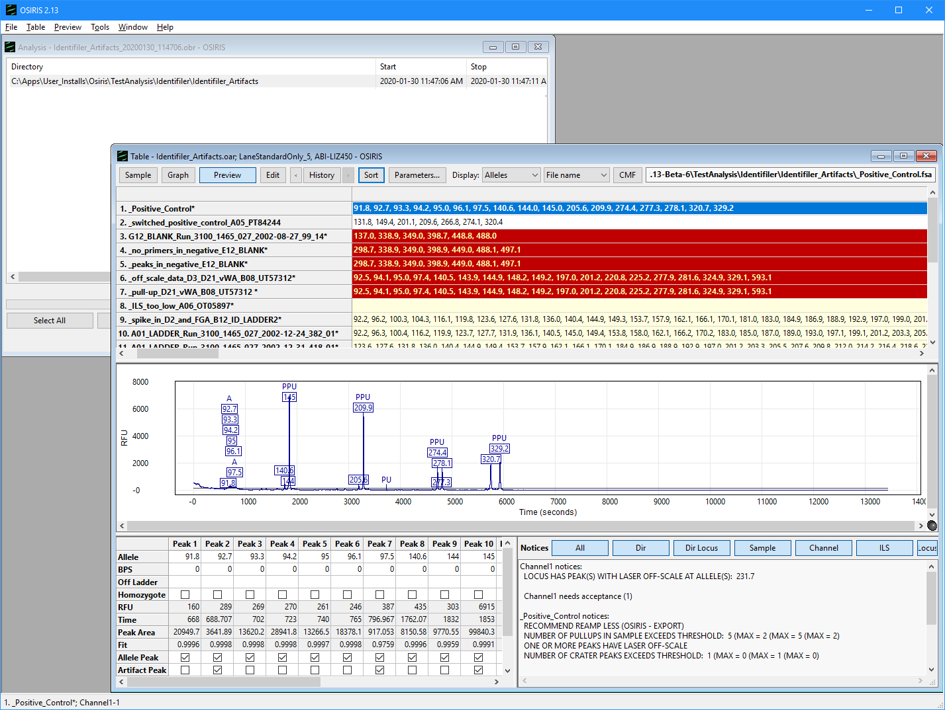

Data selected in the table will display in the preview window below. The blue channel data is selected in the figure above. In the table, the user can choose which peak data to display (base pairs (BPS), RFU, time, peak area), view plots containing the data, and edit the data using the toolbar buttons at the top of the table window, the pulldown menu labeled “Table” on the menu bar, or by right clicking the table cell of interest to display a pop-up menu.

1. Open the full Graph view shown in the figure below by either double clicking the first sample name or clicking the sample name and selecting the “Graph” button on the Table toolbar.

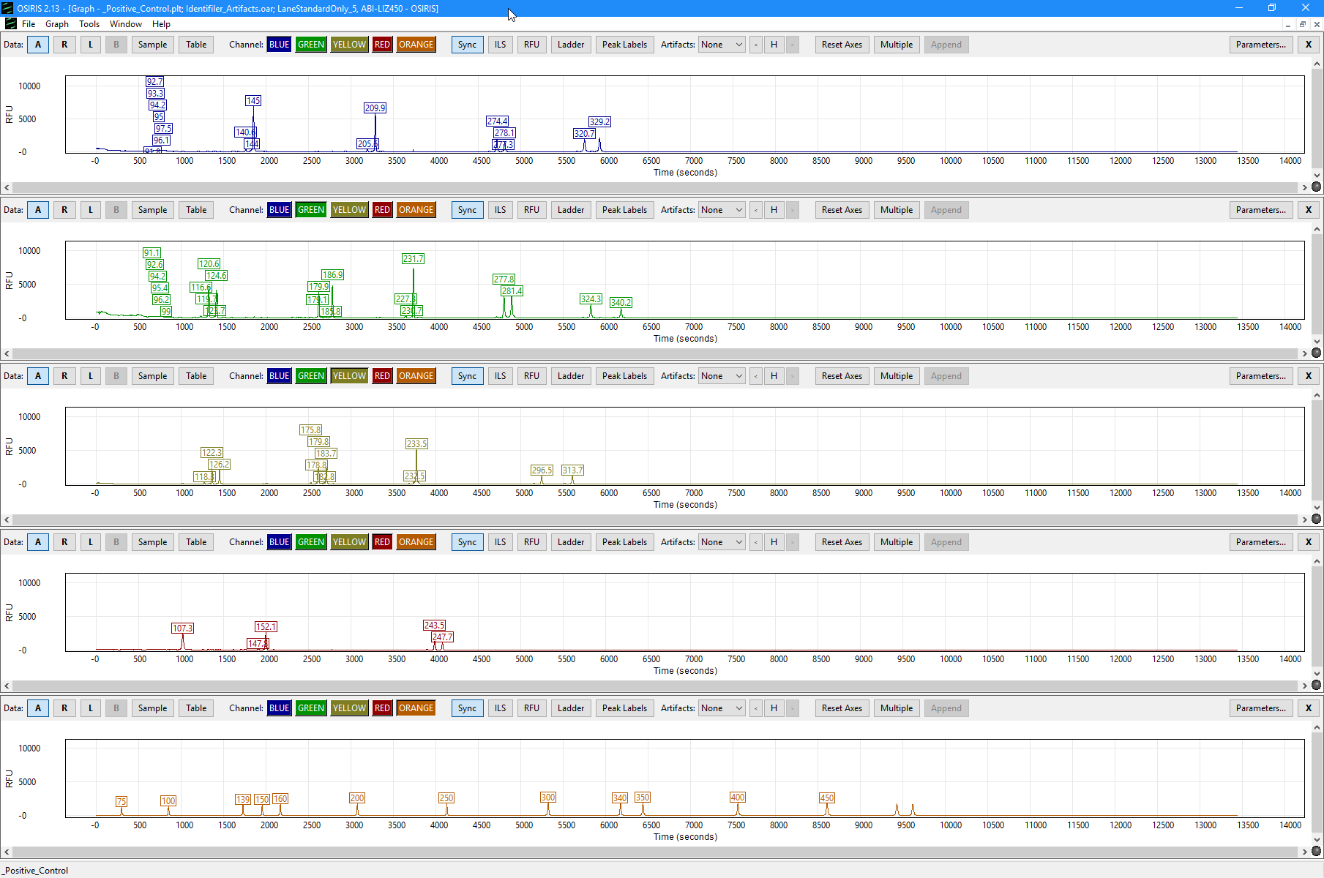

The image above shows the Graph view of the electropherograms. By default, there is a separate plot for each channel. The toolbar at the top of each plot as well as the pull-down menu labeled “Graph” provides many display options.

Hover the cursor over buttons to display a tip regarding their function.

Adjust the height of the plots for your screen size. Click and drag the bottom edge of the top plot down to resize the plots to a convenient size for your screen. When the stacked plots are larger than the screen, use the scroll bar that appears on the right to scroll through the plots that are off-screen. If you have upgraded a previous OSIRIS version, you may have to select “Resizable plots” from the “Graph” pull down menu before resizing the plots.

Hold the cursor over one of the allele labels to display the allele peak information pop-up. Hold the cursor over one of the artifact labels to display the artifact information pop-up for the peak. Further information is described in detail in the rest of the OSIRIS User Guide.

Click in the graph and drag to box allele peaks to zoom in. Click the “Reset axis” button to zoom back out.

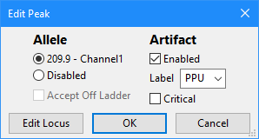

Edit a peak. Click on a peak label to open the Edit Peak window. Here you can turn artifact and allele labels off or on by selecting enable or disable. You can select a different artifact label than the one chosen by OSIRIS from the Artifact Label dropdown list. Clicking ‘OK’ will save your changes. Click the “Edit Locus” button to open the Sample Editing window, which allows review and acceptance of quality notifications that are associated with loci. See Editing Peaks, Loci and Samples. in the User Guide.

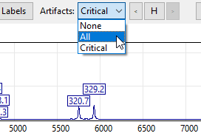

Display all the artifact labels. Select “All” from the “Artifacts” dropdown list to display all of the artifact labels, including non-critical artifact labels. See OSIRIS Artifact Handling for a discussion of how OSIRIS defines critical and non-critical artifacts.

You can zoom in by clicking and dragging to box an area of one of the plots. See Zooming and Panning the Graph.

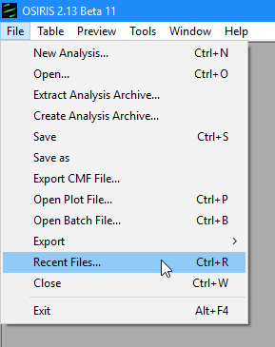

Recently viewed files can be accessed through a dialogue window by selecting “Recent Files…” from the “File” pull down menu, as shown here. An example is shown below. Type part of a file name in the Search bar to find files.

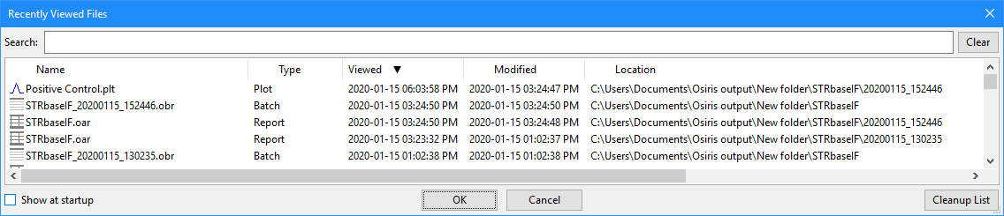

This list shows up to 1000 files that have been opened by OSIRIS and can be sorted by name, type, last time viewed, modification time, or location. To open a file, double-click on the file name or select one or more files and select the “OK” button. You may select and view up to 10 files at a time. To search for a desired file, simply type part of the file name in the “Search” text box at the top of the window and the list will be updated immediately to filter out all files that do not match the search criteria.

### Analyze Your Own Data

For fragment size-based analysis, there are four default Operating Procedures in version 2.13 and higher. These defaults are named LaneStandardOnly_2, LaneStandardOnly_3, LaneStandardOnly_4, and LaneStandardOnly_5. The number in the name refers to the number of channels being analyzed. As with all the default Operating Procedures (OP’s), users can make a new OP based on a default to customize the settings. There are additional parameters in the Lab Settings that allow users to identify the lane standard and adapt the default channel assignments to their specific needs. These parameters are specified in the Sample Thresholds tab of the Lab Settings. The default assignments are to assign OSIRIS display channel 1 to fsa/hid channel 1, OSIRIS channel 2 to fsa/hid channel 2, etc. **The user must take care to assign the last OSIRIS display channel (e.g., channel 3 for a 3-channel lane standard-only analysis) to the fsa/hid channel that contains the internal lane standard.** All fsa/hid file channel numbers must fall in the range of 1 through 8. If the user specifies an fsa/hid channel that contains no collected data, the analysis will fail. In the example for this tutorial, the default settings are satisfactory.

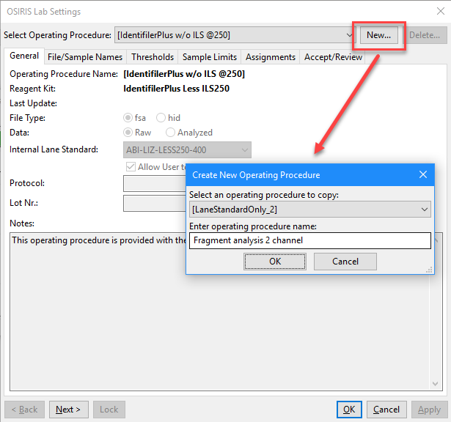

1. Make a custom Operating Procedure for your data. From the files menu select Tools>Lab Settings>”New” button (at top)>select an Operating Procedure from the dropdown list that matches your number of channels of data collected in the collection software, like [LaneStandardOnly_2] for two channels. If an Operating Procedure with the wrong number of channels is selected, the analysis will fail. The number of channels of data collected in the .fsa or .hid files is controlled by the ABI collection software. Note that if your internal lane standard marker is not in the correct channel, the analysis will fail to identify fragment sizes. If it is necessary to change which channel contains the internal lane standard marker, you can tell OSIRIS the correct channel. See Override Default Channel Map for Fragment Analysis on the Thresholds tab in the Lab Settings.  
     
   Enter a name for your Operating Procedure and click “Ok.”
2. 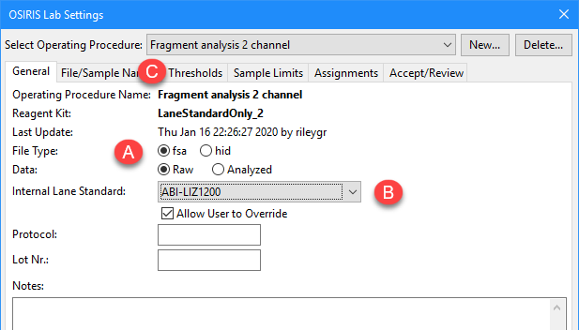Select the File Type (A) (fsa or hid).   
   Select your Internal Lane Standard size marker from the dropdown list (B).  
   Set your analytical and other RFU thresholds on the Thresholds tab (C).
3. 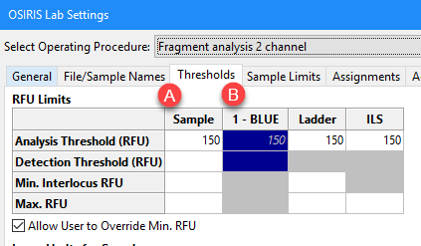Set the analytical threshold default for all channels (A) or override the default by setting individual channel thresholds (B).

Please see Lab Settings for other settings.

Please send questions, comments, suggestions and feedback to [forensics@ncbi.nlm.nih.gov](mailto:forensics@ncbi.nlm.nih.gov).

## OSIRIS User’s Guide Revision History

| **Version, Revision** | **Changes** |
| --- | --- |
| **Version 2.03 Rev. 1** |  |
| **Version 2.04 Rev. 1** | * Added detail and examples to “Appendix G. Adding a new kit”. * Added detail regarding displaying and sorting by sample names versus sample file names. Sorting samples and Display * Added detail regarding searching sample names versus sample file names for controls and other sample types. File/Sample Names * Modified Sample Thresholds figure and text to indicate “Max. No. of pull-up peaks per sample” indicates sample severity rather than affecting sample analysis and that “Incomplete profile threshold for Reamp More/Reamp Less” value is optional. |
| **Version 2.1 Rev.1** | * Added detail regarding analysis of .hid file type. * Added information regarding new parameters in Sample Thresholds tab of Lab Settings * Updated cpmsg.bat description * Added names.bat description |
| **Version 2.2 Rev. 1** | * Added ‘Baseline’ Signal Artifacts to Artifact List * Added information regarding new Baseline parameters in Sample Thresholds tab of Lab Settings * Added Appendix H.-Dynamic Baseline Analysis regarding the functioning of OSIRIS dynamic baseline analysis * Added to Appendix I: Troubleshooting section * Added to OSIRIS Artifact Handling * Added detail regarding flagging artifacts when a peak is in Core and Extended loci * Added detail regarding Baseline Data and Ladder label display options * Added description of demonstration files in the Quick Tutorial * Added thresholds descriptions in Sample Thresholds section |
| **Version 2.3 Rev. 1** | * Added information regarding OSIRIS’s creation of the \Volumes directory * Operating Procedure upgrades no longer required * Additions to Artifact list: Five new messages listed at bottom of Signals list (pg. 60) * Extended Locus Lab settings parameters no longer refer to “inter-locus” where “extended locus” is meant * Added new Lab Settings parameters (Sample Thresholds):  Percentage of Standard Noise Threshold For Peak Identification  Ladder Fit Threshold for Accurate Sizing  Baseline Estimation Threshold  Filter Window Width for Baseline Estimation  Min RFU for a peak to be considered as a primary pull-up  Max % BP for Residual Displacement Test  Enable Raw Data Filter For Baseline Normalization Estimation  Enable Ladder Fit Threshold Test  Enable Residual Displacement Allele Validation Test  Make Excessive Residual Displacement Message Critical |
| **Version 2.3 Rev. 2** | * Added information regarding centralized MessageBook file * Added information on lab settings to differentially analyze single source and possible mixture samples. |
| **Version 2.4 Rev. 1** | * Reorganized, added information to, and edited Lab Settings Sample Thresholds section. * Added kits and controls to controls table in Appendix A. * Edited Detecting the true baseline in Appendix H. |
| **Version 2.5 Rev. 1** | * Added description of change to “Ignore Artifacts Smaller Than” in the Settings that affect sample analysis in Lab settings. * Added description of ILS Peak Shoulder filtering settings in “Internal Lane Standard Analysis Criteria” in the Settings that affect sample analysis in the Lab Settings * Added description of the Reduce Ladder Artifacts parameters in the Settings that affect sample analysis in the Lab Settings * Changed “Crater or Poor Morphology: Possible Critical Adenylation” artifact message to “Low Signal to Noise in Peak” * Added how to display multiple peak labels using the new Peak Labels button on the Graph Toolbar and how to label Ladder peaks with the “Ladder” button and Plot->Show Ladder Labels menu option. * Changed “Viewport and Zooming” heading to “Zooming and Panning the Graph” * Added description of centralized predefined Positive Controls available for all kit definitions and table of defined positive control loci and alleles. Removed table of positive controls defined for each kit in Positive Controls Defined in Default Operating Procedures in Appendix A. |
| **Version 2.6 Rev. 1** | * In the Lab Settings, the “Locus/ILS Thresholds” and “Sample Thresholds” sections have been renamed to “Thresholds” and “Sample Limits” respectively to reflect the tab name changes. The Analysis, Detection, Min. Interlocus RFU and Max. RFU Thresholds have been moved to the “Thresholds” tab. * Thresholds and Sample Limits sections have been rewritten to describe channel specific thresholds settings and the tab name and settings location changes above. * Figures were updated to take into account the changes in the Lab Settings tab names and the ability to set channel specific thresholds. * Description of new setting “Make Laser Off-Scale Artifacts Non-Critical” was added to the Sample Limits section. * Description of new settings for “Extended Locus Options” to ensure that all peaks between loci are callable was added to the Sample Limits section. * New functionality for lab positive controls explained in the Assignments section * Redundant “Excess Residual in Multi Allele” Artifact deleted from the Artifact List appendix * Updated description of Extended loci and criteria for identifying alleles that fall in overlapping extended loci in Core/Extended/Interlocus Boundaries |
| **Version 2.7 Rev. 1** | * Added note that some User’s Guide figures display better in some PDF readers when the Guide is zoomed to the width of the screen. * Version 2.7 is a release to add Operating Procedure functionality for additional kits definitions where kits may use more than one ILS. There are no other revisions to the User’s Guide. |
| **Version 2.8** | * Internal development version only. No public release. |
| **Version 2.9 Rev. 1** | * Updated Getting Started with navigation instructions for this guide * Updated tutorial with display and peak editing * Updated “Max. stutter threshold” and “Max. plus stutter threshold” sections of the Thresholds section regarding optionally giving allele labels to stutter peaks * Added the Non Standard Stutter section regarding setting up detection of stutter other than plus or minus one repeat. * Updated Make Pull-up at Allele Artifact Non-Critical in the Settings that affect sample analysis of the Sample Limits section regarding partial pull-up. * Added Call Allele and Stutter Artifact and “Call Artifact but Not Allele” to the Settings that affect sample analysis regarding optionally making allele calls on stutter peaks. * Added “Scale ILS Primer Peak Search Based on Last ILS Peaks” and “Number of End Peaks Used in Scaling” settings description in the Settings that affect sample analysis regarding a setting that improves ILS recognition and analysis. * Renamed Acceptance/Review section Configure Editing – Acceptance/Review Tab and added detail regarding setting up editing acceptance and review. * Added Artifact Label Setup detailing changing artifact labels and their display priority. * Added detail regarding the Reanalyze Selection button to the bottom of the Analysis section. * Modified Table Toolbar and Menu regarding editing. * Added Editing Peaks, Loci and Samples. * Expanded Pullup And Spikes in Artifact Handling section to describe new OSIRIS Pull-Up detection mechanism. * Updated the Stutter section of Artifact Handling to include non-standard stutter. * The Artifact table in Appendix F. Artifact List was updated add “Laser Off Scale”, “Partial Pullup”, “Pullup”, “Partial Pullup Corrected Below MinRFU”, and delete |
| **Version 2.9.1 Rev. 1** | * Added to the Curve fit options section of Settings that affect sample analysis: Apply Enhanced Shoulder-Fitting Algorithm Percentage of Standard Noise Threshold for Shoulder Acceptance Minimum Number of Points Concave Down * Added to the Internal Lane Standard Analysis Criteria section of Settings that affect sample analysis: Save Ladder ILS History To Aid Sample Analyses Latitude For ILS Fit Use Ladder ILS End Point Algorithm |
| **Version 2.10 Rev. 1** | * Clarified the name and description of the Cross Channel Options parameter “Min RFU for a peak to be considered as a peak that causes pull-up (primary pull-up)” in Settings that affect sample analysis. * Added section on Editing Operating Procedures. * Added section describing new parameters “Constrain Pull-up Pattern Analysis,” “Save Ladder ILS History To Aid Sample Analyses,” and “Use Ladder ILS End Point Algorithm” in Settings that affect sample analysis. * Added sections on new Deleting Samples, Creating an Archive, and Extracting an Archive features. * Added statement that spikes are not included in pull-up pattern analysis to OSIRIS Artifact Handling. * Added three new “Shares Allele Bin…” messages to the Signals section of the Artifact list in Appendix F. * Updated the Troubleshooting section regarding inability to edit and Operating Procedure. |
| **Version 2.10.1** | * not a public release |
| **Version 2.10.2 Rev. 1** | * The “Curve Fit Options” section of the Lab Settings that affect sample analysis was updated to describe the new optional peak detection sensitivity setting. NOTE: To clarify the function of settings, “Ignore noise analysis in peak detection when above detection threshold” has been renamed “Or, require Height > Detection Threshold (overrides Default Height threshold)”; and “Percentage of Standard Noise Threshold for Peak Identification” has been renamed “Require Area > Percent of Standard Area Threshold (Default = 100)”. * The “Ignore artifacts smaller than” section of the Lab Settings that affect sample analysis was updated to describe its improved function. |
| **Version 2.10.3 Rev. 1** | * No significant changes to the User’s Guide |
| **Version 2.11 Rev. 1** | * Modified installation instructions * Added Optimizing Settings in Lab Settings section * Updated Editing Operating Procedures * Updated Thresholds figure and stutter settings sections to include allele-specific stutter settings * Added “Display Sigmoidal Peaks” and “Test Pull-up Corrected Heights for Stutter, Adenylation, Etc.” to Cross Channel Options in the Lab Settings * Added “Tail Fitting Sensitivity Options” to “Curve Fitting Options” in the Lab Settings * Updated explanations in “Curve Fitting Options” in the Lab Settings * Added baseline testing parameters to Baseline Analysis Options” in Lab Settings * Added parameters and text to “Residual Displacement Allele Validation” is the lab settings * Added “Suppress Critical Level Artifacts for ILS Control Peaks” and expanded explanations to “Internal Lane Standard Analysis Criteria” in Lab Settings * Added “Suppress Critical Peak Level Artifacts for Ladder Alleles” to “Reduce Ladder Artifacts” in Lab Settings * Added “Restricted Priority Editing Options” to Lab Settings * Added section “Display Bases or Time on the x-axis” * Added “Noise Estimation” and expanded p” Pull-up and Spikes “to OSIRIS Artifact Handling * Expanded “Stutter” in OSIRIS Artifact Handling * Expanded Appendix H. Dynamic Baseline Analysis and Normalization * Deleted section “Checking calculated dynamic baseline goodness-of-fit” * Updated troubleshooting sections “I can’t edit the Operating Procedure” and “I can’t figure out the name of an Operating Procedure in the folders listed in the Volumes directory” * Added Appendix J. Other Information Output to Analysis Files regarding new process QC data |
| **Version 2.12 Rev. 1** | * Added Note About Edge Browser For Viewing Help Document To Getting Started. * Added Details Regarding Operating Procedure Permissions and updated information regarding Optimizing Lab Settings to the “Lab Settings” section. * Added Primary Pull-up Threshold: Computed parameter and description and updated the Min RFU for a peak to cause pull-up and Make Pull-up at Allele Artifact Non-Critical descriptions in “Sample limits - Settings that affect sample analysis” in Lab Settings. * Updated Tail fitting sensitivity options in in “Sample limits - Settings that affect sample analysis” in Lab Settings. * Added a “Peak tail fitting sensitivity” section and updated the “Non-critical artifact” section with details regarding “restricted priority” artifacts and their editing in OSIRIS Artifact Handling. * Updated Appendix A Operating Procedures and Kit definitions and Kit definitions and Positive control allele table. * Changed Appendix B from obsolete “Upgrading an Operating Procedure to a new version OSIRIS” to “Site Folder Locations and Upgrading” with details regarding the locations and permissions for the Volumes directory containing the Operating Procedures, and instructions for modifying the permissions from the Tools menu. * Updated Appendix G. Adding a New Kit. * Added figure to Appendix H. Dynamic Baseline Analysis and Normalization. * Updated Appendix I. Troubleshooting. * Added additional data fields that can be exported in Appendix J. Other Information Output to Analysis Files. * Added Appendix K. Privacy Information. |
| **Version 2.13 Rev. 1** | * Added information describing fragment analysis using only an internal lane standard marker in the Analysis section including in Operating Procedure Name. * Added information regarding “Override Default Channel Map for Fragment Analysis” settings in Lab Settings for internal marker-only fragment analysis set-up. * Added Appendix L. A Quick Tutorial for Fragment Analysis * Added information regarding character text search strings for identifying Single Source/Possible Mixed samples to Lab Settings File/Sample Names in Possible mixture and single source character strings. * Added information regarding new setting “Make Default Sample Type Possible Mixtures (checked)(unchecked for Single Source)” in Lab Settings * Added Allele and Artifact Hover Boxes section. * Added information regarding Flexible Spreadsheet Export. * Added a partial list of Definitions of terms. * Added description of Lab Settings folder identification button in Operating Procedures and Kit definitions |

1. # [NIJ Journal (2007) 256; Identifying Remains: Lessons Learned From 9/11](http://www.nij.gov/journals/256/lessons-learned.html)

  
2. Kalafut *et al.* [Forensic Science International: Genetics 35 (2018) 50–56](https://www.fsigenetics.com/article/S1872-4973(18)30199-6/fulltext)